**CHAPTER 1**

**INTRODUCTION**

**1.1 BACKGROUND OF THE STUDY**

Starting 2012, the Philippines’ Department of Education passed K12 as the basis of curriculum in throughout the nation. Yet, there are only so much of schools where can deal with the new curriculum, due to lack of facilities, classrooms or even just the population itself is just too low. In Cebu City, there is already an international grade of school adapting the K12 system, which means to enroll in the college, the students are to complete 14 years of education which are 2 years of kindergarten, 6 years of elementary and 6 years of high school education. But it is also true that the facility there is very expensive compared to other schools which makes local students hard to approach.

Watching to the Olympics 2012 made the author wonder about how poor the Philippines facilities for the raising athletes participating the athletic games. It is sad to know that the Philippines did not get any medal after 1996 Atlanta Summer Games with only one silver medal. Last Olympics of 2012, even the entrusted game boxing, the Philippines could not be led to a medal. It is sad to know that there are not many facilities that can be approached by the students who have talents in sportsmanship.

Not many of people would have heard of ‘Olympism’, the philosophy was developed by the founder of the modern Olympic Movement, who is Baron Pierre de Coubertin, a French aristocrat who had been much influenced by the British Public School tradition of sport in education. This philosophy has as its attention of interest not just the elite athletes, but for everyone; not just a short truce period, but for the whole of life; playing sports not just for competition and winning, but also learning the values of participation and co-operation; not just sport as an activity, but also as a formative and developmental influence contributing to desirable characteristics of individual personality and social life.[1]

In other nations especially in China, they teach sports and physical education at least 6 hours per week, not only to teach them to participate the games, but to raise them stronger in physical and mental aspects. In Korea, the students from elementary to high school every during lunch time, they are allowed to play freely on the ground open for the students. In these fields, students play football, basketball and volleyballs as they please. During the physical education subjects, the teachers not only just let them play around, but they teach how to play, the concept and techniques behind them. The teachers also give tests if the students have understood completely. It is very disappointing that the Philippines do not have many schools like these.

For the countries like the Philippines or other countries those can’t afford to teach separate academic sports, IOC has come to solution called “Olympism.” This Olympism has goal to unite the countries as one, holding youths to learn the sportsmanship, developing them through sports. This has been implemented throughout the world, Singapore, China, European countries and several American countries have adapted this system benefiting many athletes around the world.

**1.2 STATEMENT OF PROBLEM**

Mandaue City is located at the central Visayas of the Philippines. It is located at beside of Cebu City, which had been a center of Hispanic era since Magellan landed on island of Mactan of Cebu Province. Mandaue City is a vast piece of land where 331,320 people (by census year 2010) lives in 34.87km² which includes 27 Barangays. Mandaue City currently is having a booming with developments for there are many factories and service based buildings are built.

The concern of the researcher is that since the time when the Philippines has entered Olympic Games, they barely have won any medals for themselves due to lack of facilities and hard to approach the present facilities while other countries have more than enough facilities to aid not only themselves but also foreigners. Since IOC has promoted Olympism to teach the countries with hardships with sports, the committee decided to promote them in the Philippines as well. They would help building and maintaining the school, sometime after when it is already manageable by government, will hand them to the private owner of committee’s choice.

This study aims to come up with architectural solutions and designs for constructing new school facility that will implement Olympism along with K12 curriculum. The following studies will show what kind of facilities will be needed in designing the school and following the K12 curriculum in local setting through research and programming. The study focuses on understanding and implementing the values and characteristics of Olympism.

In this proposal, the author seeks to find answers to these questions:

* What are the facilities that are needed in the school development?
* What are the advantages to the community and government when the said facility is built?
* What kinds of sports are suitable and popular in current Philippines condition?
* If upper question is answered, what are the facilities that will be needed for facilitating those sports?
* What are the requirements by DepED to build a K to 12 school facility?
* What are the facilities to apply Olympism in the project?

**1.3 OBJECTIVES OF THE STUDY**

The goal of this study is to provide the architectural solution and design of new K12 School which implements Olympism and finding out their needs of fa**c**ilities and developments according to the requirements of DepEd and IOC. The site will also be provided with dormitory structure, which will accommodate not only the local students from different areas, but also the international students who are willing to study in the school structure.

Furthermore, it is not only to provide with an ordinary school structure, but to provide them with sustainable design of school structure which it can earn some part of their spending of energy and water by integrating the technologies such as photovoltaic, wind and rainwater collection.

It is also to provide the students with maximum comfort in using the school building, providing the school with ergonomic designs by providing proper measurements and designs for the facilities.

This study’s objectives are:

* To provide the site with elementary and high school building with properly laid out sports facilities. This would include the dormitory building which will be used by local and international students who are away from their home.
* To fulfill the requirements for the school stated by DepEd for designing of school.
* To be able to integrate the values of Olympism and Philippine’s culture at the same time and relating them both to be shown on the design of structures.
* To integrate sustainable design suitable for the said structures.
* To find out the most suitable sports that the Philippines people are good at.

**1.4 SIGNIFICANCE OF STUDY**

This study is not about training the youths to be Olympic athletes. It is to educate the youths to the values of importance of what Olympism is sharing to us about the values and teachings, which the studies are not only passive stance where you just sit on the chair and look into the books, but it is learning through active stance, like you have to go outside and feeling the breeze.

The study would benefit the community first, but in large picture, whole Philippines would be involved to get the benefit, since this offers the globalization for the Philippines and gives broader sights and choices of entering the different types of not only the Olympics, but other games like Asian games.

Particular benefactors of this study’s outputs are the following:

* The students who want learn more about the sports and have talents, but not provided with many of facilities gets in their way.
* To the community giving the higher quality of living and education.
* To the athletes, they can also rent the place as their training hall, for they are valuable to the country.
* To the DepEd, they can also benefit for which they can also come up with better curriculum plans by adapting advanced measures done by other organizations like IOC.
* Ultimately, it can benefit the country by producing better quality players by giving them proper educations and values of athletes.

**1.5 SCOPE AND LIMITATIONS**

The study focuses on the architectural design of the said structure which is the K12 School implementing Olympism, which includes elementary through high school, and the sports facilities like gymnasium, swimming pool and etc. required by the DepEd or IOC.

This also includes the dormitory building which will be used by the students who came from different regions around the Philippines, not only those, but accommodating the students from different countries. In this facility, researcher shall provide with the alternative homes for the students and study places for the students can experience the maximum services provided by the school, not only the sports, but also in studying.

The researcher assumes that the site of request is not in use, and has been cleared up for further development. Furthermore, the proposal will concentrate on architectural design, not the political and educational issues of government.

The proposal mainly concentrates on the architectural design; however, the unavoidable technologies included for the facilities will be illustrated, although the detailing it will not be as accurate as it seems for there are specialists who have more knowledge than the researcher himself.

The engineering utilities will be presented by concepts and on the design spaces, the detailing- which includes structural, mechanical, electrical, etc.- are not detailed in the scope of the proposal and will be reserved to specialized engineers.

**1.6 RESEARCH METHODOLOGY**

**Introduction**

This study was conducted to identify the possible solutions the researchers can offer for the K12 Schools promoting with sports. In order to gather the necessary data, the researchers utilized research, survey, and site analysis, using quantitative and qualitative methods. Determining of primary users and its essential needs would result to the desired development and objectives.

**Preparation**

This details the researcher’ data gathering process, on how data was gathered through interviews, library works, internet research and site visits. The data was gathered in the sequence of the following.

1. Site Data Gathering
   1. Through library research and internet
   2. Through interviews and visits
   3. Through library research
   4. Through Internet
   5. Through Interviews
2. Facilities Data Gathering
   1. Through gathering requirements from Department of Education
   2. Through library research
   3. Through internet

**Synthesis**

Identifying the advantages and disadvantages of existing site condition in relation to the project development will be undertaken in relation to its site analysis. The data gathered was analyzed for the progress of the project development. These will serve as guiding principles for the design and planning process. The design process were bounded by implemented and existing laws to be pursued such as building codes, fire codes and other stand requirements to guarantee the safety and efficiency of the structures and of the site, maximizing land use for its development. Site conditions will be taken into considerations to contribute to the planning and design of the project proposal. All data gathered will determine the needed spaces, facilities, and development for the users. All data were interpreted and analyzed for the result of the project proposal.

**Hypothesis**

This formulates tentative assumptions in order to conceptualized and test its analytic interferences.

**Design Alternative**

Set of schemes, concepts and ideas are formulated in line with the project proposal. These will serve as preferences for the final design or master plan of the project.

**Design Development**

This provides preliminary plans and concept for the proposed project development. Certain changes are encountered from time to time until it reaches the most efficient plan and design.

**Evaluation**

Simulating, testing, and modifying acceptable alternative design solutions according to specified goals, objectives and criteria that have been followed.

**Translation**

This produces the plans, elevations, sections, perspectives, architectural details and designs which will become the output of these architectural programs.

**1.7 CONCEPTUAL FRAMEWORK**

Here lies 2012 year of the Philippines when K to 12 has already been approved and ready to be implemented throughout the nation, it does quite look like not many schools are prepared for this curriculum. There have been only few schools where K12 is implemented; still, there is a lot of school still following the old system. It quite looks as if there is any public school where it is ready for facilitating this new curriculum.

In many years back, the Philippines has joined the Olympic Games. But only a few prizes came back from training the valuable talented athletes. Ever since 1996, the Philippines could not win a single medal. Last 2012, the trusted boxing has also been annihilated by the tall walls of international boxing. Now, there should be changes for the people to learn how to play sports, not from their late teenage or later, but from school activities facilitated by the school.

The reality in the Philippines is quite disappointing. Those who want to learn sports and dreaming to be an athlete one day to shine the name of one’s country have to go through spending time not only in school, but also in their respective private facilities built by private owner. But then the results are not also promising, as they go further, they can hardly catch up with both studies and sports.

The researcher’s job is to connect the both studies and physical education together. It does seem quite possible when you see the schools of foreign countries like in Japan and other Asian countries nearby. They have integrated the both together at the same time resulting them a good promises, not only in their Olympic games, but also in their country, since the value of Olympism is not only to raise the athletes, but to developing the potential individuals for the country.

By going through these things, the researcher seeks forward to come up with structures that will be able to seek and raise the potential individuals throughout the country.

**CONCEPTUAL DIAGRAM**

EVALUATION AND CONCEPTUALIZATION

ARCHITECTURAL PROGRAMMING

SPACE PROGRAM

SPACE REQ.

SPACE DESC.

USERS

SITE ANLYSIS

PHYSICAL PROFILE

CHARACTERISTICS

LAND USE

UTILITIES

DESIGN PROGRAM

CONCEPTS

FEATURES

ISSUES

APPROACH

SYNTHESIS AND APPROACH

ARCHITECTURAL SOLUTION

INFORMATION CLASSIFICATION AND ANALYSIS

LOCAL

●CURRICULUM

●REQUIREMENTS

●RULES ●REGULATIONS

●POLICIES

●LAWS

●CURRICULUM

●REQUIREMENTS

●POLICIES

●EDUCATIONAL PROGRAM

OLYMPISM

PROPOSED K12 SCHOOL INTEGRATING OLYMPISM

**CHAPTER 2**

**REVIEW OF RELATED LITERATURE**

**Olympism**

- For many of people, the word ‘Olympics’ will be thought as Olympic Games or particular sports. However, only few have heard of ‘Olympism’ the philosophy developed by the founder of the modern Olympic Movement, Baron Pierre de Coubertin, who is a French aristocrat who had influenced by the British Public School tradition of sports in education. This philosophy has its focus of interest not just the elite athlete, but everyone; not just a short truce period, but the whole of life; not just competition and winning, but also the values of participation and cooperation; sports not just as an activity, but also as a formative and developmental influence contribution to desirable characteristics of individual personality and social life.

The Olympism is a social philosophy which emphasizes the role of sports in development, individually or internationally, for peaceful harmony and social and moral education. Towards the tip of nineteenth century, sports were becoming growth point in popular culture. (Dr. PerryJim, 2003)

The Olympic symbol, which is five interlocked rings, represents the union of the five original major continents (Africa, America, Asia, Australia and Europe) and the meeting of the athletes from all over the world at the Olympic Games. The five colors of the rings from left to right are blue, black and red across the top and yellow and green along the bottom. The colors of the rings represent the flags of the countries that participate in the Olympics. Every flag of a country participating in the Olympics includes one of those colors.

**Olympic Charter**

**-** The Olympic Charter of 1995 states simply the relationship between Olympic philosophy, ethics and education.

Fundamental principle 2 says:

-Olympism is a philosophy of life, exalting and combining in a balanced whole the qualities of body, will and mind. Blending sport with culture and education, Olympism seeks to create a way of life based on the joy found in effort, the educational value of good example and respect for universal fundamental ethical principles.

Fundamental Principle 6 says:

-The goal of the Olympic Movement is to contribute to building a peaceful and better world by educating youth through sport practised without discrimination of any kind and in the Olympic spirit, requires mutual understanding with a spirit of friendship, solidarity and fair play.

Chapter IV deals with National Olympic Committees, and again states simply and prominently the Pre-eminent duties of NOCs with regard to Olympic education (p31):

-The mission of the NOCs is to develop and protect the Olympic Movement ... (and to) propagate the fundamental principles of Olympism at national level within the framework of sports activity and otherwise contribute, among other things, to the diffusion of Olympism

in the teaching programmes of physical education and sport in schools and university establishments ... (and to) see to the creation of institutions which devote themselves to Olympic education (Dr. PerryJim, 2003)

**Fundamental Principles of Olympism**

1. Olympism is a philosophy of life, exalting and combining in a balanced whole the qualities of body, will and mind. Blending sport with culture and education, Olympism seeks to create a way of life based on the joy of effort, the educational value of good example and respect for universal fundamental ethical principles.

2. The goal of Olympism is to place sport at the service of the harmonious development of man, with a view to promoting a peaceful society concerned with the preservation of human dignity.

3. The Olympic Movement is the concerted, organised, universal and permanent action, carried out under the supreme authority of the IOC, of all individuals and entities who are inspired by the values of Olympism. It covers the five continents. It reaches its peak with the bringing together of the world’s athletes at the great sports festival, the Olympic Games. Its symbol is five interlaced rings.

4. The practice of sport is a human right. Every individual must have the possibility of practising sport, without discrimination of any kind and in the Olympic spirit, which requires mutual understanding with a spirit of friendship, solidarity and fair play. The organisation, administration and management of sport must be controlled by independent sports organisations.

5. Any form of discrimination with regard to a country or a person on grounds of race, religion, politics, gender or otherwise is incompatible with belonging to the Olympic Movement.

6 Belonging to the Olympic Movement requires compliance with the Olympic Charter and recognition by the IOC.

**Educational Values of Olympism**

1. JOY OF EFFORT- Young people develop and practice physical, behavioural and intellectual skills by challenging themselves and each other in physical activities, movement, games and sport.

2. FAIR PLAY- Fair play is a sports concept, but it is applied worldwide today in many different ways. Learning fair play behaviour in sport can lead to the development and reinforcement of fair play behaviour in the community and in life.

3. RESPECT FOR OTHERS- When young people who live in a multicultural world learn to accept and respect diversity and practice personal peaceful behaviour, they promote peace and international understanding.

4. PURSUIT OF EXCELLENCE- A focus on excellence can help young people to make positive, healthy choices, and strive to become the best that they can be in whatever they do.

5. BALANCE BETWEEN BODY, WILL AND MIND- Learning takes place in the whole body, not just in the mind, and physical literacy and learning through movement contributes to the development of both moral and intellectual learning. This concept became the foundation of Pierre de Coubertin’s interest in a revival of the Olympic Games.

**Department of Education**

**Historical background**

The system of education in the Philippines was planned, from the educational systems of Spain and the United States. However, after the liberation of the Philippines in 1946, the system of education has been liberated to the Philippines own governance.

The Department of Education is the administration for the whole educational system, which also includes the allocation of funds utilized for school services and equipment, hiring of teachers for all public schools in the Philippines, and the management and organization of the school curricula.

Since June 4, 2012, DepEd started to implement the new K-12 educational system, which includes the new curricula for all schools. In this system, education is now compulsory.

All public and private schools in the Philippines must start classes from a date mandated by the Department of Education (usually every first Monday of June for public schools only), and must end after each school completes the mandated 200-day school calendar of DepEd.

**DepEd Region 7 Vision and Mission**

**DepEd Vision**

-A region that is God-loving, transforming, systematic, and highly technological in the delivery of services for quality basic education.

**DepEd Mission**

-To provide the Central Visayas Division Offices with technical assistance, operationalize the basic education curriculum and the Regional Education Development Plan, mobilize resources, ensure quality assurance and accountability through God-loving, intellectually capable and technologically equipped Regional Office to achieve quality basic education. (DepEd)

**Structure and governance**

**Elementary**

- Elementary school, sometimes called primary school or grade school (Filipino: paaralang elementarya, sometimes mababang paaralan), is the first part of the educational system, and it includes the first six years of compulsory education (grades 1-6). These grades are further grouped (informally) accordingly into: primary level, which includes the first three grades (grades 1-3), and intermediate level, which includes the last three grades (grades 4-6).

The elementary school education covers a smaller but wider than the junior and senior high school because of the spiral approach educational technique.

**Secondary**

-Secondary school in the Philippines, more commonly known as "high school" (Filipino: paaralang sekundarya, sometimes mataas na paaralan), consists of four levels largely based on the American schooling system as it was until the advent of the comprehensive high schools in the US in the middle of last century. The Philippine high school system has not moved much from where it was when the Philippines achieved independence from the US in 1946. It still consists of only four levels with each level partially compartmentalized, focusing on a particular theme or content. (Wikipedia, 2008)

DepEd specifies a compulsory curriculum for all high schooling, public and private. The first year of high school has five core subjects, Algebra I, Integrated Science, English I, Filipino I, and Philippine History I. Second year has Algebra II, Biology, English II, Filipino II, and Asian History. Third year has Geometry, Trigonometry, Chemistry, Filipino III, and World History and Geography. Fourth year has Calculus, Advanced Algebra, Physics, Filipino IV, Literature, and Economics. Minor subjects may include Health, Music, Arts, Technology and Home Economics, and Physical Education. (Wikipedia, 2008)

**Problems and issues**

1. Quality - There was a decline in the quality of the Philippine education, especially at the elementary and secondary levels. For example, the results of standard tests conducted among elementary and high school students, as well as in the National College of Entrance Examination for college students, were way below the target mean score.

2. Affordability - There is also a big disparity in educational achievements across social groups. For example, the socioeconomically disadvantaged students have higher dropout rates, especially in the elementary level. And most of the freshmen students at the tertiary level come from relatively well-off families.

3. Budget - The Philippine Constitution has mandated the government to allocate the highest proportion of its budget to education. However, the Philippines still has one of the lowest budget allocations to education among the ASEAN countries.

4. Mismatch - There is a large proportion of "mismatch" between training and actual jobs. This is the major problem at the tertiary level and it is also the cause of the existence of a large group of educated unemployed or underemployed. (Philippine Network Foundation)

**Mandaue City**

1. **About Mandaue City**

- Mandaue City is a city in the Cebu Province located in the Philippines. It is one of the two highly urbanized cities in the Cebu Metropolitan area. Mandaue City is located on the central east coastal region of Cebu, bordering to its right-side are Mactan Island where Lapu-Lapu City is located. Mandaue is connected to Mactan Island with two bridges which includes the Mactan-Cebu Bridge and Marcelo Fernan Bridge and is bounded south and the west by Cebu City and north by Consolacion which is connected with Cansaga Bay Bridge. The Mandaue City has an area of about 34.87 square kilometers and has a total population of about 346,693 people. (NSCB, 2007)

- Former Mayor Demetrio Cortes launched a massive campaign to lure business entrepreneurs to invest in Mandaue during this period. Within ten years, the town which relied heavily on agriculture developed into a major job opportunity basin and residential area and a minor port of trade and navigation. The greatest number of workers was classified as craftsmen, production process workers and laborers. (Mandaue City Government, 2011)

**Mandaue city vision and mission**

**Vision**

-The premier business destination of Central Philippines with a community free from want, living in an environment that is friendly to man, and nurturing life through arts, culture and sports

**Mission**

-Provide balance between sustainable growth and a livable society, through good governance, business social responsibility and multi-sectorial involvement

1. **City profile**

City of Mandaue is the city located at the center of Cebu Province, Philippines, which is also known for 6th district. The city is consisting of 27 Barangays, total area of 34.87 sq.km and total population of 331,320 as of 2010, May. It was incorporated as town during 1599, and it became the city level during August 30, 1969. The government type is City Legislative Council, the Mayor as Jonas Cortes and Vice-Mayor as Glen Bercede.

**Geographic**

The on-going North Reclamation Project, now known as the North Special Administrative Zone, currently has about 180 hectares reclaimed land. Of the 180 hectares, about 36 hectares belong to the city. The existing mangrove area will be retained as a Marine habitat, part of the area's parks and open spaces.

**Topography (slope and soil types)**

Many of the areas of the city are extremely flat. About 77.37% is within the 0-8% slope category. Barangays belonging to this region are Centro, Looc, South Special Administrative Zone, Cambaro, Opao, Umapad, Paknaan, Alang-alang, Tipolo, Ibabao, Guizo, Subangdaku, Mantuyong, Maguikay and Tabok. The greater portion of the city, comprising about 70%, is dominated by the Mandaue Clay Loam soil series. This is found in the 0-2% and 2-5% slope ranges. Faraon clay loam characterizes the rest of the land with slope range from 5-8% and up to 25-40%.

|  |  |
| --- | --- |
| Parameters | Descriptions |
| Elevation | Less than 100 meters above sea level and mostly 2-30m above sea level |
| Slope | 79% of total area has slope of 8% and less. |
| Geology | Alluvium quaternary, mostly limestone |
| Land Use | Residential 872 hectares  Commercial 242 hectares  Industrial 1,695 hectares  Institutional 60 hectares  Parks 24 hectares  Roads 120 hectares  Agricultural 283 hectares |
| Other features | Water features such as Butuanon River and other creeks could be found. |

Table 2.2.1 Characteristics in topography of Mandaue City

**Population**

|  |  |  |
| --- | --- | --- |
| Year | Population | Percentage of growth |
| 1970 | 58,579 | - |
| 1980 | 110,043 | 6.3% |
| 1990 | 180,288 | 4.94% |
| 2000 | 259,728 | 3.65% |
| 2010 | 331,320 | 2.43% |
| 2011(est.) | 346,693 | 4.54% |

Table 2.2.2 Population census of Mandaue City

**Development Issues and Opportunities**

General Priority Issues and Concerns

The city of Mandaue plays a major role in the socio-economic performance of the province of Cebu. In fact, in terms of support, the city is totally dependent on the nature of businesses that are major income earners. However, due to many other parameters, Mandaue City has become important ingredients in the development of Metro Cebu and Cebu province. As with any other development areas, Mandaue City has its share of problems and issues that are hindrances to the city’s growth.

Specific Issues and Concerns

*High population growth*

The province’s present population growth rate of 2.38 percent per annum considerably high. Economic growths are always downgraded by high population as it directly affects per capita income, standard of living and wealth distribution.

The negative effects of high population growth can be felt more in Mandaue, having an annual average rate of 5.01 percent in 1980-1990, more than double to that of the province. Although, the population growth rate in 1990-1995 slows down to 1.5 percent, still more economic activities are expected to attract more in-migrants.

*Water supply shortage*

Water supply in Metro Cebu is already at a critical state and may pose as a constraint to further economic development. Further deferment of the implementation of pipelined water supply projects will seriously spoil Cebu’s economic potential.

Mandaue City having the highest percentage of urbanization is especially affected by this constraint. The fact that most of the water comes from outside its boundaries made the situation very worrisome.

*Insufficient infrastructure support*

Cebu is widely recognized as a port city. Because of its island geography, sea transport is the lifeline of Cebu economy. Cebu port handles 5 million tons of cargo annually. However, the port facilities need much to be desired. Drastic measures to strengthen the international domestic shipping function of the Cebu port should be undertaken, otherwise, the Cebu economy will lose its vested advantage in the Asia Pacific region.

Expansion of the existing port facilities and modernization of the port operation system must be undertaken to meet the demands for international containerized system.

Mandaue has no commercial port to speak of. However, numerous inter-island transport vessels dock along its coastline. It is also a regular landing area for commercial fishing boats.

*Road transport*

The road network in Mandaue City is generally inadequate to meet its growing local travel needs particularly for the movement of raw materials and finished products of the increasing number of local and export industries. It also lacks the necessary support road network for the fast and convenient movement of its own people from their place of work and other destination areas.

More importantly, the city’s inadequate road system and poorly managed traffic system is becoming to be a major contributor to the overall slowness in the flow goods and services. This is observed specifically, in the northern half of the province of Cebu. Traffic is generally very slow in Mandaue City where cargoes and people coming from or going to Cebu City from Mactan Island and northern Cebu are forced to pass through its narrow and congested roads before reaching their final destination. (MCDSP)

**Essential design principles in School Designs**

Over the past several months the School Design and Planning Laboratory (SDPL) has been conducting research to find school design variables that influence student achievement. Our samples have been in the State of Georgia and may not necessarily generalize to other areas. We were successful in finding 29 design patterns that significantly relate to student achievement. In all cases statistical controls were placed on social and economic variables to eliminate bias. The following list represents findings from two studies. All of the school design categories were assessed by a valid and reliable scale and correlated significantly with student achievement. The research represents findings concerning the cognitive aspect of learning. We have not examined the behavioral or affective dimensions, but these areas are on our research agenda.

**Context** - The school and grounds are compatible with the surroundings and sufficient to facilitate the curriculum and programs. This principle relates to personality of place and "in harmony" with nature and the surroundings.

**Pathways** - Clearly defined areas that allow freedom of movement among structures. These play a vital role in the way people interact with buildings. Pathways may also connect buildings to one another so that a person can walk under the cover of arcades.

**Entrance Area** - A friendly space connecting the outside world to the inside world. This age appropriate space should be inviting and highly visible for students and visitors. It should evoke a welcome feeling. Age appropriate refers to scale. For example, a huge and threatening entrance with bold colors is not good for an elementary school.

**Public Areas** - Spaces that foster a sense of community (unity and belonging) were identified as public areas (Auditorium, Amphitheater, Media Center, Commons, and Dining Room). Inviting and comfortable settings include ample lighting.

**Administration Centralized** - Administrative offices are grouped together in a centralized area allowing for connection and convenience. The person in charge should be readily accessible.

**Circulation Patterns** - Ample spaces that allow students to circulate in and between rooms should be part of the design. The passages should be broad and well-lit allowing for freedom of movement. This pattern is also related to crowding.

**Instructional Neighborhoods Within Schools** - These areas include a teacher planning area, flex zones, small and large group areas, wet areas for science and art, a hearth area, and restrooms (toilets). The hearth area is also a place used for reading and quiet time. It is amenable to technology.

**Multifunctionality of the Facility** - Multifunctionality reflects how versatile the facility is in relation to the different tasks it can accomplish.

**Physical Education Areas**- P. E. or play areas are special places where students are given the opportunity to be together, exercise, build muscles, and test new skills in supervised settings. Releasing energy is an important activity seen in these areas.

**Activity Pockets** - Spaces should be designed for small group work.

**Safe Place** - The indoor and outdoor environments guarantee students and teachers security and comfort. Supervisable circulation patterns, security systems, safe grounds and equipment, and toilets in classrooms are important safety factors.

**Personal Artifacts** - Places for display of items of a personal nature that relate to each student improve school design.

**Classroom Walls** - Walls are conducive for displaying students' work. Hallway Display - Hallways (walls and alcoves) are suitable for displaying student work.

**Windows** - These should give the best possible views overlooking life and bring natural light into the school building. The SDPL recommends at least 72 square feet for windows in a 900 square feet classroom.

**Natural Light/ Full Spectrum** - Artificial light plus natural light from the outside, preferably on two sides of every room, is ideal. Natural light influences student behavior and attitudes.

**Green Areas** - Educationally sound school design includes places outside, close to the school building, where trees, grass, or gardens may be seen, but no cars or roads are in view.

**Living Views** - Views of indoor and outdoor spaces (gardens, animals, fountains, mountains, people, etc.) improve school design. Views allow minds and eyes to take a break. Views should not be blocked by curtains, blinds, or other obstructions.

**Quiet Areas** - Quiet areas are spaces where students may go to pause and refresh themselves in a quiet and supervised setting.

**Private Spaces for Students** - Supervised private places (inside or outside) where children may go to be alone (i.e. reading area, listening area) are essential.

**Technology for Students** - Special spaces with computers, compact discs, software, internet connections, television, and video are important for learning activities. In our studies the schools that made computers available for student learning showed higher academic achievement on the average. This finding was after social and economic variables had been accounted for.

**Technology for Teachers** - Computers, multimedia, and internet connections are easily accessible. Teachers have access to technology outside the media center for use in research and planning lessons.

**Communications** - Phones in classrooms, intercom, faxes, e-mail and internet are necessary for educationally sound design.

**Outdoor Rooms** - A partly enclosed space outdoors; enough like a room, but with the added beauties of nature. This is a room with a sense of freedom. This may be a reading ares, a lecture area, or an area for exploring natural habitat. It might be an amphitheater in a natural setting.

**Outdoor Spaces** - Places which are defined learning areas. They may be surrounded by wings of buildings, trees, hedges, fences, fields, arcades or walkways. These are specific areas that are used as outdoor learning environments such as nature trails.

**Egress** - Doors allow easy access to the outside environment and learning areas. This is also a safety feature allowing for quick evacuation. The SDPL recommends that each classroom (ground level) should have a door leading to an outside patio and gardens (Outdoor learning environments).

**Climate Control** - A system of climate control maintains a comfortable temperature in the classroom learning environment. Climate controls should be within each indoor learning environment where the teacher may have control of the temperature range.

**Roof system** - A leaking roof can disrupt student learning. The roof plays an important part in the health and comfort of the students and teachers.

**Paint** - The quality and color of the paint in the halls and classrooms influence behavior. The walls and finishes should be visually stimulating.

**Overall Impression** - A student friendly and teacher friendly learning environment provides a positive impression. This involves aspects of all positive or negative design patterns.

Note: Research by graduate students ( Dr.Scott Andersen and Ms. Elizabeth Jago) has been condensed into the above set of findings. Members of the Department of Educational Leadership who served on the research committees also played a significant role in keeping the research unbiased and sound. (TannerKenneth, 2000)

**Article XIV**

Section 1. The State shall protect and promote the right of all citizens to quality education at all levels, and shall take appropriate steps to make such education accessible to all.

Section 2. The State shall:

(1) Establish, maintain, and support a complete, adequate, and integrated system of education relevant to the needs of the people and society;

(2) Establish and maintain a system of free public education in the elementary and high school levels. Without limiting the natural right of parents to rear their children, elementary education is compulsory for all children of school age;

(3) Establish and maintain a system of scholarship grants, student loan programs, subsidies, and other incentives which shall be available to deserving students in both public and private schools, especially to the underprivileged;

(4) Encourage non-formal, informal, and indigenous learning systems, as well as self-learning, independent, and out-of-school study programs particularly those that respond to community needs; and

(5) Provide adult citizens, the disabled, and out-of-school youth with training in civics, vocational efficiency, and other skills.

Section 3. (1) All educational institutions shall include the study of the Constitution as part of the curricula.

(2) They shall inculcate patriotism and nationalism, foster love of humanity, respect for human rights, appreciation of the role of national heroes in the historical development of the country, teach the rights and duties of citizenship, strengthen ethical and spiritual values, develop moral character and personal discipline, encourage critical and creative thinking, broaden scientific and technological knowledge, and promote vocational efficiency.

(3) At the option expressed in writing by the parents or guardians, religion shall be allowed to be taught to their children or wards in public elementary and high schools within the regular class hours by instructors designated or approved by the religious authorities of the religion to which the children or wards belong, without additional cost to the Government.

Section 4.(1) The State recognizes the complementary roles of public and private institutions in the educational system and shall exercise reasonable supervision and regulation of all educational institutions.

(2) Educational institutions, other than those established by religious groups and mission boards, shall be owned solely by citizens of the Philippines or corporations or associations at least sixty *per centum* of the capital of which is owned by such citizens. The Congress may, however, require increased Filipino equity participation in all educational institutions.

The control and administration of educational institutions shall be vested in citizens of the Philippines.

No educational institution shall be established exclusively for aliens and no group of aliens shall comprise more than one-third of the enrollment in any school. The provisions of this subsection shall not apply to schools established for foreign diplomatic personnel and their dependents and, unless otherwise provided by law, for other foreign temporary residents.

(3) All revenues and assets of non-stock, non-profit educational institutions used actually, directly, and exclusively for educational purposes shall be exempt from taxes and duties. Upon the dissolution or cessation of the corporate existence of such institutions, their assets shall be disposed of in the manner provided by law.

Proprietary educational institutions, including those cooperatively owned, may likewise be entitled to such exemptions, subject to the limitations provided by law, including restrictions on dividends and provisions for reinvestment.

(4) Subject to conditions prescribed by law, all grants, endowments, donations, or contributions used actually, directly, and exclusively for educational purposes shall be exempt from tax.

Section 5. (1) the State shall take into account regional and sectoral needs and conditions and shall encourage local planning in the development of educational policies and programs.

(2) Academic freedom shall be enjoyed in all institutions of higher learning.

(3) Every citizen has a right to select a profession or course of study, subject to fair, reasonable, and equitable admission and academic requirements.

(4) The State shall enhance the right of teachers to professional advancement. Non-teaching academic and non-academic personnel shall enjoy the protection of the State.

(5) The State shall assign the highest budgetary priority to education and ensure that teaching will attract and retain its rightful share of the best available talents through adequate remuneration and other means of job satisfaction and fulfillment.

**LANGUAGE**

Section 6. The national language of the Philippines is Filipino. As it evolves, it shall be further developed and enriched on the basis of existing Philippine and other languages.

Subject to provisions of law and as the Congress may deem appropriate, the Government shall take steps to initiate and sustain the use of Filipino as a medium of official communication and as language of instruction in the educational system.

Section 7. For purposes of communication and instruction, the official languages of the Philippines are Filipino and, until otherwise provided by law, English.

The regional languages are the auxiliary official languages in the regions and shall serve as auxiliary media of instruction therein.

Spanish and Arabic shall be promoted on a voluntary and optional basis.

Section 8. This Constitution shall be promulgated in Filipino and English and shall be translated into major regional languages, Arabic, and Spanish.

Section 9. The Congress shall establish a national language commission composed of representatives of various regions and disciplines which shall undertake, coordinate, and promote researches for the development, propagation, and preservation of Filipino and other languages.

**SCIENCE AND TECHNOLOGY**

Section 10. Science and technology are essential for national development and progress. The State shall give priority to research and development, invention, innovation, and their utilization; and to science and technology education, training, and services. It shall support indigenous, appropriate, and self-reliant scientific and technological capabilities, and their application to the country’s productive systems and national life.

Section 11. The Congress may provide for incentives, including tax deductions, to encourage private participation in programs of basic and applied scientific research. Scholarships, grants-in-aid, or other forms of incentives shall be provided to deserving science students, researchers, scientists, inventors, technologists, and specially gifted citizens.

Section 12. The State shall regulate the transfer and promote the adaptation of technology from all sources for the national benefit. It shall encourage the widest participation of private groups, local governments, and community-based organizations in the generation and utilization of science and technology.

Section 13. The State shall protect and secure the exclusive rights of scientists, inventors, artists, and other gifted citizens to their intellectual property and creations, particularly when beneficial to the people, for such period as may be provided by law.

**ARTS AND CULTURE**

Section 14. The State shall foster the preservation, enrichment, and dynamic evolution of a Filipino national culture based on the principle of unity in diversity in a climate of free artistic and intellectual expression.

Section 15. Arts and letters shall enjoy the patronage of the State. The State shall conserve, promote, and popularize the nation’s historical and cultural heritage and resources, as well as artistic creations.

Section 16. All the country’s artistic and historic wealth constitutes the cultural treasure of the nation and shall be under the protection of the State which may regulate its disposition.

Section 17. The State shall recognize, respect, and protect the rights of indigenous cultural communities to preserve and develop their cultures, traditions, and institutions. It shall consider these rights in the formulation of national plans and policies.

Section 18. (1) The State shall ensure equal access to cultural opportunities through the educational system, public or private cultural entities, scholarships, grants and other incentives, and community cultural centers, and other public venues.

(2) The State shall encourage and support researches and studies on the arts and culture.

**SPORTS**

Section 19. (1) The State shall promote physical education and encourage sports programs, league competitions, and amateur sports, including training for international competitions, to foster self-discipline, teamwork, and excellence for the development of a healthy and alert citizenry.

(2) All educational institutions shall undertake regular sports activities throughout the country in cooperation with athletic clubs and other sectors.

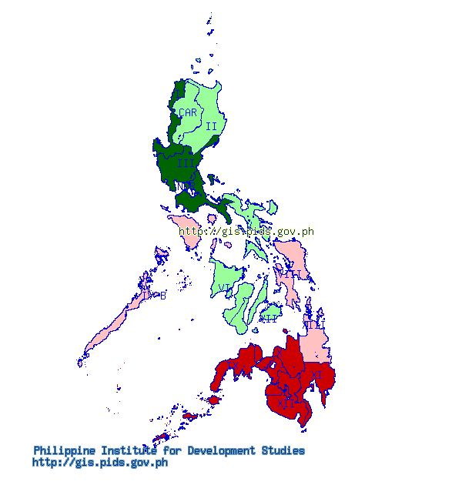

Figure SURVIVAL RATE OF ELEMENTARY STUDENTS IN THE PHILIPPINES

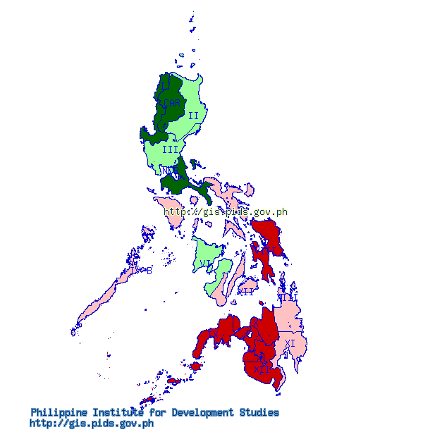

Figure SURVIVAL RATE OF HIGH SCHOOL STUDENTS IN THE PHILIPPINES

**CHAPTER 3**

**METHODS OF RESEARCH AND PROCEDURES**

3.1 METHODS AND PROCEDURES

**1st Phase**

-The researcher is asked to come up with a topic that is related to architectural designs and to pass the letter of intent to their respective coordinators. Upon the hearing of the topic, the researcher is asked to deliver the ideas and information he has gathered to explain about the topic that he is about to deliberate, then the coordinators will give them the idea of which direction he should go to organize and analyze his research. The next step is to write down the introduction, which is the first chapter of the research book, and with the information and sources he gathered, he should come up with problems that the client is experiencing and explain briefly about how the project will be directed to.

Process:

* The researcher should know what his topic is all about.
* When choosing the topic, the researcher should briefly take into consideration how big the scope of project will be.
* The researcher should know what type of project he is going to deliver.
* The researcher should be able to come up with the problem and purpose of the project.
* The researcher should also know the methods and procedures in gathering information.

**1. Problem division**

It is the division of problems that systematizes all activities to be done in the whole procedure of thesis work. It arranges all the data needed for a considerable research works to be done. This division contains the below primary steps desirable for considerable project completion

Problem:

* Identifying the problem
* Knowing the problems or the issues
* Familiarization and orientation
* Setting up

**2. Identifying the problem**

In this step, the researcher was to identify the problems and already has arrived at some of the issues from the sports educations in the Philippines. The issue which the researcher wanted to challenge is to develop a K12 school which integrates Olympism as their main concern, the school which also focuses on the sports education for future athletes.

**3. Knowing the problems or issues**

With existing issues with Olympic Games of the Philippines athletes and teams, the researcher is to analyze the problems and evaluate them to come up with a worthy solution in developing a new school structure. The problem behind the project caused from the issues done by the Philippines athletes not well trained and prepared by the government. There are also a lot of sub problems that are available other than the major problems. The study knows possibly all sorts of problems. This could be done through interviews and researches.

* Agencies or possible consultants
* Viability and sensitiveness of the subject matter as a thesis proposal
* Basic constraints, legal, architectural and the technicality in conducting the proposal
* Issues and problems

**4. Familiarization and Orientation**

When the researcher knows completely about the problem, the researcher is to familiarize the problems if the problems are quite new to the researcher and the community. This will help the researcher to make a more concentrated and focused development along with the process. Familiarization involves visual examinations and organization of review of the programs that may be further redefined.

**Setting up for the research**

This stage of the book, the researcher is already ready for the research to gather data with the accordance of his/her schedule.

In this stage, the researcher is supposed to be finished with his working schedule of the research with specific dates with calculated circumstances that it might not be going as planned. To familiarize with the problem, the schedule should be kept strictly on the date to minimize the date differences.

In doing the research and data gathering, the researcher should go along with the guidelines he made to follow. The guidelines may include the following:

1. Consultations
2. Interviewing people and agencies
3. Site evaluation
4. Personal opinions
5. Presentation activities
6. Requirement in making models/visual aids
7. Preliminary and final defense

**Research method**

The research method that will be used in the proposal is the data gathering. The researcher is to gather data from various sources that are available in the current setting, process and analyze them to produce the architectural design and solutions. This instrumental information is necessary for the study.

*Methods in gathering data*

Interview

Interview is one of most effective way of gathering data from direct personnel from the target users. Especially those who are into the field of educations, education architecture or Olympic committee are valuable interviewees that researcher can come across.

**Archives**

The archive is where the research materials are stored and they are the most research friendly environment where data are fully access-able. The archive materials are used throughout the research and also to the part where the researcher will start to come up with design solution.

The following are the probable archives that researcher can use for his research.

-Library- the books are the most informative and factual resources in doing the research. Many of the information like history, function criteria, culture of the Olympics can be researched by going through the library research. The researcher can also use former graduate students’ thesis books to refer his studies in a relation to his study.

-Internet- the sources from online database could be used in the research since it has more direct searching engine rather than having to go to library to look for the book by book. The internet sources might have less reliable information, and thus the selection of reliable sources is the researcher’s task.

-Offices and other archives- the offices or government departments have a lot of informatory resources that can be helpful to the research work. The data that researcher can gather from these offices are usually the zoning maps, technical properties of the site or other technical information.

**Architectural and Technical Division**

This source contains mostly technical data as well as the design standards. This information will help the researcher in most of designing part and solving the problems regarding the technical side.

**2nd Phase**

**Architectural Programming**

The next step in solving the problem is the architectural programming. This stage is to provide good architectural solution toward the goal of this study. This step is the stepping stone of the 3rd stage of the study which is the architectural synthesis and approaches.

* Site Analysis and Evaluation
  + Soil Maps
  + Vegetation
  + Existing utilities
  + Zoning ordinances
  + Slope map
  + Topographic map
  + Contour map
  + Hydrology
  + Traffic and circulation analysis
  + Opportunity and constraints
  + Climate
* Spaces Programming
  + Proximity
  + Space requirements
  + Dimensions
  + Workflow
  + Users
  + Space definitions
* Design programming
  + Design issues
  + Design approaches
  + Design concepts
  + Design features

**3rd Phase**

**Synthesis and Approaches**

Synthesis is to organize and analyze the gathered data in order to come up with complete set of production to make one idea of the study. This will be beneficiary to the researcher in a way that it will organize the thoughts and compare it to the current situation of the Philippines. By doing this organization and analysis, we can identify what are necessary and what are the constraints in doing further research. We can determine what are the aspects and features that should be integrated in the school structure, what are the significances in doing so.

The lists following below are the outputs of this phase.

* Site Development- the site development plan is the overall development of the whole property.
* Site Evaluation- the researcher should be capable of identifying the characteristics of the site itself in order to come up with a good design solution. The researcher should know what are the utilities and services provided in the site.
* Site Proximity- this includes the relationships between the nearing site and the relationship between the structure and other local community surrounding it.
* Opportunities and Constraints- as the designer, the researcher should know what are the advantages and disadvantages of the site for coming up with the best architectural solution.
* Microclimate Zoning- this includes the relationship of the climate of the site and the structure to be placed on the site. This will include
* Landscaping- the landscape takes part in designing the open space of the site. This will include the hard scape and soft scape. As environmentally concerning individuals, the researcher should maximize the open space to be more environmentally friendly and sustainable.
* Building Evaluation- this process is to evaluate which of the structures are suitable to build on the site. The criteria are based on the gathered information done by the researcher.
* Individual Building Planning- when the above is done, then the selected structures are detailed and take into place on the right spot within the site provided.
* Space Requirements- the individual spaces to be placed within or out the building are to be identified in order to maximize the effectiveness of the building criteria.
* Space Programming and Planning- when the above is completed, the computations and standard dimensions are laid in hands to be organized in logical way.
* Proximity of Spaces- the said step involves the relationship and adjacency of the spaces required to be functional.
* Anthropometrics- the anthropometrics gives an idea of ergonomics in the design that will help the users to be more comfortable in using the structure. Well planned design of the building will deal with human scale and dimensioning of spaces.

*At the end of this phase, the researcher is expected to provide,*

* Preliminary concepts and designs- the overall approach of the structure. It will be used as the guidelines in planning and designing the whole site.
* Site development- the whole design of the site
* Detailed structure development- this will include the building development and evaluation, the planning of individual structure and the ergonomics.

**Approaches**

It is the stage where all of the above are accomplished and translated into the physical structure. A well designed solution has a good approach to the solution of the study. To do this, the above steps and phases are strictly to be followed.

**CHAPTER 4**

**BACKGROUND OF THE STUDY**

**4.1 Background**

* *History of the Philippines Olympic Games*

It may be said that organized sports was introduced in the Philippines during the American occupation with the formation of the Philippine Amateur Athletic Federation (PAAF) in January 1911 with then Governor General William Cameron Forbes as the founding President. In 1913, the country hosted the inaugural Far Eastern Olympics which was subsequently renamed Far Eastern Championship Games (or simply Far Eastern Games) after the International Olympic Committee President Baron Pierre de Coubertin suggested the word Olympics be dropped. China, Japan and the Philippines competed in the first Far Eastern Games organized by the PAAF.

The Far Eastern Oympic Association was established September 1911 to prepare the Far Eastern Olympics with Governor General Forbes as head. FEOA which became Far Eastern Athletic Association in 1915 was the precursor of the Asian Games Federation, now the Olympic Council of Asia. In the same vein, the Asian Games grew out of the Far Eastern Games.

The IOC recognized in 1929 the PAAF as the National Olympic Committee in the Philippines after swimmer Teofilo Yldefonso won for the Philippines its first Olympic medal—a bronze in 200 meters breaststroke—in Amsterdam, Netherlands in 1928. The first Filipino Olympian was David Nepomuceno who saw action in the Athletics’ the 100 meters and 200m in Paris, France in 1924. The first Filipino President of the PAAF was President Manuel L. Quezon. He held the position from 1916 until 1935. The successors of President Quezon were:

* Jorge B. Vargas (1936-1955)
* Antonio de las Alas (1956-1968)
* Felipe Monserrat (1969-1970)
* Ambrosio Padilla (1970-1976)

In 1975, the name Philippine Olympic Committee was adopted after the creation Department of Youth and Sports Development that effectively abolished the Philippine Amateur Athletic Federation. Since then, official representation to international multi-sports competitions under the patronage of the IOC were under the Philippine Olympic Committee.

The POC Presidents succeeding Padilla were:

* Nereo Andolong (1977-1980)
* Julian Malonso (1980 provisional)
* Michael M. Keon (1981-1984)
* Jose C. Sering (1985-1992)
* Rene Cruz (1993-1996)
* Cristina Ramos-Jalasco (1997-April 1999)
* Celso L. Dayrit (May 1999-2004)
* Jose S. Cojuangco Jr. (Jan 2005-present)

The first Filipino member of the IOC was Jorge B. Vargas. He was inducted to the IOC in 1936 together with Avery Brundage who became the fifth IOC President in 1952. Vargas held the position until his death in 1980. The current IOC member in the Philippines, Francisco Elizalde, was elected to his post in 1985. Between 1980 and 1985, there was no IOC representative in the Philippines.

Currently, the Philippine Olympic Committee accredits the members of the Philippine Delegation to the Olympic Games, Asian Games and the Southeast Asian Games. Other than the above stated Games under the patronage of the IOC, the different NSAs under the umbrella of the POC also actively participate in their respective international federation's (IFs) World Championships and other multi-sports competitions such as the World Games, University Games, and others. (POC, Philippine Olympic Committee)

* *Goal of Olympism*

The ultimate goal of the Olympism is to build a better world through sports. It is also the goal of Olympic Games that it unites the world going through sportsmanship.

* *Olympic Education*

The Olympic Education means different things to different people. The stated programs below are included under the Olympic Education. These programs have different objectives and values.

* Academic Research, Courses and Seminars in Universities and Olympic Studies Centers.
* Programs of National and International Olympic Academies and National Olympic Committees.
* Information books, textbooks, videos, CDs and TV programs on the Olympic Games and Olympic Sport.
* Olympic Day Activities, Olympic festivals and competitions in schools and communities.
* High performance training and physical education from within the framework of Olympic values.
* “Education Through Olympism” integrated and life-oriented values-teaching programs for children and young people supporters.
* Education and youth programs of Olympic Games organizing committees.
* Olympic and sport youth camps.
* Olympic museums, halls of fame and art and culture exhibitions.
* Marketing and promotion programs of Olympic sponsors and supporters.
* *Preferred Subjects and Curriculums of Olympism*

There are several curriculum guided by IOC in educating Olympism, and they are fond of basic educations. The following curriculums are the basic teachings opt for Olympic Values.

* History, Geography- Ancient Greece and Modern culture study
* Science and Mathematics- Measurement, time and distance, technology, sport problems
* Language Arts- Writing, reading, listening, discussing, poems, stories
* Sports/Physical Education- Individual, team, adapted, cooperative, competitive, school club and community
* Fine Arts, Music and Design- Pictures, posters, medals, torches, flags, sculpture, murals, music and dance
* English as Second Language- for the foreign students with their primary language is not English

In teaching these curriculums, Olympism uses the proven practices for teaching values. The following enumerations are the techniques in teaching the curriculums.

* **Using discussion**- Discussion or conversation is a key learning strategy for values development. Successful discussions require a teacher or “facilitator” who ensures balanced participation, and “weaves the thoughts of different learners into a coherent pattern. The goal is to help students to develop speaking and listening skills and support a point of view with evidence and thoughtfulness.
* **Using Dilemmas**- Dilemmas introduce learners to the complex challenge of making ethical decisions when there are competing goals, and every decision has consequences. Doing nothing is also a choice of consequences.
* **Using Role Plays**- Role playing offers the opportunity to step into the shoes of someone else, and make the experiences described in writing come alive through dramatization. Successful role playing includes preparation beforehand and discussion afterward.
* **Using Small Groups**- Using small groups helps learners to share ideas, develop skills and focus on teamwork. Successful small-group work depends on clear instructions about the tasks, making time available and encouraging imaginative and effective presentation of the small group conclusions and insights to the larger group.
* *Pathway to Participation*

Olympic Education or Olympic Values can be taught in different pathway or participation of students. Although many countries have different histories, traditions and conducts, many global values are shared or mingled and modified by modernization and globalization. The Olympic Movement has created opportunities for promoting these shared values. The following lists are the pathways that can be followed by the educational vocations.

* **Pathway One** – Education Through Olympism – An Integrated and Cross- Curricular Approach Some classroom teachers use a thematic or project-based teaching approach, and develop their learning outcomes by integrating activities from a variety of subject areas. An Olympic theme with its potential references to history, mathematics, science, language studies, physical education, health and life studies is an ideal theme for this kind of integration.
* **Pathway Two** – Teacher-Centered Classrooms For systems which are more teacher-centered, or which follow a prescribed textbook and workbook plans, the reading and writing activities may be reworked and reorganized for specific age levels. For teachers with very large classes, small group work may be desirable.
* **Pathway Three** – Olympic Theme Week or Month Many of these activities will effectively support an Olympic Theme Week or Month in which a variety of classrooms participate. An Olympic Theme Week or Month would open and close with ceremonies and would include a competitive physical activity sport and games experience.
* **Pathway Four** – Excellence Through Sport and Physical Education for Young and Gifted Athletes Enhance sports education and physical education programs with activities that help students understand and practice the educational values.
* **Pathway Five** – For Post-Secondary Students and Workshop Participants (e.g. Teachers, Youth Group Leaders) Use this Toolkit as a course in “Olympic Education: A Values-Based Approach”. For example, in an Olympic Studies Centre a course in Olympic Education could be offered to Faculty of Education and Faculty of Physical Education/Kinesiology students.
* *Educational Systems*

Teaching Values: An Olympic Education Toolkit is a global education initiative. However, priorities, programs and administrations differ in the many educational systems of the world. Schools have different teacher-student relationships and different expectations from parents, students, education authorities and community members. They have different class sizes and infrastructures for teaching and learning. In many African communities, for example, there is a much greater emphasis on the informal educational systems rather than on formal schooling, on oral as compared with written communication, and on the role of the family and community.

* **Examinations** – Systems such as those of China, with its five thousand year old system based on meritocracy, or Greece, with its echoes on its ancient, classical past, emphasize memorization and written exams. These are challenges for Olympic educators in many educational systems.
* **Language** – Translation of a document from the original language in which it was written to another language is always an imperfect process, because translation is a filtered communication between an author, a translator and a reader or listener. Ideas easily expressed in one language are sometimes not so easy to express in another language. For example, the French phrase, esprit du sport does not mean quite the same thing as the English phrase fair play. In Chinese, where language is presented through thousands of different symbolic characters rather than through an alphabet, translation from a Euro- American literal language is a difficult and complex process. Olympic educators from different continents have reviewed the materials in this Toolkit in an attempt to find the best words and phrases to express the ideas of Olympism.
* **Philosophy** – The educational ideas of the Olympic Movement are grounded originally in European philosophy and educational traditions. Although these ideas seem to resonate in the two hundred nations that belong to the Olympic Family, there are many differences among their philosophical and educational systems. Therefore, receiving acceptance for the values-based teaching and learning strategies used in this manual may be a challenge in some nations. For example, in faith-based educational communities, the challenge for Olympic educators and youth group leaders will be to identify the ways that Olympic values education can support existing educational priorities, and to adapt and use the various activities in ways that are appropriate for the realities of local belief systems and situations. (IOC)
* *Examples of Other Countries*

The method of Olympic Education is something that has not been adapted fully by many countries. The French philosopher Baron Pierre de Coubertin, who is the father of modern Olympic Movement, was very much influenced by British Public School tradition of sport in education. The focal point of the school is not only to the elite athletes, but to everyone. It is to harmonize the people to people by cooperation, competition and participation. The exemplified countries below adapted the spirit of de Coubertin and integrated it to their teaching values.

* Algeria

-Historically, the project of the establishment of the NOA of Algeria was borne from the will of the NOC to create an institution which would be capable of taking charge of the Olympic Education programs in Algeria... There was a need for carrying the ideals and values of Olympism beyond a domain which had always been dedicated to sports practice. Established on the 25th February 2002 the NOA of Algeria is constituted by a Director, a Coordinator a “Pedagogy and Planning” Department, and an “Organization and Communication” Department.

*ACTIVITIES 2004/2005*

-Activity under the title: Olympic Races

-Target Group: Pupils of the 5th and 6th grade of primary schools

-Concept and implementation of 2000 participation cards

-Distribution of the participation cards to the schools

-Distribution of T-shirts, hats and balloons to the participating pupils and schools

-Activity “Sport and Fair Play”

-Target group: Students of high schools and colleges

-Action’s objective: To raise public awareness through games and questions

-Concept and implementation of a leaflet in 5000 copies

-Activity “Sports and ill children”

-Target group: Children and teenagers who are hospital patients

-Action’s objective: To raise awareness and comfort through sport

-Distribution of leaflets “Games and Questions” on the occasion of the Olympic Games

|  |  |  |
| --- | --- | --- |
| Activity | Target Group | Period |
| “Sport and Fair Play”  To raise awareness through games and questions | Students of colleges and high schools | January, February, March, April, may, June 2006 |
| National literary Olympic competition on the subject : “Sport without doping: The champions do not cheat” | Young people from 18 to 21 years old | April-June 2006 |
| National Session  “School and Olympism” | Sports educators, coaches of the EPS or school leaders | October 2006 |
| National Arts Competition “Works of Olympic inspiration” | People of art and culture | June 2006 |

Fig. 4-1 Algeria Action Plan for 2006

* Guatemala

-**Olympic festival** – During three days, the Guatemalan Olympic Academy and the Guatemala Olympic Committee organize an annual Olympic festival including different activities: sponsor’s show, sport exhibitions, conferences and workshops on topics related to Olympism, as well as a painting and drawing contest entitled “Draw your sport and name it” aimed at all age groups. The activity, held annually, aims to disseminate Olympic principles and promote all sports, relating them to art and culture.

-Cine Forum – The Olympic Academy of Guatemala holds, periodically, a series of Cine Forum in different educational institutions throughout the country, in order to make Olympic Philosophy known through an interactive educational program. Approximately 150 students aged between 12 and 18 are divided into several groups to watch a movie related to Olympism and discuss the values or anti-values identified in the movie.

* Albania

**-Olympic week in schools-** Educational programs organized by the National Olympic Committee and Academy of Albania in collaboration with the Ministry of Education, the Regional Directorate of Education, and the University of Sport, are aimed to increase familiarization with the Olympic ideals and sport for a better life. The initiative involves the organization of an Olympic Week every two years in each school of Albania, from elementary to gymnasium (high level). For one week, various activities are organized by the schools including class activities in all curriculum subjects, art contests, a sporting contest during the last day of the week and an Olympic quiz.

* New Zealand

- New Zealand’s active National Olympic Academy works closely with the country’s Ministry of Education. Learning outcomes related to the values of Olympism appear throughout the New Zealand Health and Physical Education Curriculum. The national Olympic committees of countries such as New Zealand, Australia, United Kingdom, Germany, and Canada, promote Olympic education through excellent web sites and special Olympic Education promotional programs for schools. They also produce educational materials for teachers prior to each Olympic Games. Many national Olympic committees organize Olympic Day activities – youth runs, art contests and youth leadership seminars.

**CHAPTER 5**

**CLIENT AND USER PROFILE**

5.1 Client

**Philippines Olympic Committee**

The Olympics in the Philippines trains numerous athletes every year. It develops individual beings to be physically fit and strong. With their efforts, there should be outcome. It seems like the result is not always going as the POC intended. After the silver medal in boxing during 1996 Atlanta Olympics there hanged no more medals in the Philippines neck.

The sad thing in the situation in the Philippine is that there are enough facilities compared to other 3rd world countries, but seems like utilizing and maintenance are always the problem. There are athletes who want to train, but there is so much facility that are properly maintained or handled by proper trainers.

The Olympics Committee should have come up with solution to the above problems. The sports education in the Philippines especially from the primary education is not well implemented. Other countries especially in European countries, American countries and 1st world countries from Asia already have implemented sports education from their primary school until high school and they also provide the course in the college only specialized for sports and physical education.

There have been many circumstances that only few of the many talented athletes have privilege to enter certain facility to train properly, and there have been imbalance between sports activities. There are many boxing players who can join the boxing competition, but there are only few who can actually join since there are limited entries for each competition. To provide the balance between sports and number of players, there should be proper physical and sports education.

What client wants to try is to build a school facility that can handle primary and secondary students who have interests in sports to learn freely in the school facility without concerns of facilities. Hence, the researcher is to come up with the solution that will cater all the students who are eligible for the education.

POC Code of Ethics

Rules of the POC Ethics Commission

Rules of Procedure Governing the Investigation of Cases Brought Before the

POC Ethics Commission

Statutes of the POC Ethics Commission

AMENDED CONSTITUTION AND BY-LAWS

Under the terms of the “Olympic Charter” there is hereby constituted and ordained the “Philippine Olympic Committee” hereinafter referred to by its abbreviated title “POC” under the Constitution and By-Laws herein promulgated.

PREAMBLE

We, the National Olympic Committee of the Philippines, an organization belonging to the Olympic Movement, duly represented by the undersigned, hereby undertake to respect the provisions of the Olympic Charter and the World Anti-Doping Code and to abide by the decisions of the IOC.

We undertake, in accordance with our mission and role at national level, to participate in actions to promote peace and to promote women in sport. We also undertake to support and encourage the promotion of sports ethics, to fight against doping and to demonstrate a responsible concern for environmental issues.

POC CONSTITUTION AND BY-LAWS

**Article I**

**AIMS**

Section 1. The POC shall have the following aims:

a. To develop and protect the Olympic Movement in the Philippines in accordance with the Olympic Charter.

b. To propagate the fundamental principles of Olympism at the national level within the framework of sports activity and otherwise contribute, among other things, to the diffusion of Olympism in the teaching programs of physical education and sport in schools and universities.

c. To see to the creation of institutions that devote themselves to Olympic education, such as the National Olympic Academy, Olympic Museum and cultural programs related to the Olympic Movement.

d. To ensure the observance of the Olympic Charter in the Philippines.

e. To disseminate among young people an interest in sports and a sporting spirit.

f. To encourage the development of high performance sports as well as sport for all.

g. To help in the training of sports administrators by organizing courses and ensure that such courses contribute to the propagation of the Fundamental Principles of Olympism.

h. To guard and take action against all form of discrimination and violence in sports.

i. To fight against the use of substances and procedures prohibited by the International Olympic Committee or the International Sports Federations, in particular by approaching the competent authorities in the country so that all medical controls may be performed in optimum conditions. J. To adopt and implement the World Anti-Doping Code, thereby ensuring that the Philippine Olympic Committee’s anti-doping policies and rules, membership and/or funding requirements and results management procedures conform with the World Anti-Doping Code and respect all the roles and responsibilities for NOCs that are listed within the World Anti-Doping Code.

k. To safeguard its absolute autonomy and to resist all pressures of any kind, including those of political, religious or economic nature that may prevent it from complying with the Olympic Charter.

l. To organize, together with the respective National Sports Associations, the preparation and selection of athletes, thereby ensuring that the Philippines is represented at the Olympic Games as well as at regional, continental and intercontinental games having the patronage of the International Olympic Committee.

m. To undertake the organization of these Games when they are held in the Philippines. It shall have the exclusive authority to select and designate the city which may apply to organize Olympic Games in the Philippines.

n. To submit proposals to the IOC with regard to the “Olympic Charter”, the Olympic Movement in general as well as the organization and conduct of the Olympic Games.

o. To work in concert with private or governmental bodies concerning the promotion of a sound sports policy. However, it shall not associate itself with any activity which would be in contradiction with the Olympic Charter.

p. To help in the training of sports administrators and athletes’ coaches by organizing courses to ensure the further development of sports in the country and the uplifting of the level of performance of Filipino athletes in international competitions.

**Article V**

**NATIONAL SPORTS ASSOCIATION**

Section 1. Each National Sports Association (NSA) shall have the following functions and duties:

1. To be the national governing body of the sport to which it corresponds in the country;
2. To develop its sport nationwide and give opportunity to all Filipino athletes to participate in its activities, subject to reasonable conditions;
3. To adopt an Articles of Incorporation/Constitution and By-Laws for its internal organization and government and to submit the same to the POC for review;
4. To dedicate and commit its organization toward the development of the sport, and in coordination and/or through the POC promote the ideals of the Olympic Movement and the true spirit of sportsmanship;
5. To render an annual report to the POC, furnish pertinent records and calendar of activities to the same when requested; keep accurate records of all official marks attained by the athletes as well as official results of local, national and international competitions conducted, sanctioned or attended by it;
6. To formulate qualification standards and license and accredit referees, umpires and arbiters and other game officials in its sport; decide, subject to appeal to the POC, all questions on the amateur status and discipline of athletes as well as members of the NSAs and all disputes between their members;
7. To adopt a program for organization strengthening such as but not limited to development programs for the training of the athletes for international competitions, resources development and such other programs aimed at accomplishing its purposes;
8. To select the athletes, trainers, coaches and other officials for its national teams taking into consideration not only their athletic abilities but also their moral character;
9. To designate one official representative to the POC General Assembly. Such official representative shall either be the President, the Secretary General, or a Vice President of the NSA duly authorized by the President in writing and attested to by the Secretary General;

The NSA President, the Secretary General and its duly designated representative to the POC General Assembly, if any, must be citizens of the Philippines, of age, and in full possession of their civil and political rights;

1. To perform such other acts as may be necessary for the proper accomplishment of its purposes and not inconsistent with the By-Laws of the POC.

**Article IX**

**COMMISSIONS AND COMMITTEES**

Section 1. The Standing Commissions of the POC are the Membership, Arbitration, Ethics, Technical, Ways and Means and Athlete’s Commissions.

Section 2. Other Commissions or Committees may be created upon recommendation by the President and subject to the approval of the Executive Board. The President shall appoint, subject to the confirmation of the Executive Board, the Chairman and members of the Commissions and Committees to study particular aspects of the work of the POC and to advise and assist the Executive Board in dealing with these aspects.

Section 3. The duties, tasks, and authorities of these Commissions and Committees shall be recommended by the President to and approved by the Executive Board.

*THE POC EXECUTIVE BOARD (2009-2012)*

Mr. Francisco J. Elizalde

**IOC Member**

Monico O. Puentevella

**Chairman**

Jose S. Cojuangco Jr.

**President**

Manuel Luis T. Lopez

**First Vice President**

Mario C. Tanchanco

**Second Vice President**

Stephen C. Hontiveros

**Secretary General**

Julian G. Camacho

**Treasurer**

Corinna B. Mojica

**Auditor**

*BOARD MEMBERS*

Leonora Fe S. Brawner

**David F. Carter**

Mark P. Joseph

Jeff Antonio DL Tamayo

*OTHER MEMBERS*

Dr. Sim Chi Tat

**Deputy Treasurer**

Salvador Andrada

**Deputy Secretary General (Ex-Officio Member)**

Joey Romasanta

**POC Spokeperson**

Atty. Ramon Malinao

**Legal Counsel**

(POC, Philippine Olympic Committee)

**5.2 User Profile**

**The Students in the Philippines**

Generally speaking, all types of students around the Philippine and also international students are eligible to enroll in the school property. The census shows that the total number of enrollment for year 2012-2013, is 21.49 million excluding the senior high school and higher education students.

The Olympic guidelines for Olympism indicate that the education for Olympism starts at 8 years old and finishes at 18 years old. This includes with English as a second language, therea re activities for a variety of different age levels and reading abilities.

**Principles of Learning:**

* Learning is an active and not a passive activity. Learning processes include writing activities, discussion or debate, creative activities, e.g., art, drama or music, and physical movement through activities like sport, dance and physical education.
* People learn in different ways. Some people learn best by reading; some learn best by listening; some learn best by creating things or moving around. The activities in this Toolkit offer a variety of approaches.
* Learning is both an individual and a cooperative activity. Some people work best independently. In order to learn and practice cooperation, however, people need to work together.

**Fundamental Principles**

* Olympism is a philosophy of life, exalting and combining in a balanced whole the qualities of body, will and mind. Blending sport with culture and education, Olympism seeks to create a way of life based on the joy of effort, the educational value of good example and respect for universal fundamental ethical principles.
* The goal of Olympism is to place sport at the service of the harmonious development of man, with a view to promoting a peaceful society concerned with the preservation of human dignity.
* The Olympic Movement is the concerted, organized, universal and permanent action, carried out under the supreme authority of the IOC, of all individuals and entities who are inspired by the values of Olympism. It covers the five continents. It reaches its peak with the bringing together of the world’s athletes at the great sports festival, the Olympic Games. Its symbol is five interlaced rings.
* The practice of sport is a human right. Every individual must have the possibility of practicing sport, without discrimination of any kind and in the Olympic spirit, which requires mutual understanding with a spirit of friendship, solidarity and fair play. The organization, administration and management of sport must be controlled by independent sports organizations.
* Any form of discrimination with regard to a country or a person on grounds of race, religion, politics, gender or otherwise is incompatible with belonging to the Olympic Movement.
* Belonging to the Olympic Movement requires compliance with the Olympic Charter and recognition by the IOC.

**CHAPTER 6**

**SITE EVALUATION**

**6.1 Site Evaluation**

**6.1.1General**

The site of this study is placed at the **F.E. Zuellig Avenue, Tipolo, Mandaue City located near the Cebu Doctor’s University, facing Cebu-Mactan Channel.** The area is approximately 17.5 has.

**6.1.2 Topography**

The site is the product of reclamation. It is surrounded by an institutional building which is Cebu Doctor’s University (CDU), several industrial structures and malls. Since the site is reclaimed, the slope of the site is relatively flat. The site is currently vacant and used by locals to dock their ships illegally. Thus, a development could be started immediately.

**6.1.3 Accessibility**

The site could be entered in 2 ways, one is to follow the F.E. Zuelling Avenue, which is 4-lane RROW, that across right in the north-west of the site. Another way of entering is to use the C.D Seno Street which is a 2 lane RROW.

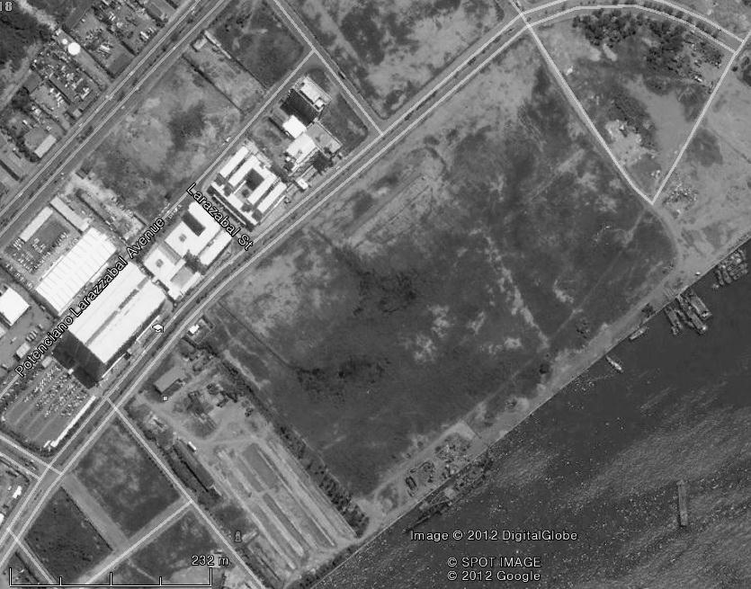

SITE

**C.D. Seno Street**

**F.E. Zuellig Avenue**

Figure 6 Site and Accessibility

The current situation of the site in relation to the accessibility, there would not be much of problems in respect to the traffic, because the road is not used as much as the major roads, but the number of lanes are as much as one. Since the 2 sides of the site is covered with RROW, one could be used for the major entrance, and the other could be used as the service road and so on.

**6.1.4 Situation**

The current situation in the site is it is undeveloped and also used as docking the ships which do not even use 1/10 of the whole site. The site is free from any obstructions or developments excluding the dock they have placed near the shoreline. It barely has any type of vegetation.



SITE

**Cebu Doctor’s University**

**Harbor**

Figure 6 Situation of the Site

The surrounding environment is suitable for development of the site. The Cebu Doctor’s University is located at the northwest side of the site, and at the southeast of the site, there situated the Cebu-Mactan Channel. This is a great advantage for the Sports facility, that it can further develop this area for water based sports like yachts and triathlon.

**6.1.5 Orientation**

The site is oriented longitudinal toward northeast and southwest. The shoreline is facing toward the southeast of the lot and the main road is facing toward the northwest of the site.



HABAGAT

AMIHAN

SITE

Figure 6 Seasonal Monsoon Orientation of the Site

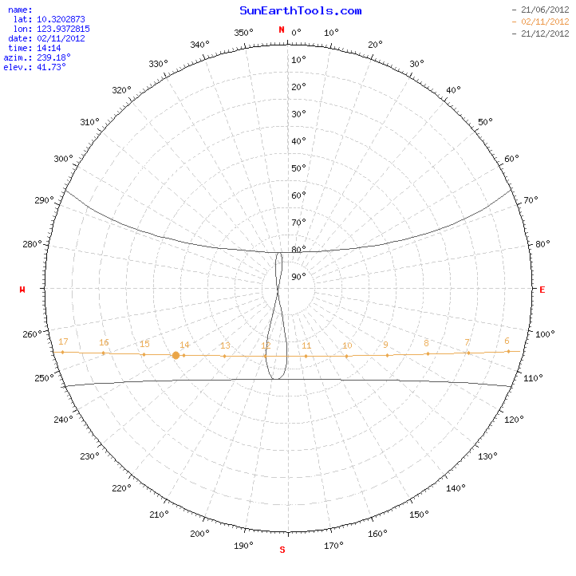

Figure 6 Seasonal Solar Orientation

It is a great advantage for the site that its short sides are facing southwest, because that part is where the hot afternoon sun gets in the most. What is referred as advantage is that since the orientation is what it’s said above, the structure will receive the least amount of hot afternoon sun.

**CHAPTER 7**

**FUNCTION CRITERIA**

**7.1 FUNCTIONAL ANALYSIS**

* **Functional Elements**

Ventilation

*Windows*- windows should be located on the both toward outside and toward the corridor with not less than 1.5 meters in height and at least 0.6 meters wide. Windows should be wide enough to maximize the air flow and natural light penetration.

Acoustics- The ability of learners to hear what is being said by their teacher and peers is important for learning to occur. A noisy room can also cause voice fatigue in teachers if they have to often raise their voice to be heard. Open space designs allow for excellent flexibility in learning modalities but they can be loud spaces if no consideration is given to acoustic design.

Light- Day light can have a positive effect on the learning environment. It is claimed that increasing the amount of daylight into learning spaces can have positive impacts on motivation, alertness and attendance rates. According to Dan Butin, North Carolina State School Board recommends that the area allocated for windows in elementary school classrooms be equivalent to at least eight percent of the total floor space.

Daylight can be introduced into learning spaces through windows, glass doors and sky lights. According to Nair & Fielding, higher windows allow greater light penetration into the building. One rule of thumb calls for the depth of the room to be 1.5 times the height of the window.

North facing windows allow the most light in and permit winter sun to penetrate into the learning space. In hot climates, consideration must also be given to the amount of heat generated through the use of glass.

Ceiling Height- The ceiling height in Mandaue City should be at least 2.8 meters. If there will be higher ceiling, there are more chance to have wider windows to maximize lights and ventilation. If the room is provided with air-conditioning, there should be lower ceiling height to minimize cool reduction

Flooring- The flooring of the school should be differing from area to area. The designer should consider what kind of activities the area will be having, if the flooring is suitable for the students to interact with, if it will easily be cleaned or easily dragged by furniture. There should be also be consideration where the flooring can be easily replaced like carpet squares. The flooring should be also being free from spilling of food and drink.

The color of the flooring should be considered. The color is one of the psychological elements that affect human emotions. In school environment, the psychology of students matters in their learning activities.

Circulation

*Corridors*- Corridor is the horizontal traffic of the building. Corridor should be properly so that the all kinds of users can be accommodated. The corridor should also have good natural ventilation and lighting to minimize the relying of active lighting and ventilation.

Corridors should be well planned to minimize the complication. It should be well organized to make the circulation to be fluid.

*Stairs*- The stairs is the vertical traffic of the building. The stairs is important in the manner that it will be only traffic that will accommodate users when natural disasters happen.

Stairs should be at least 1.2 meters wide and should be made of non-slippery materials.

*Ramps*- Ramps are usually for the people with disabilities that will make the vertical travel safe for them. The ramps should be at least be 1.2 meters wide and made of non-skid materials.

Walls- The walls are important element in building that separates space to space. The walls should be determined whether the wall should be fixed wall or CHB walls. The acoustical elements are also to be included in the wall, so that the noises from other space won’t be heard from other side.

Environmental Factors- It is quite important that the environmental concerns regarding the climate control within the building is essential. The sunlight, wind, humidity and etc. should be controlled to maximize comfort of the users.

**7.2 ARCHITECTURAL PROGRAMMING**

**A. ADMINISTRATION**

Qualifications and Quantifications

* **Lobby**

|  |  |
| --- | --- |
| **User** | : Students, faculty members, employers, employees, visitors |
| **Spaces** | : It is an open space where the people come in first; where there are informative materials are available like bulletin boards or announcement boards. |
| **Activity** | : The middle space between the outside and the inside spaces like admin area and etc. |
| **Remarks** | : The space should have open and good welcoming feeling with proper lights and ventilation. |

|  |  |  |  |
| --- | --- | --- | --- |
| **Space** | **No. of occupant** | **Unit area/occupant (sq.m)** | **Computed Area (sq.m)** |
| Lobby | 200 | 0.75 | **150 sq.m** |

* **Director’s Office**

|  |  |
| --- | --- |
| **User** | : The school director, secretary of director and the visitors. |
| **Spaces** | : Director’s office, secretary’s area for the desk, lounge |
| **Activity** | : The school’s overall academic programs and activities are monitored and integrated for the whole levels from kindergarten to high school. |
| **Remarks** | : The area should have a focused ambiance for the convenience of director to concentrate on school works and welcoming for visitors with inquiries. |

|  |  |  |  |
| --- | --- | --- | --- |
| **Space** | **No. of occupant** | **Unit area/occupant (sq.m)** | **Computed Area (sq.m)** |
| Director’s office | 1 | 10 | 10 sq.m |
| Secretary’s desk | 1 | 5 | 5 sq.m |
| Office assistant’s area | 1 | 5 | 5 sq.m |
| Lounge | 1 | 5 | 5 sq.m |
| Total | 4 | 25 | **25 + 7 = 32 sq.m** |

* **Elementary Principal’s Offices**

|  |  |
| --- | --- |
| **User** | : The elementary school principal, secretary, and visitors |
| **Spaces** | : The elementary school principal’s office, secretary’s area, and lounge. |
| **Activity** | : The space where the principal of elementary school plans of academic programs and activities of elementary school |
| **Remarks** | : The area should have a focused ambiance for the convenience of principal to concentrate on school works and welcoming for visitors with inquiries. |

|  |  |  |  |
| --- | --- | --- | --- |
| **Space** | **No. of occupant** | **Unit area/occupant (sq.m)** | **Computed Area (sq.m)** |
| Elementary school principal’s office | 1 | 10 | 10 sq.m |
| Secretary’s desk | 1 | 5 | 5 sq.m |
| Lounge | 1 | 5 | 5 sq.m |
| Total | 3 | 25 | **20 + 6 = 26 sq.m** |

* **High School Principal’s Offices**

|  |  |
| --- | --- |
| **User** | : The high school principal, secretary, and visitors |
| **Spaces** | : The high school principal’s office, secretary’s area, and lounge. |
| **Activity** | : The space where the principal of high school plans of academic programs and activities of elementary school |
| **Remarks** | : The area should have a focused ambiance for the convenience of principal to concentrate on school works and welcoming for visitors with inquiries. |

|  |  |  |  |
| --- | --- | --- | --- |
| **Space** | **No. of occupant** | **Unit area/occupant (sq.m)** | **Computed Area (sq.m)** |
| High school principal’s office | 1 | 10 | 10 sq.m |
| Secretary’s desk | 1 | 5 | 5 sq.m |
| Lounge | 1 | 5 | 5 sq.m |
| Total | 3 | 25 | **20 + 6 = 26 sq.m** |

* **Philippines Olympic Committee’s office**

|  |  |
| --- | --- |
| **User** | : The representative of POC, secretary, faculty, students and visitors |
| **Spaces** | : The representative’s office, secretary’s area, display area for the trophies and records, clerk’s area, and lounge |
| **Activity** | : The space where the representative of POC holds his/her works on athletic programs and academics for the whole school. It is also where the reports to POC are made. |
| **Remarks** | : The area should be fitting for the representative, should also have welcoming ambiance for the people to reach easily. |

|  |  |  |  |
| --- | --- | --- | --- |
| **Space** | **No. of occupant** | **Unit area/occupant (sq.m)** | **Computed Area (sq.m)** |
| Representative’s office | 1 | 10 | 10 sq.m |
| Secretary’s desk | 1 | 5 | 5 sq.m |
| Clerk’s area | 3 | 5 | 15 sq.m |
| Lounge | 1 | 10 | 10 sq.m |
| Display area | 1 | 5 | 5 sq.m |
| Total | 7 | 30 | **45 + 6 = 51 sq.m** |

* **Registrar’s Offices**

|  |  |
| --- | --- |
| **User** | : The school’s registrar, assistant registrar, records officers, clerks and the public |
| **Spaces** | : Registrar’s office, assistant registrar’s office, head record’s office, assistant record’s office, secretary’s area, storage and lounge. |
| **Activity** | : Evaluating of TOR (transcript of records) and application of students are worked on. |
| **Remarks** | : should be accessible by all students and as well as the public. Should have good flow for the information to be passed flow ably. |

|  |  |  |  |
| --- | --- | --- | --- |
| **Space** | **No. of occupant** | **Unit area/occupant (sq.m)** | **Computed Area (sq.m)** |
| Registrar’s office | 1 | 9 | 9 sq.m |
| Assistant registrar’s office | 1 | 5 | 5 sq.m |
| Head record’s office | 1 | 9 | 9 sq.m |
| Assistant record’s office | 2 | 5 | 10 sq.m |
| Secretary’s area | 2 | 5 | 10 sq.m |
| Storage | 1 | 5 | 5 sq.m |
| Lounge | 1 | 5 | 5 sq.m |
| Total | 9 | 33 | **63+10=73 sq.m** |

* **Accounting Office**

|  |  |
| --- | --- |
| **User** | : Accountant, assistants, bookkeepers, audit analysts, clerks |
| **Spaces** | : Accountant’s office, assistants’ space, book keeper’s space, audit analysts’ office, clerk’s area, records room and lounge |
| **Activity** | : Accounting services of the school, evaluations and consultations |
| **Remarks** | : Should give a transparent space to reflect the transparency of the accounting |

|  |  |  |  |
| --- | --- | --- | --- |
| **Space** | **No. of occupant** | **Unit area/occupant (sq.m)** | **Computed Area (sq.m)** |
| Accountant’s office | 1 | 9 | 9 sq.m |
| Assistant accountant’s office | 3 | 5 | 15 sq.m |
| Bookkeeper’s space | 1 | 5 | 5 sq.m |
| Audit analyst’s office | 3 | 5 | 15 sq.m |
| Clerk’s area | 4 | 5 | 20 sq.m |
| Records room | 1 | 10 | 10 sq.m |
| Lounge | 1 | 5 | 5 sq.m |
| Total | 14 | 44 | **79+6=85 sq.m** |

* **Treasurer’s Office**

|  |  |
| --- | --- |
| **User** | : Treasurer, assistant treasurer, bookkeeper, secretary and public |
| **Spaces** | : Treasurer’s office, secretary’s area, assistant treasurer’s area, bookkeeper’s area, storage and lounge |
| **Activity** | : Budget planning and cash flow of the school |
| **Remarks** | : Should easily be accessed through the administratives |

|  |  |  |  |
| --- | --- | --- | --- |
| **Space** | **No. of occupant** | **Unit area/occupant (sq.m)** | **Computed Area (sq.m)** |
| Treasurer’s office | 1 | 9 | 9 sq.m |
| Assistant treasurer’s office | 3 | 5 | 15 sq.m |
| Secretary’s area | 1 | 5 | 5 sq.m |
| Bookkeeper’s area | 2 | 5 | 10 sq.m |
| Storage/records room | 2 | 6 | 12 sq.m |
| Lounge | 1 | 5 | 5 sq.m |
| Total |  | 44 | **56 + 6=62 sq.m** |

* **Cashier’s Office**

|  |  |
| --- | --- |
| **User** | : Head cashier, cashiers/tellers, clerks, students and public |
| **Spaces** | : Tellers area, head cashier’s desk area, clerks area |
| **Activity** | : Payments done by students and public for different transactions for school properties. |
| **Remarks** | : Should easily be accessed by both students and public, and should be detected easily from the lobby. |

|  |  |  |  |
| --- | --- | --- | --- |
| **Space** | **No. of occupant** | **Unit area/occupant (sq.m)** | **Computed Area (sq.m)** |
| Teller’s area | 7 | 3 | 21 sq.m |
| Head cashier’s area | 2 | 7 | 14 sq.m |
| Clerk’s space | 6 | 5 | 30 sq.m |
| Total | 15 | 17 | **65+6=71 sq.m** |

* **Conference Room**

|  |  |
| --- | --- |
| **User** | : Administration, employees and faculty |
| **Spaces** | : Conference area and lounge |
| **Activity** | : Place for holding conferences or meetings |
| **Remarks** | : Should easily be accessed by personnel of school. |

|  |  |  |  |
| --- | --- | --- | --- |
| **Space** | **No. of occupant** | **Unit area/occupant (sq.m)** | **Computed Area (sq.m)** |
| Conference seats | 30 | 2 | 60 sq.m (divisible) |
| Lounge | 1 | 10 | 10 sq.m |
| Toilet | 1 | 5 | 5 sq.m |
| Total | 15 | 17 | **75+6=81 sq.m** |

* **Information Area**

|  |  |
| --- | --- |
| **User** | : The visitors for the most, could be used for newly coming students |
| **Spaces** | : Small area where information clerk awaits for visitors with concerns. |
| **Activity** | : The information and guidance of the school is shared by the clerks. |
| **Remarks** | : The space should have open and good welcoming feeling with proper lights and ventilation. |

|  |  |  |  |
| --- | --- | --- | --- |
| **Space** | **No. of occupant** | **Unit area/occupant (sq.m)** | **Computed Area (sq.m)** |
| Clerk’s area | 4 | 5 | **20 sq.m** |

* **Examination Room**

|  |  |
| --- | --- |
| **User** | : Students and teachers |
| **Spaces** | : the room itself with appropriate furniture |
| **Activity** | : Testing of new coming students and transferees |
| **Remarks** | : Should be located near the registrar’s office and the whole room should be clearly be seen by the teacher in charge. |

|  |  |  |  |
| --- | --- | --- | --- |
| **Space** | **No. of occupant** | **Unit area/occupant (sq.m)** | **Computed Area (sq.m)** |
| Examination room | 30 | 3 | **90 sq.m (inclusive of the teacher’s table)** |

* **Reception Room**

|  |  |
| --- | --- |
| **User** | : Employees, administration, parents, and public |
| **Spaces** | : Dining area and kitchen |
| **Activity** | : Area for personnel meetings or service for guests |
| **Remarks** | : Should be located where it is easily be seen and accessed by users. (ex. Lobby) |

|  |  |  |  |
| --- | --- | --- | --- |
| **Space** | **No. of occupant** | **Unit area/occupant (sq.m)** | **Computed Area (sq.m)** |
| Dining area | 50 | 1 | 50 sq.m |
| Service area | 1 | 5 | 5 sq.m |
| Kitchen | 1 | 15 | 15 sq.m |
| Total | 52 | 21 | **70 + 10=80 sq.m** |

* **Alumni Office**

|  |  |
| --- | --- |
| **User** | : Alumni, visitors, clerks |
| **Spaces** | : Office area, lounge |
| **Activity** | : Area for alumni concerns |
| **Remarks** | : Should be located where it is easily be seen and accessed by users. (ex. Lobby) |

|  |  |  |  |
| --- | --- | --- | --- |
| **Space** | **No. of occupant** | **Unit area/occupant (sq.m)** | **Computed Area (sq.m)** |
| Alumni in charge area | 1 | 15 | 15 sq.m |
| Secretary | 1 | 5 | 5 sq.m |
| Lounge | 1 | 5 | 5 sq.m |
| Total | 3 | 25 | **25+6=31 sq.m** |

* **Scholarship/Evaluation Office**

|  |  |
| --- | --- |
| **User** | : Scholarship officer, secretary and students |
| **Spaces** | : Office area, lounge |
| **Activity** | : Office where the scholarship concerns are being held |
| **Remarks** | : Should be located where it is easily be seen and accessed by users. (ex. Lobby) |

|  |  |  |  |
| --- | --- | --- | --- |
| **Space** | **No. of occupant** | **Unit area/occupant (sq.m)** | **Computed Area (sq.m)** |
| Scholarship officer | 1 | 10 | 10 sq.m |
| Secretary | 1 | 5 | 5 sq.m |
| Lounge | 1 | 5 | 5 sq.m |
| Total | 3 | 20 | **20+6=26 sq.m** |

* **School Supply Services Area**

|  |  |
| --- | --- |
| **User** | : Supply officer, assistants, public |
| **Spaces** | : Supply officer’s office, assistant’s area, storage/records section |
| **Activity** | : It is the area where the school supplies and materials are being received, stored and distributed. |
| **Remarks** | : must be accessible for faculty and employees. Should also be near to the lobby for ease of transferring. |

|  |  |  |  |
| --- | --- | --- | --- |
| **Space** | **No. of occupant** | **Unit area/occupant (sq.m)** | **Computed Area (sq.m)** |
| Supply officer’s office | 1 | 7 | 7 sq.m |
| Assistant’s area | 4 | 3 | 12 sq.m |
| Mechanic’s area | 4 | 3 | 12 sq.m |
| Electrician’s area | 4 | 3 | 12 sq.m |
| Total | 13 | 22 | **43+6=49 sq.m** |

* **Maintenance**

|  |  |
| --- | --- |
| **User** | : Foreman, assistants, mechanics, electricians |
| **Spaces** | : Foreman’s office, assistants area, mechanic’s area, electrician’s area, storage |
| **Activity** | : It is where the maintenance of the school is being held responsible of. |
| **Remarks** | : should have a storage area for them to store the supplies and equipment |

|  |  |  |  |
| --- | --- | --- | --- |
| **Space** | **No. of occupant** | **Unit area/occupant (sq.m)** | **Computed Area (sq.m)** |
| Foreman’s office | 1 | 7 | 7 sq.m |
| Assistant’s area | 4 | 3 | 12 sq.m |
| Mechanic’s area | 2 | 3 | 6 sq.m |
| Electrician’s area | 2 | 3 | 6 sq.m |
| Storage | 1 | 10 | 10 sq.m |
| Total | 13 | 22 | **41+6=47 sq.m** |

**Sub-total area for administration:**

**150+32+26+26+52+73+85+62+71+81+20+90+80+31+26+49+47=1001 sq.m**

**B. GRADE SCHOOL WITH KINDERGARTEN**

Qualifications and Quantifications

* **Lobby**

|  |  |
| --- | --- |
| **User** | : Students, faculty members, employers, employees, visitors |
| **Spaces** | : It is an open space where the people come in first; where there are informative materials are available like bulletin boards or announcement boards. |
| **Activity** | : The area where students comes in first before going to their respective classrooms. |
| **Remarks** | : The space should have open and good welcoming feeling with proper lights and ventilation. |

|  |  |  |  |
| --- | --- | --- | --- |
| **Space** | **No. of occupant** | **Unit area/occupant (sq.m)** | **Computed Area (sq.m)** |
| Lobby | 500 | 0.9 | **450 sq.m** |

* **Kindergarten 1&2 (3 classes ea.)**

|  |  |
| --- | --- |
| **User** | : Students and teachers |
| **Spaces** | : Classroom |
| **Activity** | : Lecture and recreational activities |
| **Remarks** | : should have good ventilation and well lighted, should also be big enough for recreational activities |

|  |  |  |  |
| --- | --- | --- | --- |
| **Space** | **No. of occupant** | **Unit area/occupant (sq.m)** | **Computed Area (sq.m)** |
| Classroom | 35 | 2.5 | 9x10=90 sq.m |

**Sub-total for kindergarten area= 90*6= 540 sq.m**

* **Grade 1, 2 & 3 (5 classes ea.)**

|  |  |
| --- | --- |
| **User** | : Students and teachers |
| **Spaces** | : Classroom |
| **Activity** | : Mostly lecture and class activities |
| **Remarks** | : should have good ventilation and well lighted. Should also have ambiance where students can focus |

|  |  |  |  |
| --- | --- | --- | --- |
| **Space** | **No. of occupant** | **Unit area/occupant (sq.m)** | **Computed Area (sq.m)** |
| Classroom | 45 | 1.75 | **80 sq.m** |

* **Grade 4, 5 & 6 (5 classes ea.)**

|  |  |
| --- | --- |
| **User** | : Students and teachers |
| **Spaces** | : Classroom |
| **Activity** | : Mostly lecture and class activities |
| **Remarks** | : should have good ventilation and well lighted. Should also have ambiance where students can focus |

|  |  |  |  |
| --- | --- | --- | --- |
| **Space** | **No. of occupant** | **Unit area/occupant (sq.m)** | **Computed Area (sq.m)** |
| Classroom | 45 | 2 | **90 sq.m** |

**Sub-total for kindergarten area= (63*15) + (90*15)= 2,295 sq.m**

* **Faculty Room**

|  |  |
| --- | --- |
| **User** | : Teachers |
| **Spaces** | : Individual cubicles, conference area |
| **Activity** | : Teachers will prepare for their classes |
| **Remarks** | : should have good ventilation and well lighted. The arrangement of furniture should have well circulation for users. |

|  |  |  |  |
| --- | --- | --- | --- |
| **Space** | **No. of occupant** | **Unit area/occupant (sq.m)** | **Computed Area (sq.m)** |
| Cubicle area | 36 | 9 | 324 sq.m |
| Conference area | 18 | 2 | 36 sq.m |
| Total | 54 | 11 | **360 sq.m** |

* **Clinic Room**

|  |  |
| --- | --- |
| **User** | : Physician, nurse and students |
| **Spaces** | : Bed area, toilet, desk area for doctor and nurse |
| **Activity** | : check-up for sick people |
| **Remarks** | : should have good ventilation and well lighted. |

|  |  |  |  |
| --- | --- | --- | --- |
| **Space** | **No. of occupant** | **Unit area/occupant (sq.m)** | **Computed Area (sq.m)** |
| Bed area | 8 | 4 | 32 sq.m |
| Doctor’s desk | 1 | 3 | 3 sq.m |
| Nurse’s area | 2 | 3 | 6 sq.m |
| Total | 11 | 10 | **41 sq.m** |

* **Library**

|  |  |
| --- | --- |
| **User** | : Students and teachers |
| **Spaces** | : Reading area, shelves area, library counters |
| **Activity** | : Reading and research |
| **Remarks** | : should be well lighted and ventilated. Should be designed to lessen the noise |

|  |  |  |  |
| --- | --- | --- | --- |
| **Space** | **No. of occupant** | **Unit area/occupant (sq.m)** | **Computed Area (sq.m)** |
| Reading area | 10% of total population = 200 | 2 | 400 sq.m |
| Shelves area | 1 | 20% of reading area | 80 sq.m |
| Counter | 4 | 5 | 20 sq.m |
| Total | 205 | - | **500 sq.m** |

* **Computer Room**

|  |  |
| --- | --- |
| **User** | : Students and teachers |
| **Spaces** | : Computer room, storage area |
| **Activity** | : Computer class |
| **Remarks** | : should be well lighted and ventilated. Should be air-conditioned. |

|  |  |  |  |
| --- | --- | --- | --- |
| **Space** | **No. of occupant** | **Unit area/occupant (sq.m)** | **Computed Area (sq.m)** |
| Computer room | 45 | 4.6 | 207 sq.m |
| Storage area | 1 | 5 | 5 sq.m |
| Total | 46 | 9.6 | **212 sq.m** |

* **Science Laboratory**

|  |  |
| --- | --- |
| **User** | : Students and teachers |
| **Spaces** | : Laboratory, storage area |
| **Activity** | : Science activities and experiments |
| **Remarks** | : should be well lighted and ventilated. Should be air-conditioned. |

|  |  |  |  |
| --- | --- | --- | --- |
| **Space** | **No. of occupant** | **Unit area/occupant (sq.m)** | **Computed Area (sq.m)** |
| Laboratory | 45 | 4.6 | **207 sq.m** |

* **Canteen**

|  |  |
| --- | --- |
| **User** | : Teachers and students |
| **Spaces** | : Kitchen, serving area, storage room, dining area, convenience store, toilets |
| **Activity** | : Where people will be having their lunch and snacks |
| **Remarks** | : Should be well lighted and ventilated. Should have good arrangement of furniture for comfort. |

|  |  |  |  |
| --- | --- | --- | --- |
| **Space** | **No. of occupant** | **Unit area/occupant (sq.m)** | **Computed Area (sq.m)** |
| Kitchen | 20 | 3 | 60 sq.m |
| Serving Area | 5 | 2 | 10 sq.m |
| Dining Area | 1,500 | 1 | 1,500 sq.m |
| Storage Room | 1 | 5 | 5 sq.m |
| Convenience Store | 1 | 10 | 10 sq.m |
| Toilets | 2 | 10 | 20 sq.m |
| Total | 1029 | 31 | **1,605 sq.m** |

**Sub-total of the Grade School and Kindergarten = 5,773 sq.m**

**C. HIGH SCHOOL**

Qualifications and Quantifications

* **Lobby**

|  |  |
| --- | --- |
| **User** | : Students, faculty members, employers, employees, visitors |
| **Spaces** | : It is an open space where the people come in first; where there are informative materials are available like bulletin boards or announcement boards. |
| **Activity** | : The area where students comes in first before going to their respective classrooms. |
| **Remarks** | : The space should have open and good welcoming feeling with proper lights and ventilation. |

|  |  |  |  |
| --- | --- | --- | --- |
| **Space** | **No. of occupant** | **Unit area/occupant (sq.m)** | **Computed Area (sq.m)** |
| Lobby | 500 | 0.9 | **450 sq.m** |

* **High School Classroom Year 1-6 (4 classrooms ea.)**

|  |  |
| --- | --- |
| **User** | : Students and teachers |
| **Spaces** | : Classroom |
| **Activity** | : Mostly lecture and class activities |
| **Remarks** | : should have good ventilation and well lighted. Should also have ambiance where students can focus |

|  |  |  |  |
| --- | --- | --- | --- |
| **Space** | **No. of occupant** | **Unit area/occupant (sq.m)** | **Computed Area (sq.m)** |
| Classroom | 36 | 2.2 | **80 sq.m** |

**Sub-total for High School Classroom area= (80*24) = 1,960 sq.m**

* **Faculty Room**

|  |  |
| --- | --- |
| **User** | : Teachers |
| **Spaces** | : Individual cubicles, conference area |
| **Activity** | : Teachers will prepare for their classes |
| **Remarks** | : should have good ventilation and well lighted. The arrangement of furniture should have well circulation for users. |

|  |  |  |  |
| --- | --- | --- | --- |
| **Space** | **No. of occupant** | **Unit area/occupant (sq.m)** | **Computed Area (sq.m)** |
| Cubicle area | 30 | 9 | 270 sq.m |
| Conference area | 15 | 2 | 30 sq.m |
| Total | 45 | 11 | **300 sq.m** |

* **Clinic Room**

|  |  |
| --- | --- |
| **User** | : Physician, nurse and students |
| **Spaces** | : Bed area, toilet, desk area for doctor and nurse |
| **Activity** | : check-up for sick people |
| **Remarks** | : should have good ventilation and well lighted. |

|  |  |  |  |
| --- | --- | --- | --- |
| **Space** | **No. of occupant** | **Unit area/occupant (sq.m)** | **Computed Area (sq.m)** |
| Bed area | 8 | 4 | 32 sq.m |
| Doctor’s desk | 1 | 3 | 3 sq.m |
| Nurse’s area | 2 | 3 | 6 sq.m |
| Total | 11 | 10 | **41 sq.m** |

* **Library**

|  |  |
| --- | --- |
| **User** | : Students and teachers |
| **Spaces** | : Reading area, shelves area, library counters |
| **Activity** | : Reading and research |
| **Remarks** | : should be well lighted and ventilated. Should be designed to lessen the noise |

|  |  |  |  |
| --- | --- | --- | --- |
| **Space** | **No. of occupant** | **Unit area/occupant (sq.m)** | **Computed Area (sq.m)** |
| Reading area | 10% of total population = 90 | 2 | 180 sq.m |
| Shelves area | 1 | 20% of reading area | 36 sq.m |
| Counter | 4 | 5 | 20 sq.m |
| Total | 95 | - | **236 sq.m** |

* **Computer Room**

|  |  |
| --- | --- |
| **User** | : Students and teachers |
| **Spaces** | : Computer room, storage area |
| **Activity** | : Computer class |
| **Remarks** | : should be well lighted and ventilated. Should be air-conditioned. |

|  |  |  |  |
| --- | --- | --- | --- |
| **Space** | **No. of occupant** | **Unit area/occupant (sq.m)** | **Computed Area (sq.m)** |
| Computer room | 45 | 4.6 | 207 sq.m |
| Storage area | 1 | 5 | 5 sq.m |
| Total | 46 | 9.6 | **212 sq.m** |

* **Science Laboratory (Chemistry and Physics)**

|  |  |
| --- | --- |
| **User** | : Students and teachers |
| **Spaces** | : Laboratory, storage area |
| **Activity** | : Science activities and experiments |
| **Remarks** | : should be well lighted and ventilated. Should be air-conditioned. |

|  |  |  |  |
| --- | --- | --- | --- |
| **Space** | **No. of occupant** | **Unit area/occupant (sq.m)** | **Computed Area (sq.m)** |
| Laboratory | 45 | 4.6 | **207 sq.m** |

* **Science Laboratory (Biology)**

|  |  |
| --- | --- |
| **User** | : Students and teachers |
| **Spaces** | : Laboratory, storage area |
| **Activity** | : Science activities and experiments |
| **Remarks** | : should be well lighted and ventilated. Should be air-conditioned. |

|  |  |  |  |
| --- | --- | --- | --- |
| **Space** | **No. of occupant** | **Unit area/occupant (sq.m)** | **Computed Area (sq.m)** |
| Laboratory | 45 | 4.6 | **207 sq.m** |

* **Department of Student Services Office**

|  |  |
| --- | --- |
| **User** | : Officer in charge, students and guests |
| **Spaces** | : Offices |
| **Activity** | : Evaluation of the conduct of students |
| **Remarks** | : should be well lighted and ventilated. Should be air-conditioned. |

|  |  |  |  |
| --- | --- | --- | --- |
| **Space** | **No. of occupant** | **Unit area/occupant (sq.m)** | **Computed Area (sq.m)** |
| Offices | 4 | 15 | **60 sq.m** |

* **Guidance Office**

|  |  |
| --- | --- |
| **User** | : Councilor and students |
| **Spaces** | : Offices, students’ area consulting room |
| **Activity** | : Area where the student’s problems are being handled and took care of. |
| **Remarks** | : should be well lighted and ventilated. Should be air-conditioned. |

|  |  |  |  |
| --- | --- | --- | --- |
| **Space** | **No. of occupant** | **Unit area/occupant (sq.m)** | **Computed Area (sq.m)** |
| Office | 4 | 15 | 60 sq.m |
| Lounge | 1 | 10 | 10 sq.m |
| Consulting room | 1 | 10 | 10 sq.m |
| Total | 6 | 35 | **80 sq.m** |

* **Activity Rooms**

|  |  |
| --- | --- |
| **User** | : Teachers and students |
| **Spaces** | : Activity room |
| **Activity** | : Area where students are having activities provided by the curriculum, whether group or single activity. |
| **Remarks** | : should be well lighted and ventilated. |

|  |  |  |  |
| --- | --- | --- | --- |
| **Space** | **No. of occupant** | **Unit area/occupant (sq.m)** | **Computed Area (sq.m)** |
| Activity room | 50 | 3 | **150 sq.m** |

* **Canteen**

|  |  |
| --- | --- |
| **User** | : Teachers and students |
| **Spaces** | : Kitchen, serving area, storage room, dining area, convenience store, toilets |
| **Activity** | : Where people will be having their lunch and snacks |
| **Remarks** | : Should be well lighted and ventilated. Should have good arrangement of furniture for comfort. |

|  |  |  |  |
| --- | --- | --- | --- |
| **Space** | **No. of occupant** | **Unit area/occupant (sq.m)** | **Computed Area (sq.m)** |
| Kitchen | 20 | 3 | 60 sq.m |
| Serving Area | 5 | 2 | 10 sq.m |
| Dining Area | 1,000 | 1 | 1,000 sq.m |
| Storage Room | 1 | 5 | 5 sq.m |
| Convenience Store | 1 | 10 | 10 sq.m |
| Toilets | 2 | 10 | 20 sq.m |
| Total | 1029 | 31 | **1,105 sq.m** |

**Sub-total of High School areas = 5,008 sq.m**

**D. GYMNASIUM**

Qualifications and Quantifications

* **Lobby**

|  |  |
| --- | --- |
| **User** | : Students, coaches, referees, spectators and general public |
| **Spaces** | : Lobby |
| **Activity** | : People pass through this area to go to other areas |
| **Remarks** | : Should have welcoming ambiance and should also directly guide the users |

|  |  |  |  |
| --- | --- | --- | --- |
| **Space** | **No. of occupant** | **Unit area/occupant (sq.m)** | **Computed Area (sq.m)** |
| Basketball Court | 500 | 2 | 1000 sq.m |
| Toilet | 20 ea. male and female | 3 | 60 sq.m |
| Total | 540 | 5 | **1,060 sq.m** |

* **Basketball Court (US High School Standard)**

|  |  |
| --- | --- |
| **User** | : Students, coaches, referees, spectators and general public |
| **Spaces** | : Basketball court, seats, 3 meters of setback for all sides. |
| **Activity** | : Indoor sports like basketball or other activities like cultural presentations or sport events could also be handled. |
| **Remarks** | : This is the main usage of the gymnasium. The utilities or variety of function should be concerned. Should have high ceiling, good ventilation and good lighting |

|  |  |  |  |
| --- | --- | --- | --- |
| **Space** | **No. of occupant** | **Unit area/occupant (sq.m)** | **Computed Area (sq.m)** |
| Basketball Court |  |  | 25.60+6 x 15.24+6= 671.184 sq.m |
| Seating area | 1000 | 1.5 | 1500 sq.m |
| Total |  |  | **2171.184 sq.m** |

* **Badminton Court**

|  |  |
| --- | --- |
| **User** | : Students, coaches, referees, spectators and general public |
| **Spaces** | : Badminton court, seats, 2 meters of setback for all sides. |
| **Activity** | : Badminton plays |
| **Remarks** | : Should have high ceiling, well ventilated and well lighted |

|  |  |  |  |
| --- | --- | --- | --- |
| **Space** | **No. of occupant** | **Unit area/occupant (sq.m)** | **Computed Area (sq.m)** |
| Badminton Court |  |  | 6.1x13.4=81.74 x 4  = 326.96 |
| Bench area | 60 | 1 | 60 sq.m |
| Total |  |  | **386.96 sq.m** |

* **Multi-Purpose Sports Court**

|  |  |
| --- | --- |
| **User** | : Students, coaches, referees, spectators and general public |
| **Spaces** | : court and seats |
| **Activity** | : Other sports that can be held in the non-special surfaces. Ex.)martial arts |
| **Remarks** | : Should be well ventilated and well lighted |

|  |  |  |  |
| --- | --- | --- | --- |
| **Space** | **No. of occupant** | **Unit area/occupant (sq.m)** | **Computed Area (sq.m)** |
| Court |  |  | 15 x 30 = 450 sq.m |
| Bench area | 120 | 1 | 120 sq.m |
| Total |  |  | **470 sq.m** |

**Sub-total of Gymnasium = 4,340 sq.m**

**D. OUTDOOR FACILITIES**

* **Swimming Pool**

|  |  |
| --- | --- |
| **User** | : Students, coaches, referees, spectators. |
| **Spaces** | : Swimming pool, changing area, toilet with shower |
| **Activity** | : swimming activities |
| **Remarks** | : should be well oriented to minimize the sunlight |

|  |  |  |  |
| --- | --- | --- | --- |
| **Space** | **No. of occupant** | **Unit area/occupant (sq.m)** | **Computed Area (sq.m)** |
| Swimming Pool |  |  | 50 x 25 = 1250 sq.m |
| Changing Rooms | 40 | 2 | 80 sq.m |
| Shower Rooms | 40 | 2 | 80 sq.m |
| Total |  |  | **1410 sq.m** |

* **Track and Field**

|  |  |
| --- | --- |
| **User** | : Students, coaches, referees, spectators. |
| **Spaces** | : Track, field |
| **Activity** | : Training for athletes and football players |
| **Remarks** | : should be well oriented to minimize the sunlight |

|  |  |  |  |
| --- | --- | --- | --- |
| **Space** | **No. of occupant** | **Unit area/occupant (sq.m)** | **Computed Area (sq.m)** |
| Track and Field |  |  | **183 x 85 = 15,555 sq.m** |

**Sub-total Outdoor Space = 16,965 sq.m**

**CHAPTER 8**

**OBJECT CRITERIA**

**8.1 Occupancy Criteria**

The occupancy criteria are the classification and general requirements of all building by the use of occupancy. The current study falls under the group of C which falls under Education and Recreation.

**8.2 Planning Criteria**

**8.2.1 Floor to Floor Height**

The perpendicular distance or vertical measurement between the uppermost surface of two successive floors of a proposed building. The generally recommended minimum vertical distance between such uppermost surfaces is 3m.

**8.2.2 Required Air Space**

The schools require 3cu.m/person for their air space. The air space means the proportion of the atmosphere that can be held by each person, more specifically, their territory. The workshops, factories and offices require 12cu.m/person and habitable rooms require 14cu.m/person

**8.2.3 Allowable Building Footprint**

*Interior lot*- 50% open space for Group C (educational and recreational) occupancy

*Inside lot* – 20% open space for Group C occupancy

*Corner lot*- 10% open space for Group C occupancy

*Through lot*- 10% open space for Group C occupancy

*Corner-through lot*- 5% open space for Group C occupancy

*Corner lots abutting or more streets alleys, rivers, etc* – 5% open space for Group C occupancy

**8.3 Sanitation**

**8.3.1 Water Supply System**

Whenever possible, the water source is optimal that it is from municipal or city waterworks system (MCWD). The piping should be in accordance with National Plumbing Code of the Philippines.

**8.3.2 Wastewater Disposal**

The wastewater shall be discharged to municipal or city sewer system in accordance with Code on Sanitation and the National Pollution Control Commission, or shall be discharged to “Imhoff” or septic tank.

**8.3.3 Storm Drainage**

The drainage for rainwater should be separate from wastewater disposals and should not be discharged to the sanitary sewer system.

**8.4 Streets/RROWs (Road Right of Ways)**

**8.4.1 General**

No building shall be constructed unless it adjoins or has direct access to a public space, yard or street on at least one of its sides. All buildings shall face a public street, alley, or a road, which has been duly approved by the proper authorities for residential, institutional, commercial, and industrial groups.

**8.4.2 Sidewalks**

The portion on each side of the RROW is reserved for the exclusive use of pedestrians and the disable that are in transit. (NBC, 1979)

**8.4.3 RROW (Road Right of Way)**

It is a kind of public open space for the continuous flow of pedestrian and vehicular traffic that must be free of all forms of prohibited physical obstructions. The RROW is the area lying between two or more parallel properties and its width is horizontally measured from opposite property line. The primary components of the RROW are the following:

8.4.3.1 *Roadway/carriageway*

8.4.3.2 *Pedestrian access-way at grade level such as open sidewalks, arcades and the like*

8.4.3.3 *The RROW also includes any of the following components*:

8.4.3.3.1 Curb and gutter

8.4.3.3.2 Pedestrian crossings at/above/below the roadway/carriageway

8.4.3.3.3 Vehicle separators such as islands/medians; shoulders

8.4.3.3.4 Pedestrian separators such as planting strips

8.4.3.3.5 Street furniture

8.4.3.3.6 Utility/service elements;

8.4.3.3.7 Special features such as bicycle lanes, accessibility provisions

**8.5 Parking and Loading Space Requirement**

Parking space rating varies from different types of specific use, occupancy or structure. Parking areas for disabled should also be considered and shall allow enough space for person for its specific transfer. Accessible parking slots should be provided with a minimum width of 3.7 meters. At front ends of the parking areas, walkways should be provided with a minimum width of 1.2 meters.

8.5.1 Standard Parking Requirements

|  |  |
| --- | --- |
| Office | : 1 slot per 125 sq.m of gross area |
| Commercial Buildings | : 1 slot per 125 sq.m of gross area |
| Public Assembly Spaces | : 1 slot per 50 sq.m of spectator area |
| Recreational Facilities | : 1 slot per 100 sq.m gross area |
| Fast Food Center | : 1 slot 30 sq.m customer area |

There should be one loading slot per 5000 sq.m of gross floor area with a minimum of one truck loading slot.

**8.6 Structural Elements**

**8.6.1 Footing and Foundation**

Safety and stability of the structures are paramount in footing and foundation therefore the appropriate type, adequate size and capacity should be used in order to safely sustain the superimposed load under seismic or any condition of external forces. Thus, it is the architect’s and/or the engineer’s responsibility to adopt the design of the same in accordance with the standards.

8.6.2 Building Entrance

There should be at least one entrance to every building provided for arrival and departure through the lobby. The entrance should be provided with proper access like ramps and stairs.

**8.7 Windows**

**8.7.1 Windows for Rescue and Ventilation**

Except in building with complete automatic fire suppression system in accordance with Sec. 3.504, every room or space used for classroom or other educational purposes or normally subject to student occupancy, unless it has a door leading directly to the outside of the building, shall have at least one outside window which can readily be used for emergency rescue or ventilation purposes, and which meets all of the following provisions:

1. It can readily be opened from the inside without the use of tools.
2. It provides a clear opening with a minimum dimension of approximately 55 cm. and is approximately 0.50 sq.m in area.
3. The bottom window, screens or anti-burglar devices are used, these shall be provided with quick opening mechanism so that they must be readily opened they will not drop to the ground.

**8.7 Emergency Details**

**8.7.1 Requirements**

Exit requirements of a building or part thereof used for different purposes shall be determined by the occupant load, which gives the largest number of persons. No obstruction shall be placed in the required width of an exit except projections allowed by this code. (NBC, 1979)

**8.7.2 Fire Containing Architectural Components**

8.7.2.1 Firewalls

8.7.2.2 Resistive Floors

8.7.2.3 Curtain Boards

8.7.2.4 Shutters

8.7.2.5 Dampers

8.7.2.6 Self-closing doors

**8.7.3 Exit Plan**

Components that can reduce the hazards:

8.7.3.1 *Automatic fire suppression system* : an integrated system of underground or overhead piping or both connected to a source of extinguishing agent or medium which when actuated by its automatic detecting device suppresses fire.

8.7.3.2 *Fire protective assembly* : a fire alarm system activated by the presence of a fire, where the signal is transmitted to designated locations instead of sounding a general alarm, in order to prevent panic.

8.7.3.3 *Firewall* : designed to prevent spread of fire, having a fire resistance of not less than 4 hours with sufficient structural stability to remain standing even if construction on either side collapses under fire conditions.

8.7.3.4 *Means of Egress* : a continuous and unobstructed route of exit from any point in a building, structure or facility to a public way.

**8.7.4 Doors**

Door swing should be opening outward if the occupancy in the room is more than 50 people. Only one locking or latching device shall be allowed on a door at leaf of pair doors.

Any exterior door and any room door subject to use by 100 or more people shall be operated by bars or other panic hardware device, in accordance with Sec 3.402, except that the door leading directly to the outside from a classroom occupied by less than 100 persons may be equipped with the same leading to corridor, with no provision whatsoever for locking against egress from the classroom

**8.7.5 Travel Distance**

To an exit shall be measured on the floor or other walking surface along the center line of the natural path of travel, starting 30cm from the remote point, curving around any corner or construction with a 30cm. clearance there from, and ending at the center of the doorway or other point at which the exit begins.

**8.7.6 General Safety Requirements**

8.7.6.1 Units of exit width- single door in a doorway shall not be less than 0.71m and not more than 1.22m.

8.7.6.2 Treads and risers- sum of 2 risers and a tread exclusive of nosing projection should be between 0.60-0.635m and the minimum number of risers in any 1 flight is 3.

8.7.6.3 Loads- stair, platform, landing, balcony and stair hallway shall carry a load of 88kg per sq.m or a concentrated load of 136kg.

8.7.6.4 Ramps- Class A ramp- 8-10% slope

Class B ramp- 10-17% every fire section shall have, in addition to the horizontal exit or exits at least 1 stairway, doorway leading outside, or other standard exit.

8.7.6.5 Emergency escape stairs- may be used as required means of egress only for existing buildings. It shall not constitute more than 50 percent of required exit capacity.

8.7.6.6 Emergency lighting- shall be arranged to maintain specified level of illumination in the event of failure of the normal lighting for a period of at least 1.5 hours in building more than 36.5 meters in height.  
 8.7.6.7 Exit signs- every exit shall have the word “EXIT” in plainly legible letters not less than 15cm height with principal strokes of letters at least 19mm wide. (PD 1185, 1986)

**8.8 Accessibility**

**8.8.1 Planning Principle**

8.8.1.1 *Accessibility*- The built environment shall be designed so that it shall be accessible to all people. This means that no criteria shall impede the use of facilities by either the handicapped or non-disabled citizens.

8.8.1.2 *Reachability*- provisions shall be adapted and introduced to the physical environment so that as many places or buildings as possible can be reached by all.

8.8.1.3 *Usability*- The built environment shall be designed so that all persons, whether they are disabled or not, may use and enjoy it.

8.8.1.4 *Orientation*- Finding a person’s way inside and outside of a building or open space shall be made easy for everyone.

8.8.1.5 *Safety*- Designing for safety insures that people shall be able to move about with fewer hazards to life and death.

8.8.1.6 *Workability* *and* *Efficiency*- the built environment shall be designed to allow the disabled citizens to participate and contribute to developmental goals. (BP 344, 1983)

**8.8.2 Outside And Around Buildings**

*1. Dropped Curbs*

1. Changes in level walkways should be by a dropped curb.

2. Dropped curbs should be provided at pedestrian crossings and at the end of walkways of a private street or access road.

3. Dropped curbs at crossings have a width corresponding to the width of the crossing; otherwise, the minimum width is 0.90 m.

4. Dropped curbs shall be ramped towards adjoining curbs with a gradient not more than 1:12.

5. Dropped curbs shall be sloped towards the road with a maximum cross gradient of 1:20 to prevent water from collecting at the walkway.

6. The lowest point of a dropped curb should not exceed 25 mm from the road or gutter.

*2. Curb Cut-Outs*

1. Curb cut-outs should only be allowed when it will not obstruct a walkway or in any way lessen the width of a walkway.

2. The minimum width of a curb cut-out should be 0.90 M.

3. Curb cut-outs should have a gradient not more than 1:12.

*3. Walkways and Passageways*

1. Walkways should be kept as level as possible and provided with slip-resistant material.

2. Whenever and wherever possible, walkways should have a gradient no more than 1:20 or 5%.

3. Walkways should have a maximum cross gradient of 1:100.

4. Walkways should have a minimum width of 1.20 meters.

5. If possible, gratings should never be located along walkways. When occurring along walkways, grating openings should have a maximum dimension of 13 mm x 13 mm and shall not project more than 6.5 mm above the level of the walkway.

6. Walkways should have a continuing surface without abrupt pitches in angle or interruptions by cracks or breaks creating edges above 6.50 mm.

7. In lengthy or busy walkways, spaces should be provided at some point along the route so that a wheelchair may pass another or turn around. These spaces should have a minimum dimension of 1.50 m and should be spaced at a maximum distance of 12:00 m between stops.

8. To guide the blind, walkways should as much as possible follow straightforward routes with right angle turns.

9. Where planting is provided adjacent to the walkway, regular maintenance is essential to ensure branches of trees or shrubs do not overhang walkways or paths, as not only do these present a particular danger to the blind, but they also reduce the effective footways width available to pedestrians generally.

10. Walkway headroom should not be less than 2.0 m and preferably higher.

11. Passageways for the disabled should not be obstructed by street furniture, bollards, sign posts or columns along the defined route, as they can be hazardous.

*4. Handrails*

1. Handrails should be installed at both sides of ramps and stairs and at the outer edges of dropped curbs. Handrails at dropped curbs should not be installed beyond the width of any crossing so as not to obstruct pedestrian flow.

2. Handrails shall be installed at 0.90 m and 0.70 m above steps or ramps. Handrails for protection at great heights may be installed at 1.0 m to 1.06 m.

3. A 0.30 m long extension of the handrail should be provided at the start and end of ramps and stairs.

4. Handrails that require full grip should have a dimension of 30 mm to 50 mm.

5. Handrails attached to walls should have a clearance no less than 50 mm from the wall. Handrails on ledges should have a clearance not less than 40 mm.

*5. Open Spaces*

1. Where open spaces are provided, the blind can become particularly disoriented. Therefore, it is extremely helpful if any walkway or paths can be given defined edges either by the use of planters with dwarf walls, or a grass verge, or similar, which provides a texture different from the path.

*6. Signages*

1. Directional and informational sign should be located at points conveniently seen even by a person on a wheelchair and those with visual impairments;

2. Signs should be kept simple and easy to understand; signage should be made of contrasting colors and contrasting gray matter to make detection and reading easy;

3. The international symbol for access should be used to designate routes and facilities that are accessible;

4. Should a sign protrude into a walkway or route, a minimum headroom of 2.0 meters should be provided;

5. Signs on walls and doors should be located at a maximum height of 1.60 M. and a minimum height of 1.40 meters. For signage on washroom doors, see C. Section 8.6.

6. Signage labeling public rooms and places should have raised symbols, letters or numbers with minimum height of 1 mm; braille symbols should be included in signs indicating public places and safety routes;

*7. Crossings*

1. In order to reduce the exposure time to vehicular traffic, all at grade crossing should

1. Be as near perpendicular to the carriageway as possible.

2. Be located at the narrowest, most convenient part of the carriageway.

3. Have central refuges of at least 1.5 m in depth and preferably 2 m, provided as a midcrossing shelter, where the width of carriageway to be crossed exceeds 10 m.

2. All crossings should be located close if not contiguous with the normal pedestrian desire line.

3. Provide tactile blocks in the immediate vicinity of crossings as an aid to the blind. The tactile surface has to be sufficiently high enough to be felt through the sole of the shoe but low enough not to cause pedestrian to trip, or to effect the mobility of wheelchair users. See details of recommended pairing slabs below.

Note: Tactile strips formed from brushed or grooved concrete finishes have not been proven successful as they do not provide sufficient distinction from the normal footway surface and therefore should not be used.

4. The most beneficial form of crossing as far as any disabled are concerned is the light controlled crossing having pedestrian phases and synchronized audible signals and should, wherever possible, be provided in preference to other types of crossings as determined by the duly authorized agency.

5. The audible signal used for crossings should be easily distinguishable from other sounds in the environment to prevent confusion to the blind. A prolonged sound should be audible to warn the blind that the lights are about to change. (Design of such a system shall be developed by the Traffic Engineering Center.)

6. The flashing green period required for the disabled should be determined on the basis of a walking speed of 0.90 m/sec. rather than 1.20 m/sec. which is what is normally used. The minimum period for the steady green (for pedestrians) should not be less than 6 seconds or the crossing distance times 0.90 m/sec., whichever is the greatest.

**8.8.3 Parking**

*1. Parking Areas*

1. Parking spaces for the disabled should allow enough space for a person to transfer to a wheelchair from a vehicle;

2. Accessible parking spaces should be located as close as possible to building entrances or to accessible entrances;

3. Whenever and wherever possible, accessible parking spaces should be perpendicular or to an angle to the road or circulation aisles;

4. Accessible parking slots should have a minimum width of 3.70 m.;

5. A walkway from accessible spaces of 1.20 m. clear width shall be provided between the front ends of parked cars;

6. Provide dropped curbs or curb cut-outs to the parking level where access walkways are raised;

7. Pavement markings, signs or other means shall be provided to delineate parking spaces for the handicapped;

8. Parking spaces for the disabled should never be located at ramped or sloping areas;

**8.8.4 INSIDE BUILDINGS AND STRUCTURES**

*1. Entrances*

1. Entrances should be accessible from arrival and departure points to the interior lobby;

2. One (1) entrance level should be provided where elevators are accessible;

3. In case entrances are not on the same level of the site arrival grade, ramps should be provided as access to the entrance level;

4. Entrances with vestibules shall be provided a level area with at least a 1.80 m. depth and a 1.50 m. width;

*2. Ramps*

1. Changes in level require a ramp except when served by a dropped curb, an elevator or other mechanical device;

2. Ramps shall have a minimum clear width of 1.20 m;

3. The maximum gradient shall be 1:12;

4. The length of a ramp should not exceed 6:00 m. if the gradient is 1:12; longer ramps whose gradient is 1:12 shall be provided with landings not less than 1.50 m.;

5. A level area not less than 1.80 m. should be provided at the top and bottom of any ramp;

6. Handrails will be provided on both sides of the ramp at 0.70 m. and 0.90 m. from the ramp level;

7. Ramps shall be equipped with curbs on both sides with a minimum height of 0.10 m.;

8. Any ramp with a rise greater than 0.20 m. and leads down towards an area where vehicular traffic is possible, should have a railing across the full width of its lower end, not less than 1.80 meters from the foot of the ramp;

*3. Doors*

1. All doors shall have a minimum clear width of 0.80 m;

2. Clear openings shall be measured between the surface of the fully open door at the hinge and the door jamb at the stop;

3. Doors should be operable by a pressure or force not more than 4.0 kg; the closing device pressure an interior door shall not exceed 1 kg.;

4. A minimum clear level space of 1.50 m x 1.50 m shall be provided before and extending beyond a door;

EXCEPTION: where a door shall open onto but not into a corridor, the required clear, level space on the corridor side of the door may be a minimum of 1.20 m. corridor width;

5. Protection should be provided from doors that swing into corridors;

6. Out swinging doors should be provided at storage rooms, closets and accessible restroom stalls;

7. Latching or non-latching hardware should not require wrist action or fine finger manipulation;

8. Doorknobs and other hardware should be located between 0.82 m. and 1.06 m. above the floor; 0.90 is preferred;

9. Vertical pull handles, centered at 1.06 m. above the floor, are preferred to horizontal pull bars for swing doors or doors with locking devices;

10. Doors along major circulation routes should be provided with kick plates made of durable materials at a height of 0.30 m. to 0.40 m;

*4. Thresholds*

1. Thresholds shall be kept to a minimum; whenever necessary, thresholds and sliding door tracks shall have a maximum height of 25 mm and preferably ramped;

*5. Switches*

1. Manual switches shall be positioned within 1.20 m to 1.30 m above the floor;

2. Manual switches should be located no further than 0.20 from the latch side of the door;

*6. Corridors*

1. Corridors shall have minimum clear width of 1.20 m.; waiting areas and other facilities or spaces shall not obstruct the minimum clearance requirement;

2. Recesses or turnabout spaces should be provided for wheelchairs to turn around or to enable another wheelchair to pass; these spaces shall have a minimum area of 1.50 m x 1.50 m. and shall be spaced at a maximum of 12.00 m.;

3. Turnabout spaces should also be provided at or within 3.50 m. of every dead end;

4. As in walkways, corridors should be maintained level and provided with a slip resistant surface;

*7. Washrooms & Toilets*

1. Accessible public washrooms and toilets shall permit easy passage of a wheelchair and allow the occupant to enter a stall, close the door and transfer to the water closet from either a frontal or lateral position;

2. Accessible water closet stalls shall have a minimum area of 1.70 x 1.80 mts. One movable grab bar and one fixed to the adjacent wall shall be installed at the accessible water closet stall for lateral mounting; fixed grab bars on both sides of the wall shall be installed for stalls for frontal mounting;

3. A turning space of 2.25 sq.m. with a minimum dimension of 1.50 m. for wheelchair shall be provided for water closet stalls for lateral mounting;

4. All accessible public toilets shall have accessories such as mirrors, paper dispensers, towel racks and fittings such as faucets mounted at heights reachable by a person in a wheelchair;

5. The minimum number of accessible water closets on each floor level or on that part of a floor level accessible to the disabled shall be one (1) where the total number of water closets per set on that level is 20; and two (2) where the number of water closets exceed 20;

6. In order to aid visually impaired persons to readily determine whether a washroom is for men or for women, the signage for men's washroom door shall be an equilateral triangle with a vertex pointing upward, and those for women shall be a circle; the edges of the triangle should be 0.30 m long as should be the diameter of the circle; these signages should at least be 7.5 mm thick; the color and gray value of the doors; the words "men" and "women" or the appropriate stick figures should still appear on the washroom doors for the convenience of the fully sighted;

Note: the totally blind could touch the edge of the signs and easily determine whether it is straight or curved;

7. The maximum height of water closets should be 0.45 m.; flush control should have a maximum height of 1.20 m.

8. Maximum height of lavatories should be 0.80 m. with a knee recess of 0.60 - 0.70 M. vertical clearance and a 0.50 m. depth.

9. Urinals should have an elongated lip or through type; the maximum height of the lip should be 0.48 m.

*8. Stairs*

1. Tread surfaces should be a slip-resistant material; nosings may be provided with slip-resistant strips to further minimize slipping:

2. Slanted nosings are preferred to projecting nosings so as not to pose difficulty for people using crutches or braces whose feet have a tendency to get caught in the recessed space or projecting nosings. For the same reason, open stringers should be avoided.

3. The leading edge of each step on both runner and riser should be marked with a paint or non-skid material that has a color and gray value which is in high contrast to the gray value of the rest of the stairs; markings of this sort would be helpful to the visually impaired as well as to the fully sighted person;

4. A tactile strip 0.30 m. wide shall be installed before hazardous areas such as sudden changes in floor levels and at the top and bottom of stairs; special care must be taken to ensure theproper mounting or adhesion of tactile strips so as not to cause accidents;

**8.8.5. Safety**

*1. Location Of Emergency Exit*

1. Wall mounted or free standing tablets with an embossed plan configuration of the building which also shows the location of the lobby, washrooms and emergency exits of the building (indicated by different textures with corresponding meanings) should be provided either in front of the building or at the main lobby. The markings of this tablet should be readable by both the fully sighted and the blind persons.

2. Flashing light directional signs indicating the location(s) of fire exit shall be provided at every change in direction with sufficient power provided in accordance with the provisions for emergency lighting under Section 3.410 of P.D. NO. 1185 (The Fire Code of the Philippines).

*2. Audible And Visible Alarm System*

1. Audio-visual alarm systems shall be provided in all fire sections, as defined under P.D. NO. 1185 otherwise known as The Fire Code of the Philippines, of buildings in accordance with the guidelines provided under Section 3.503 of the same.

2. For buildings of residential occupancies, i.e. Groups A and B, as defined under Section 701, of Chapter 7 of P.D. NO. 1096 otherwise known as the "The National Building Code of the Philippines", the provision of "VIBRA-ALARMS" for all occupants who are either deaf or hearing-impaired shall be compulsory. Nothing follows. (BP 344, 1983)

**Mandaue City Ordinance**

Article VII

Section 2 – BUILDING HEIGHT REGULATIONS – No building or structure in all districts in this zoning ordinance where public, semi-public, or private shall exceed the height and the allowed number of storey as shown on the table below:

|  |  |  |  |
| --- | --- | --- | --- |
|  | ZONING DISTRICT | BLDG. HEIGHT (meters) | ALLOWED NO. OF STOREYS |
| R-1 | Low Density Residential | 2.70 | 2 |
| R-2 | Medium Density Residential | 2.80 | 3 |
| R-3 | High Density Residential | 3.00 | 4 |
| C-1 | Purely Commercial Uses | 3.50 | 10 |
| C-2 & C-4 | Commercial & Compatible Ind’l Uses & Commercial /Residential | 3.50 | 4 |
| C-3 | Secondary Commercial Center | 3.00 | 6 |
| I-1 | Warehousing/Storage & Mini-Industrial Estate | 4.00 | 4 |
| I-2 | Medium-Selective & Heavy Ind’l | 5.00 | 4 |
| IN-1 & IN-2 | Government Building, Institution of Higher Learning & Special Public/Private Institution | 3.50 | 8 |
| AG | Agricultural | 3.00 | 2 |
| OS | Open Spaces |  |  |

SECTION 5- FLOOR TO AREA RATIO- The floor area to build able area (FAR) ratios for all districts in this ordinance are shown on the table below:

|  |  |  |  |  |
| --- | --- | --- | --- | --- |
|  | ZONING DISTRICT | NO. OF STOREYS | MAXIMUM % OF BUILDABLE AREA CONSTRUCTED UPON | FAR |
| R-1 | Low Density Residential | 1  2 | 80  80 | .8  1.6 |
| R-2 | Medium Density Residential | 1  2  3 | 85  85  80 | 0.85  1.7  2.4 |
| R-3 | High Density Residential | 1  2  3  4 | 85  85  80  80 | 0.85  1.7  2.4  3.2 |
| C-1 | Purely Commercial Uses | 3  4  5  6  7  8  9  10 | 80  80  80  75  75  75  70  70 | 2.4  3.2  4.0  4.5  5.25  6.0  6.3  7.0 |
| C-2  &  C-4 | Commercial & Compatible Ind’l Uses & Commercial /Residential | 1  2  3  4 | 80  80  80  75 | 0.8  1.6  2.4  3.0 |
| C-3 | Secondary Commercial Center | 1  2  3  4  5  6 | 80  80  80  80  75  75 | 0.8  1.6  2.4  3.2  4.0  4.5 |
| I-1 | Warehousing/Storage & Mini-Industrial Estate | 1  2  3  4 | 85  80  75  70 | 0.85  1.6  2.5  2.8 |
| I-2 | Medium-Selective & Heavy Ind’l | 1  2  3  4 | 70  65  60  60 | 0.7  1.3  1.8  2.4 |
| IN-1  &  IN-2 | Government Building, Institution of Higher Learning & Special Public/Private Institution | 1  2  3  4  5  6  7  8 | 65  65  65  65  60  60  60  60 | 0.65  0.3  1.95  2.6  3.0  3.6  4.2  4.8 |

**CHAPTER 9: CONCLUSIONS AND RECOMMENDATIONS**

**DESIGN APPROACH**

**9.1. DESIGN APPROACHES**

Given the current situation and issues, the function and object criteria, here are the design concepts the proponents have come up that will solve as the solution for the design proposal:

*Physical Concept*

* The complex will be benefited with sea breeze 24 hours, thus maximizing of the wind is needed and done to the design.
* Separating the high school and elementary school with public area.
* Modular type of structure for ease of expanding in the future.

*Zoning*

* The concept of the site zoning is separated into two parts which are the academic zone and the athletic zone.
* The school will have 3 parts of zoning which are the elementary school zone, high school zone and the public zone.

*Accessibility*

* Proponent provided with 4 accessible road from the main road to provide the ample amount of access of public ingress and egress, which 2 of the access will only be accessible during the pick hour and be closed by the class time.
* Each of the academic entrances are provided with its own drop off zones (elementary, high school and kindergarten)
* For the delivery of heavy equipment, the roads are separated from the public entry point as shown in the site development plan.
* The site is provided with the public access for non-student visitors.

*Salinity*

* Since the site is nearing the sea, the salinity cannot be avoided due to the salt in the air. By locating the affected areas to inward of the school and provide the air conditioning and sash windows can minimize the salt to affect the equipment.

*Safety and Security*

* The school is provided with the accessible roof deck for the photovoltaic panels which will be further developed. This area should be strictly prohibited from the students who might access it during the class times.
* Each accessible roads are to be provided with the guard posts to gain control.
* By providing the ample amount of fire exits in each building, the structures will be safe from the hazardous events.

*Classrooms*

* The classrooms are to have maximum capacity of 38 students to follow the rainbow diagram of provision of DepEd.
* 10 elementary classrooms and 8 high school classrooms are provided at each level.

*Design Principles of the Building*

* The design of the building should provide the symbolism that is integrated by the proponent which is the basic principle of the sports which is fair play. The key features of the buildings the circle within the square represents the fair and square sportsmanship.
* The material components of the building are mainly concrete, bricks and wooden. These materials provide the looks of sturdiness and flexibility which are the elements of the sports.

*Passive Cooling*

* Since the site is benefiting from sea breeze, the passive cooling is recommended. The vertical louvers of the structures provide not only the air flow, but it also blocks unnecessary sun lights to minimize the heat gain.
* The towers located in the school building act as the heat vent which hot air flows upward towards the vertical louvers to vent out.
* The school is planned in a way that it will maximize the wind to flow in between the wings to provide the maximum air flow.

**9.2. SITE DEVELOPMENT**

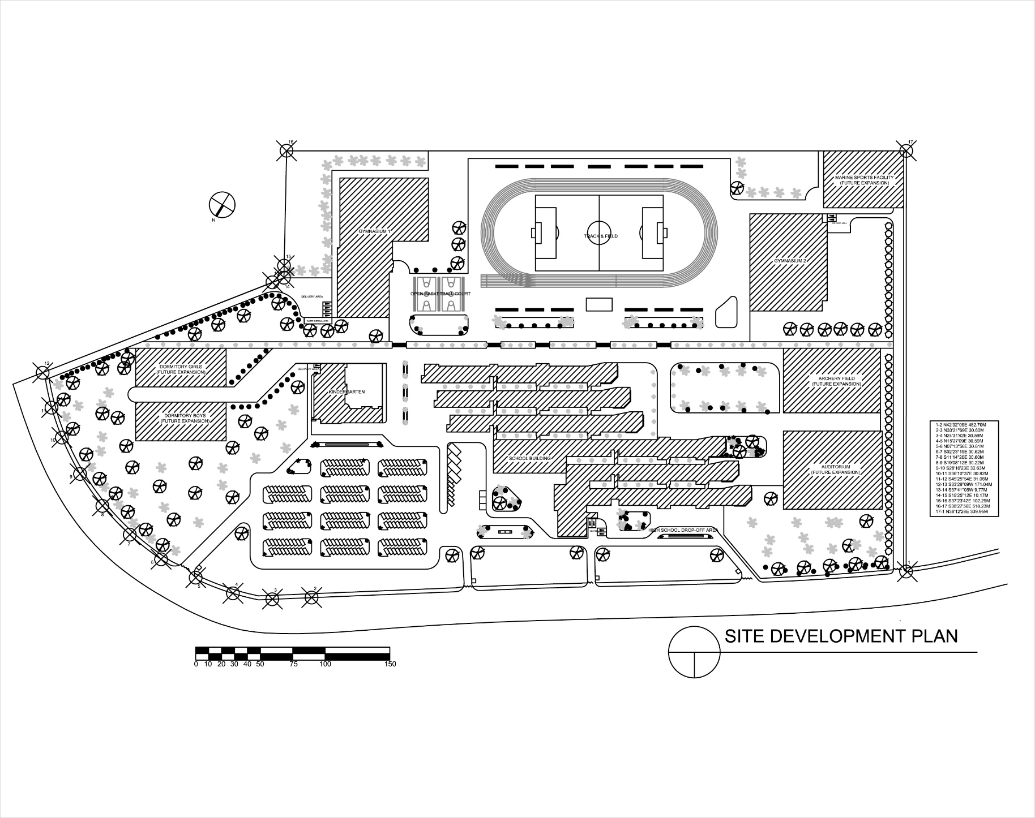

**9.3.DRAWINGS**

**9.3.1 School Building**

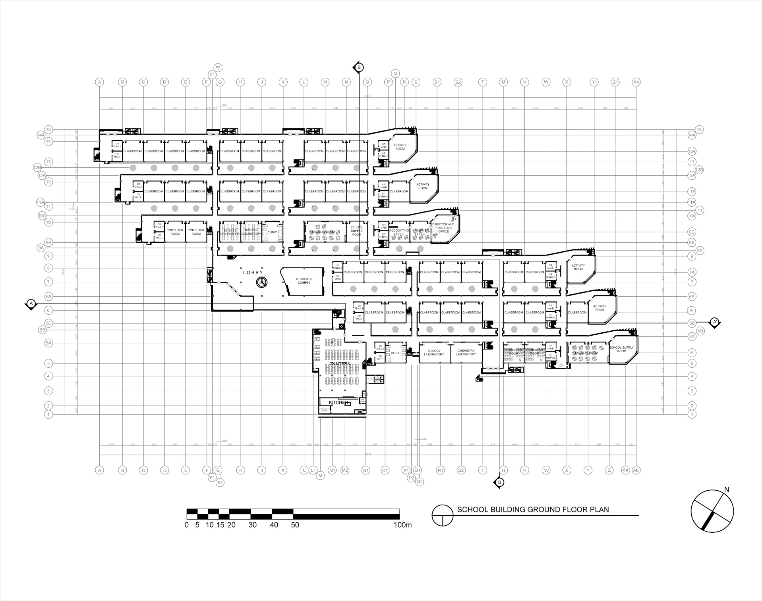

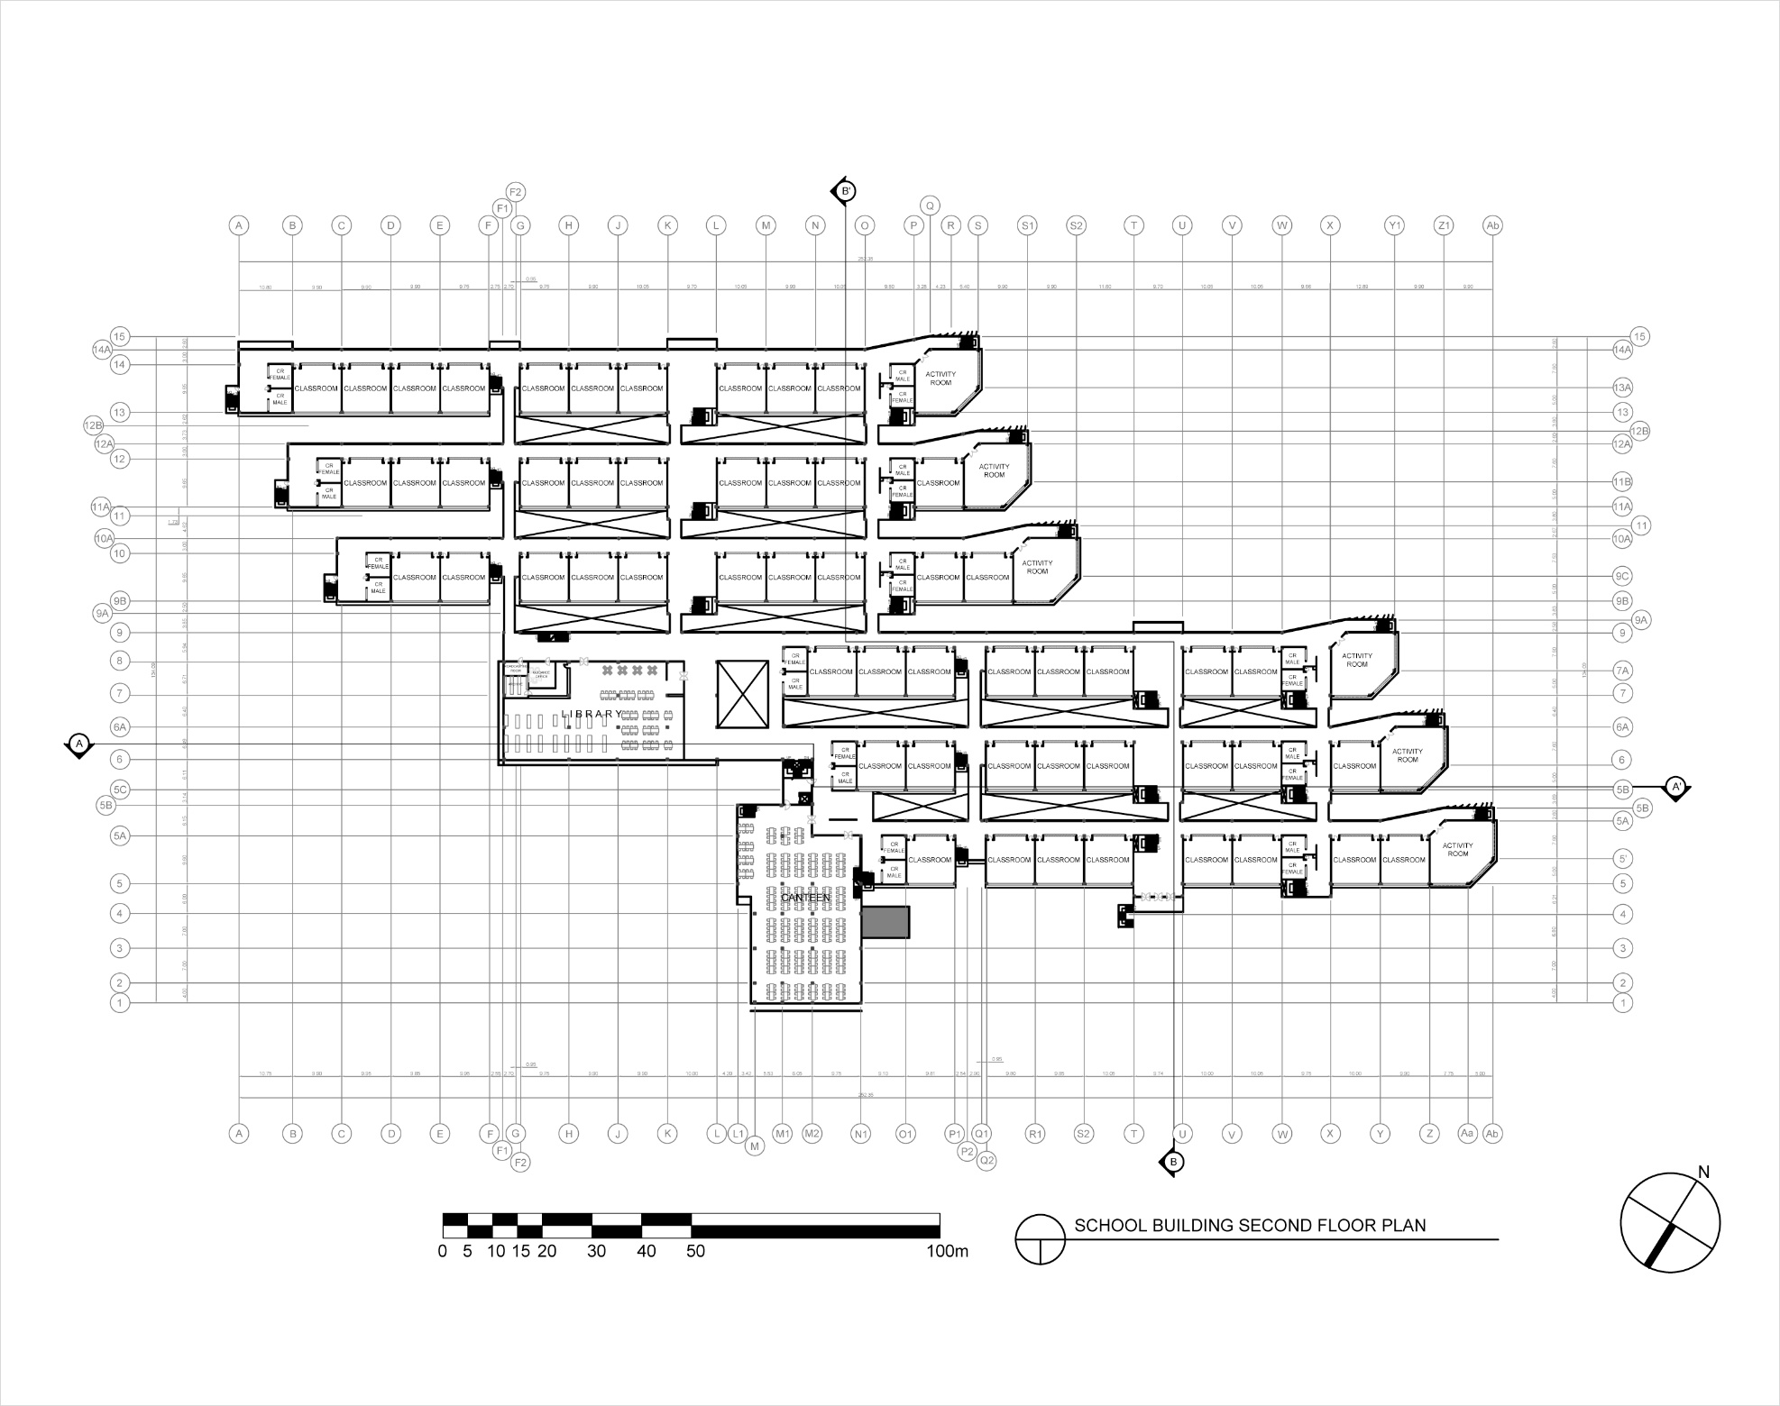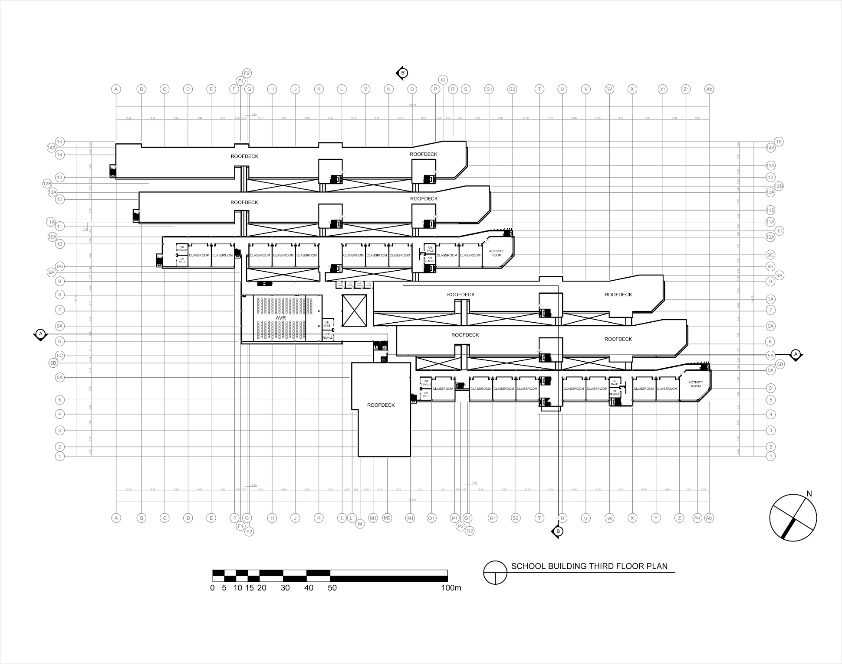

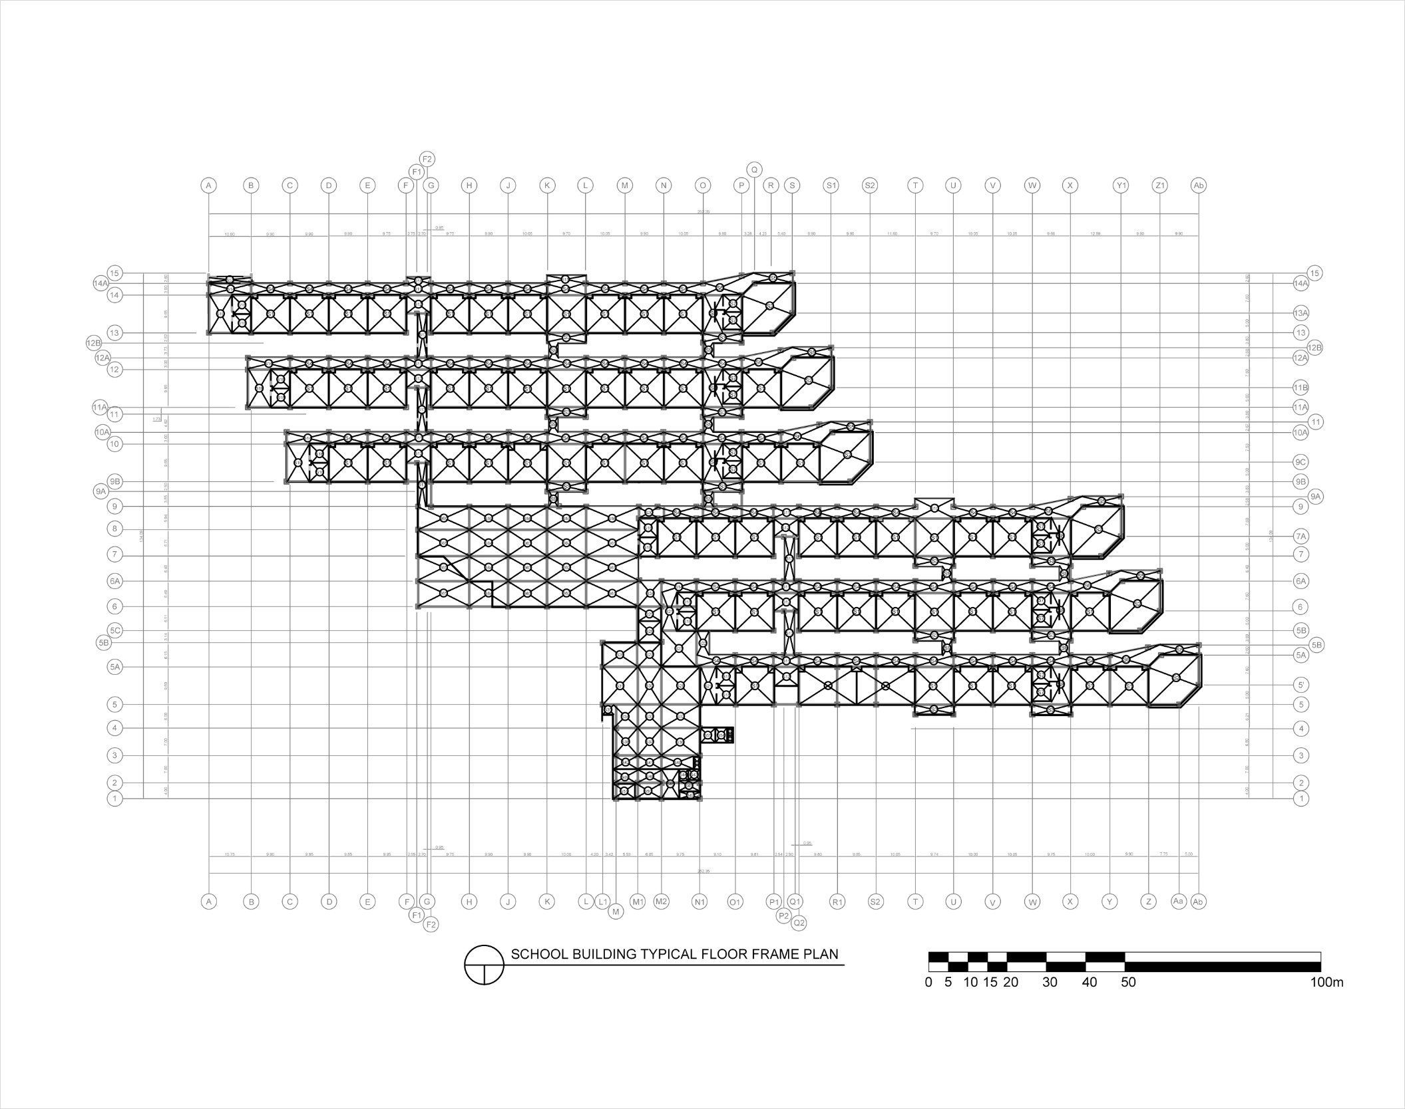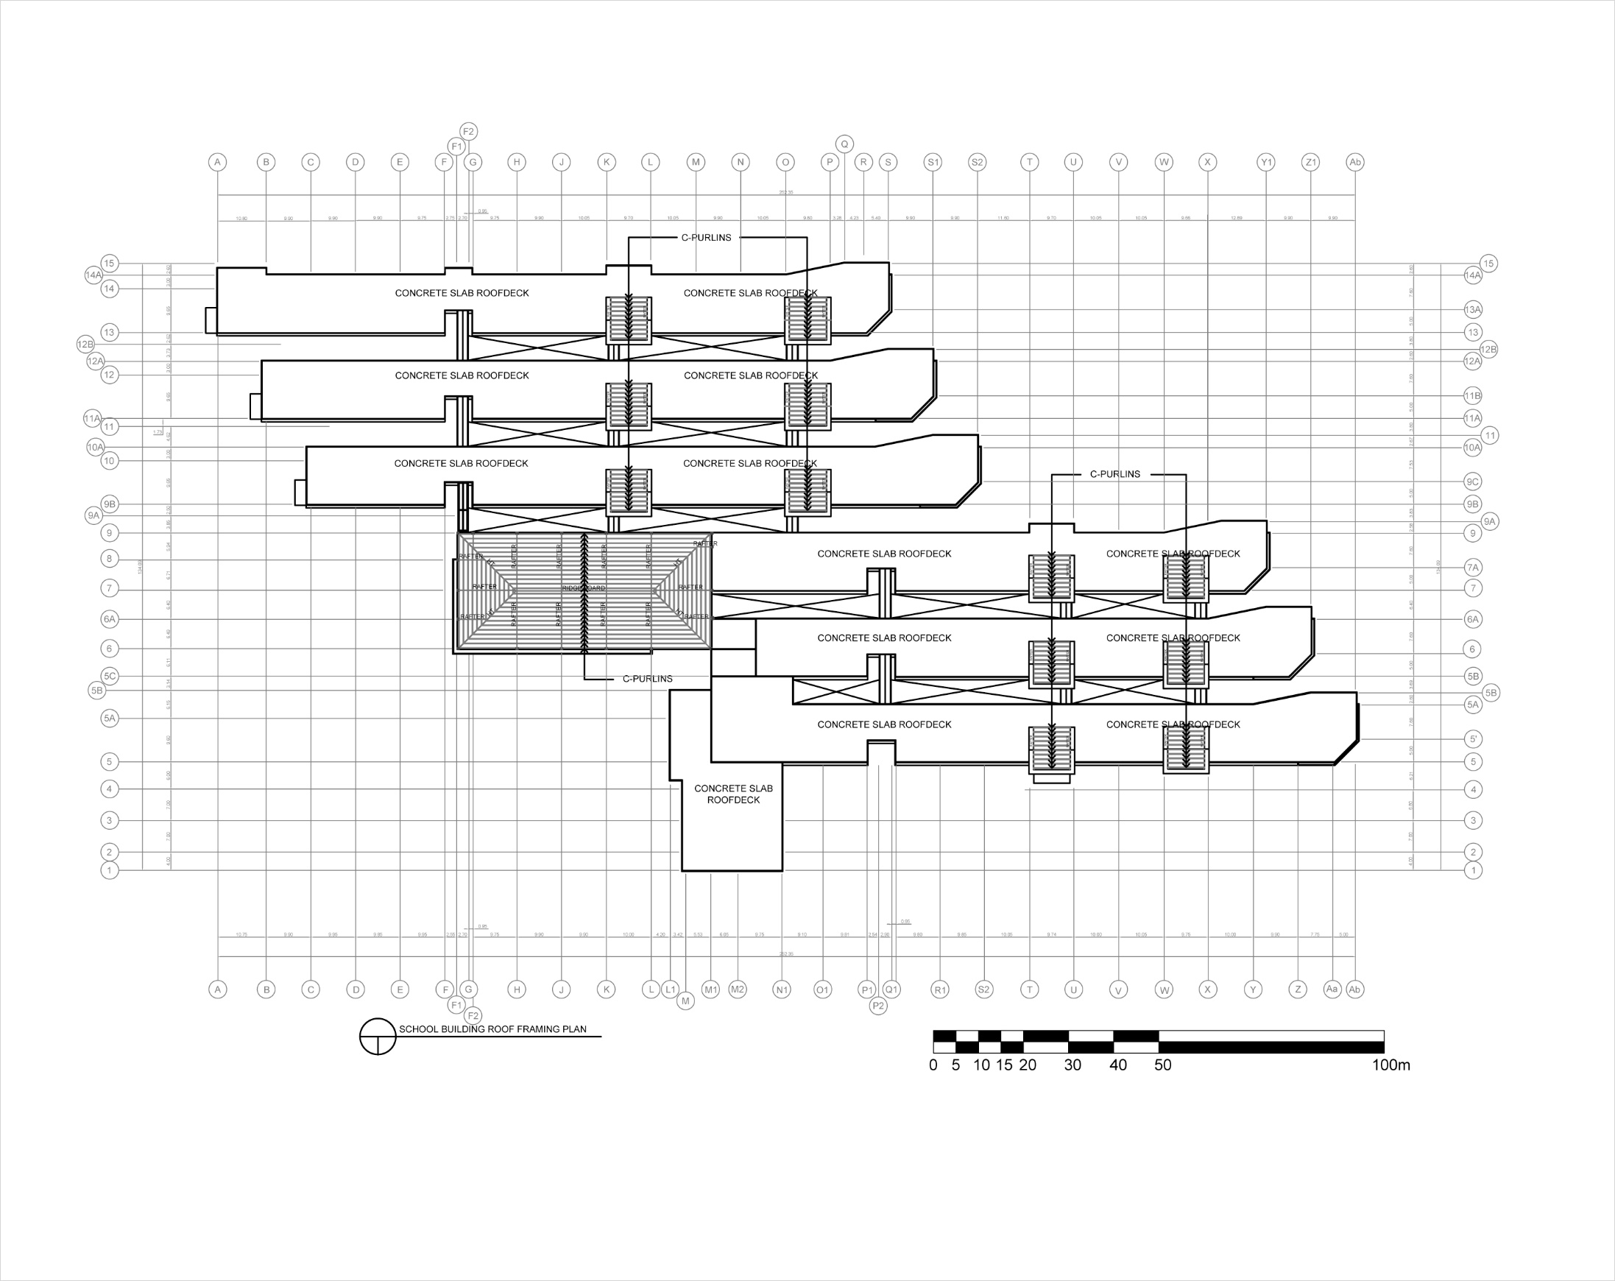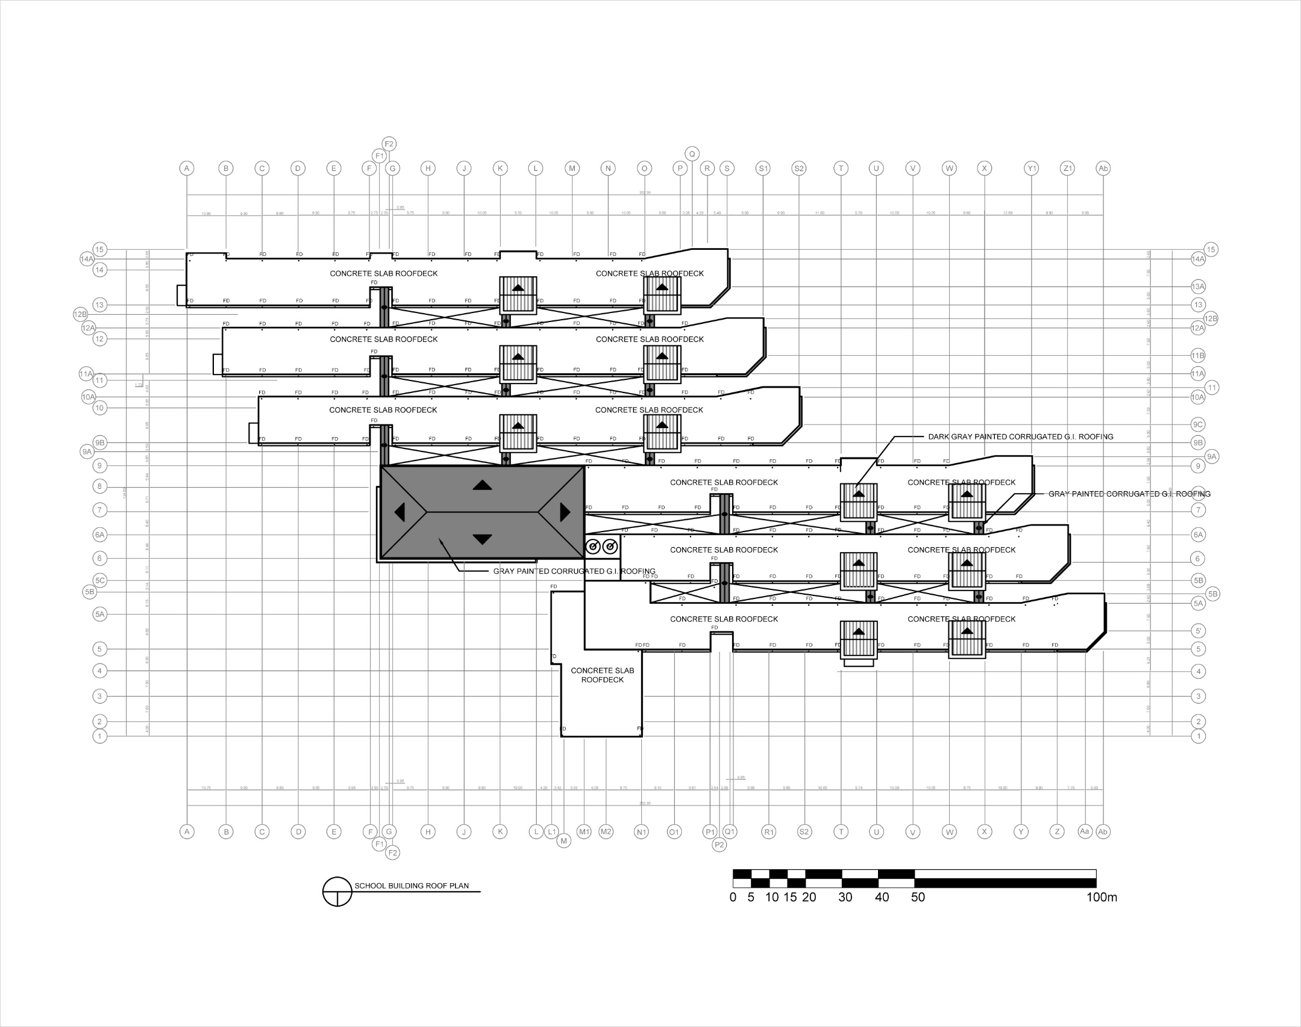

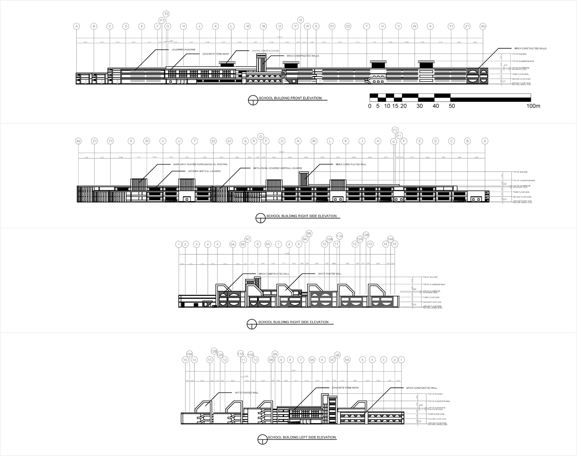

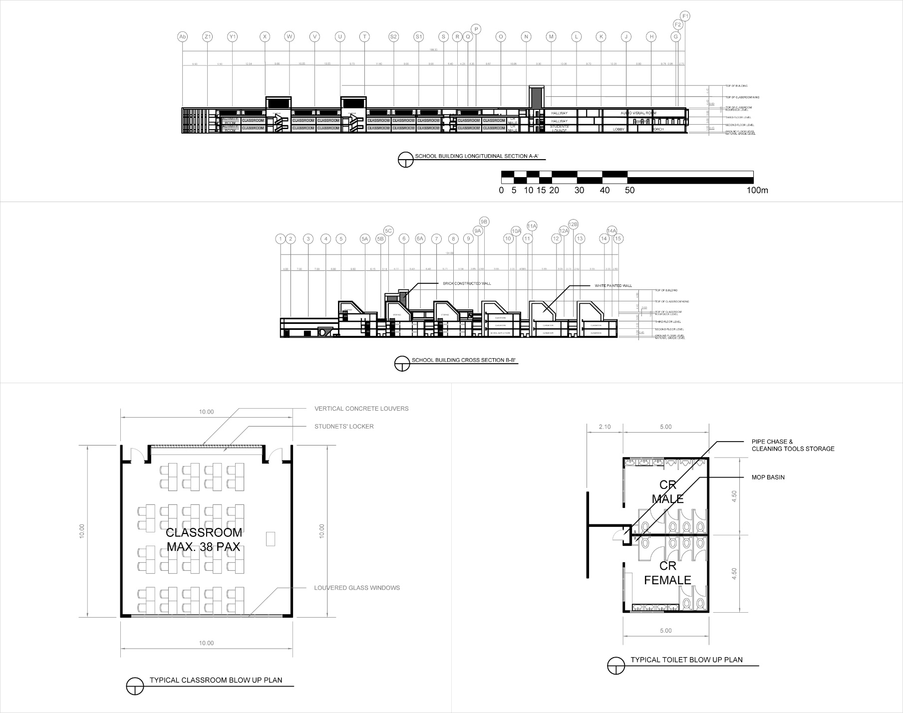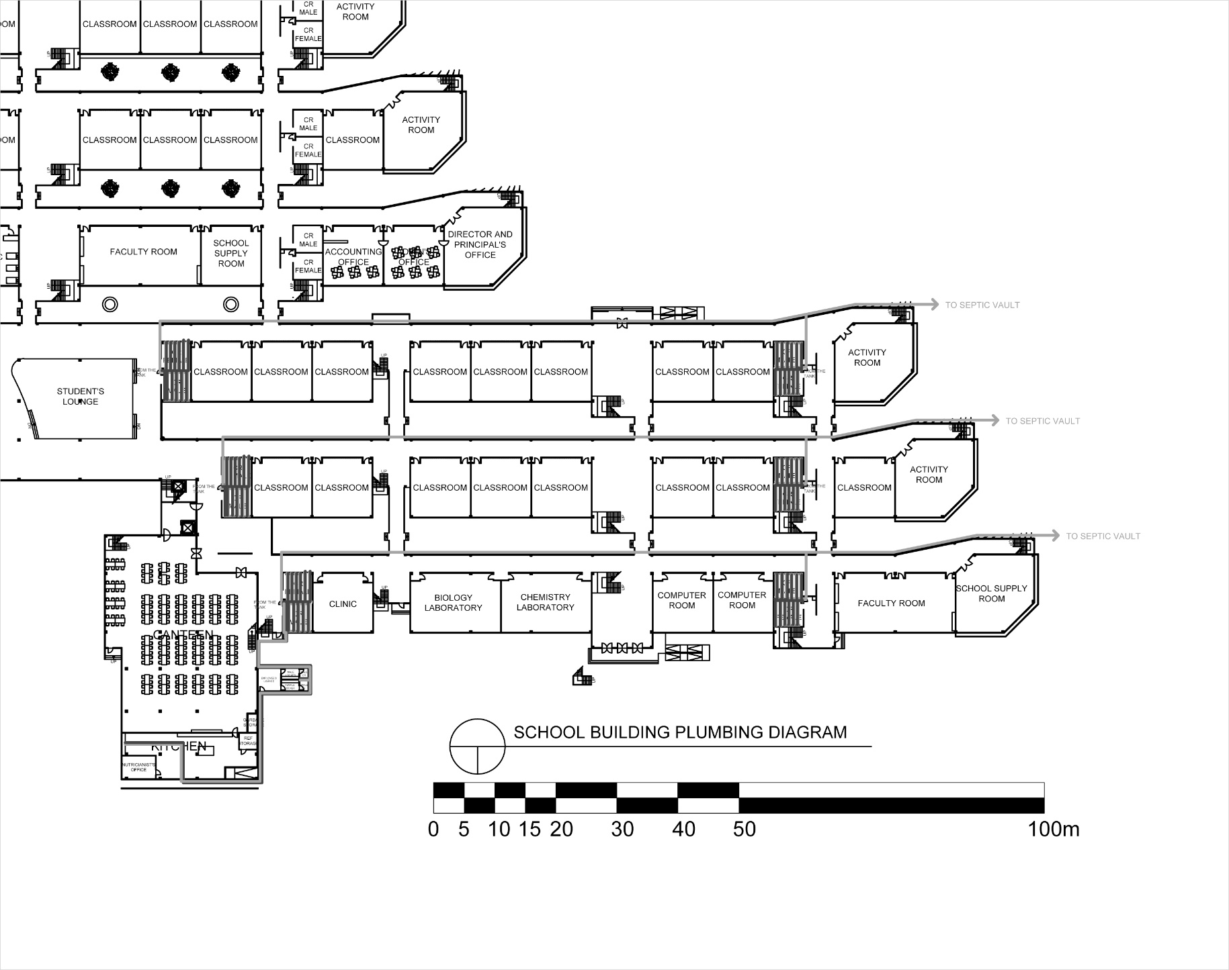

**9.3.2 Kindergarten**

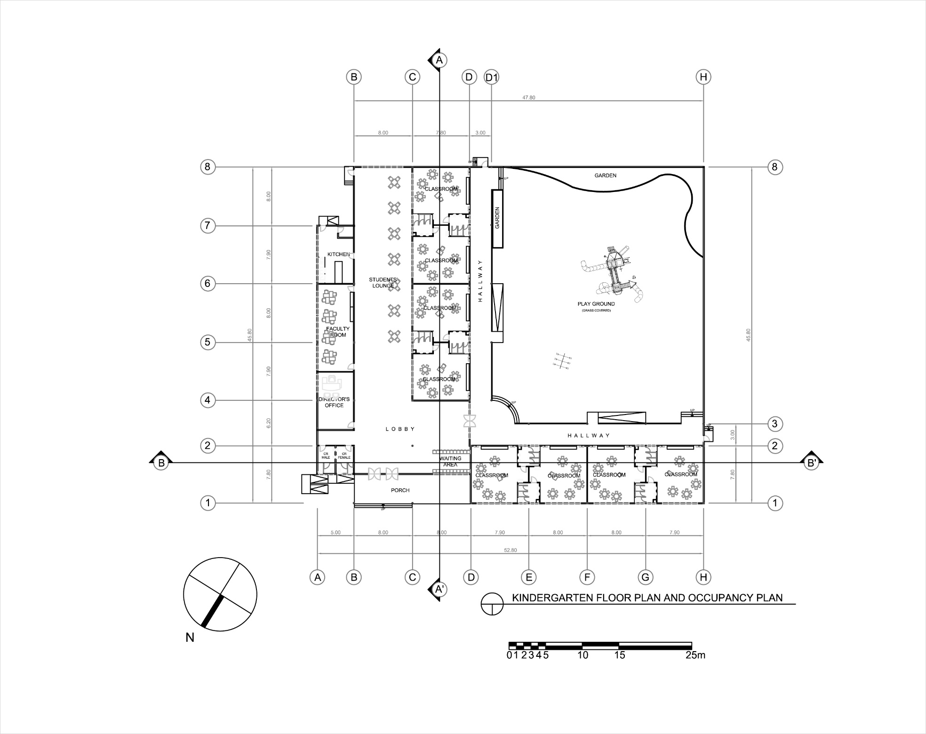

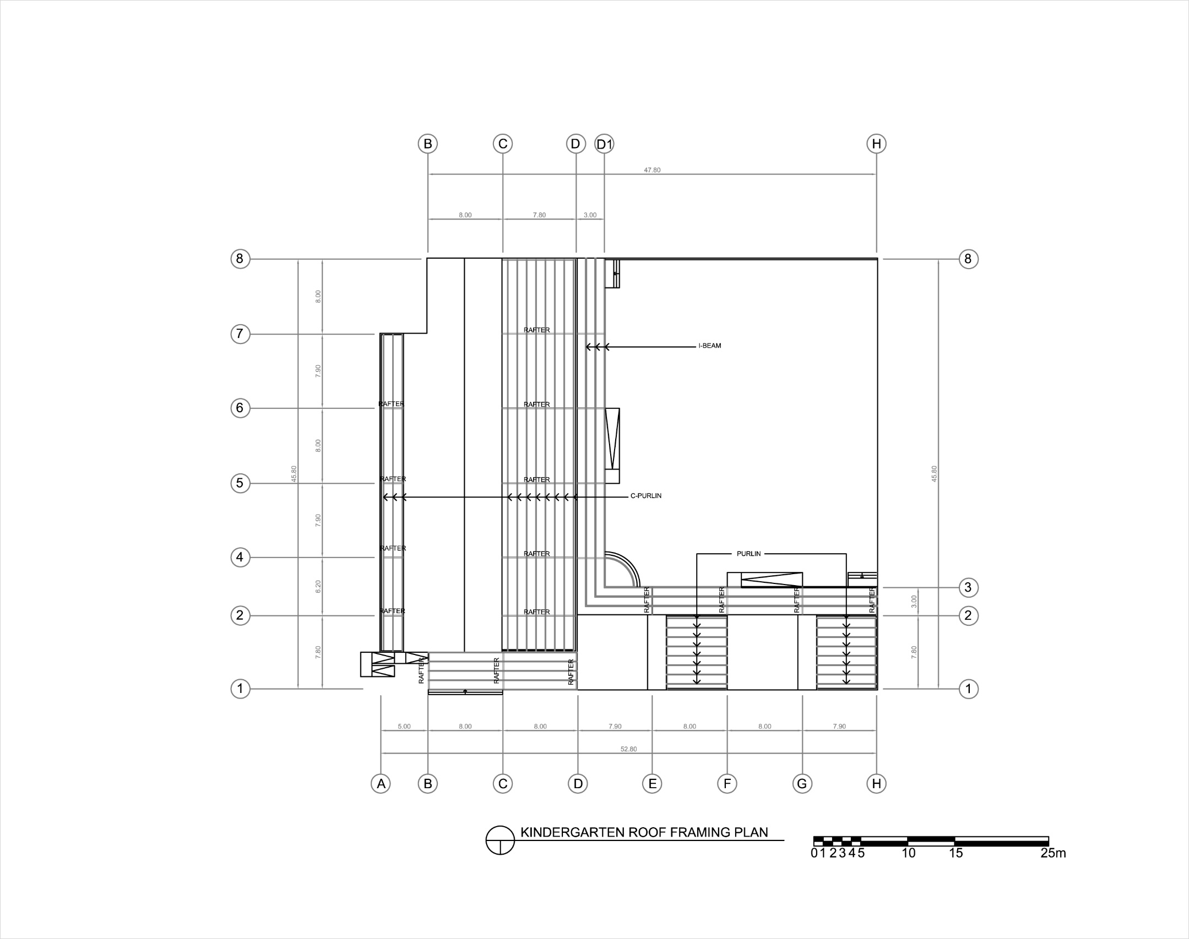

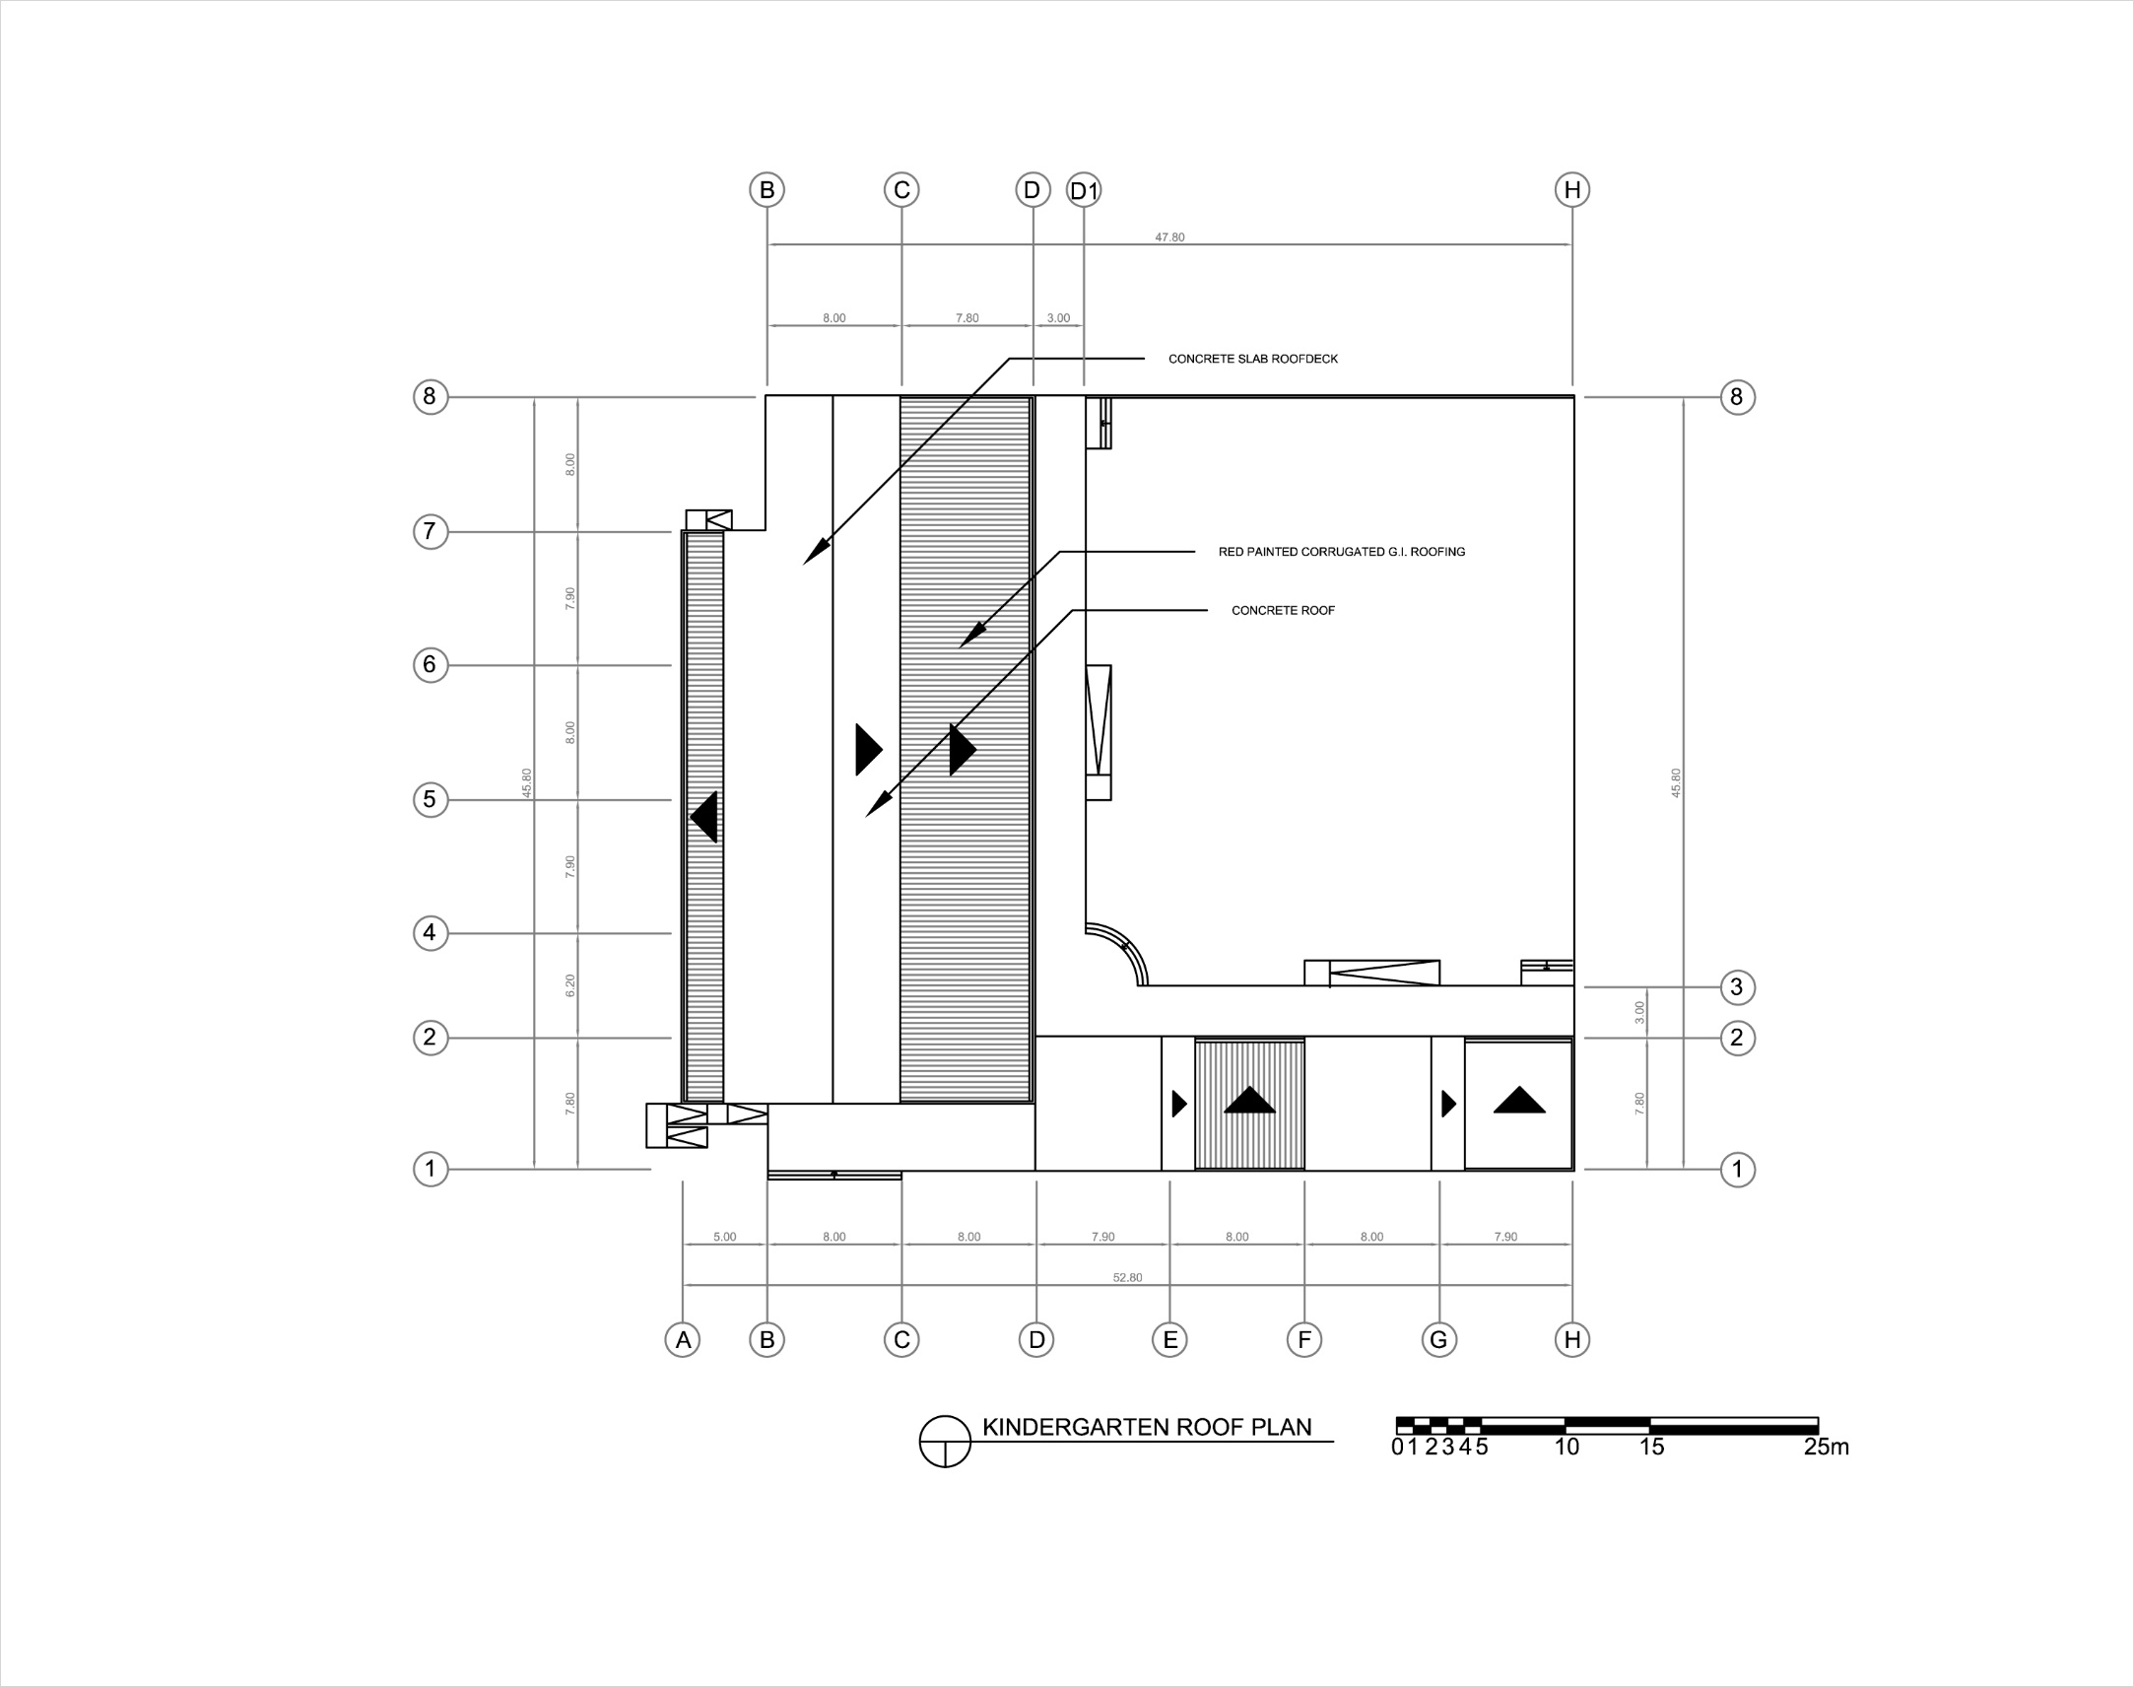

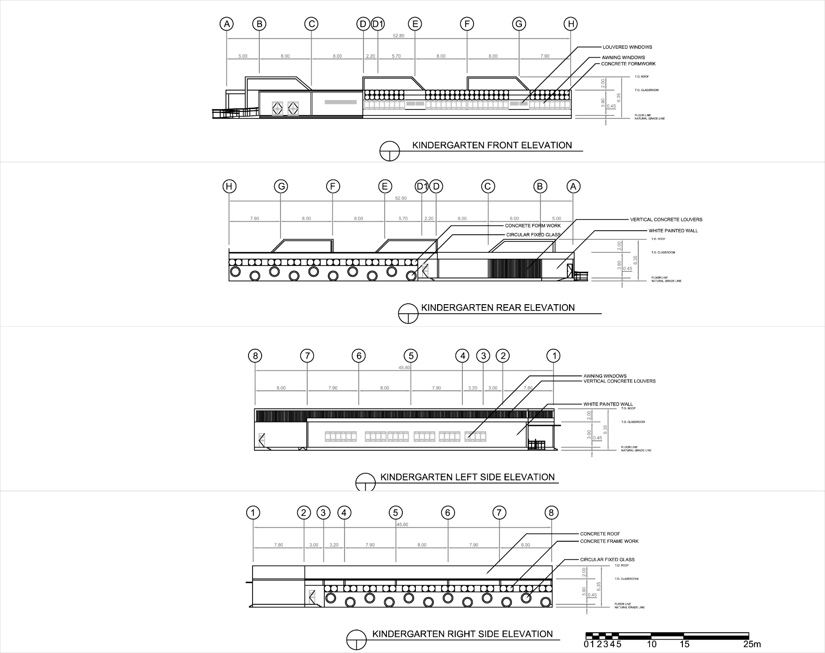

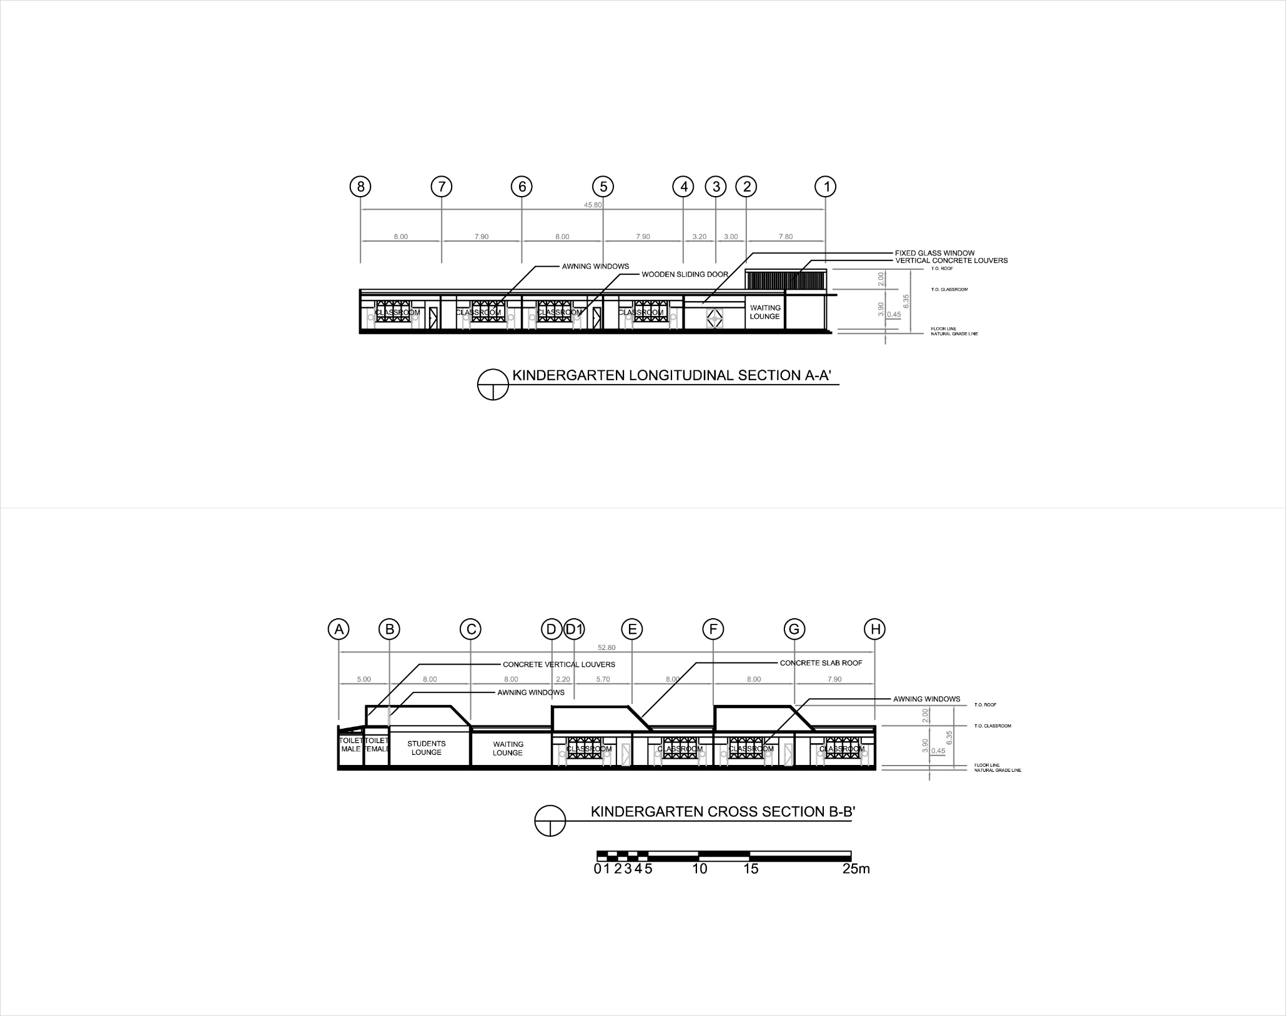

**9.3.4 Gymnasium 1**

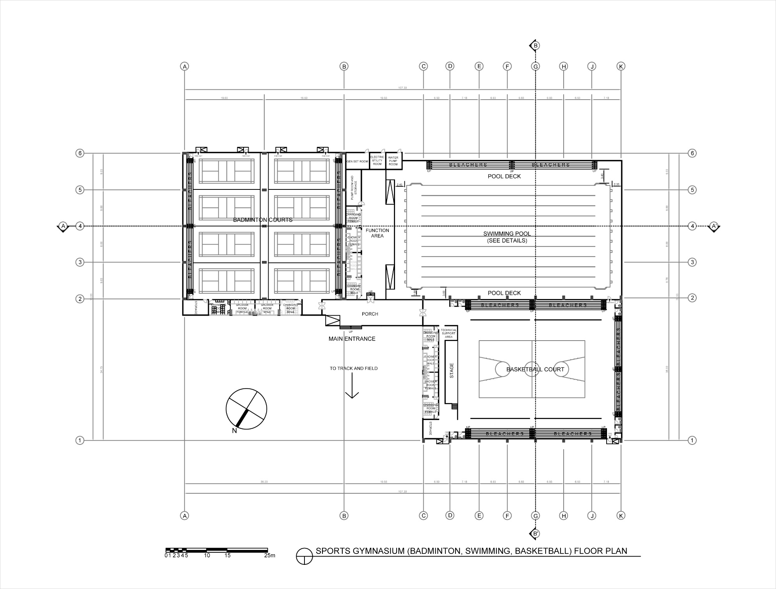

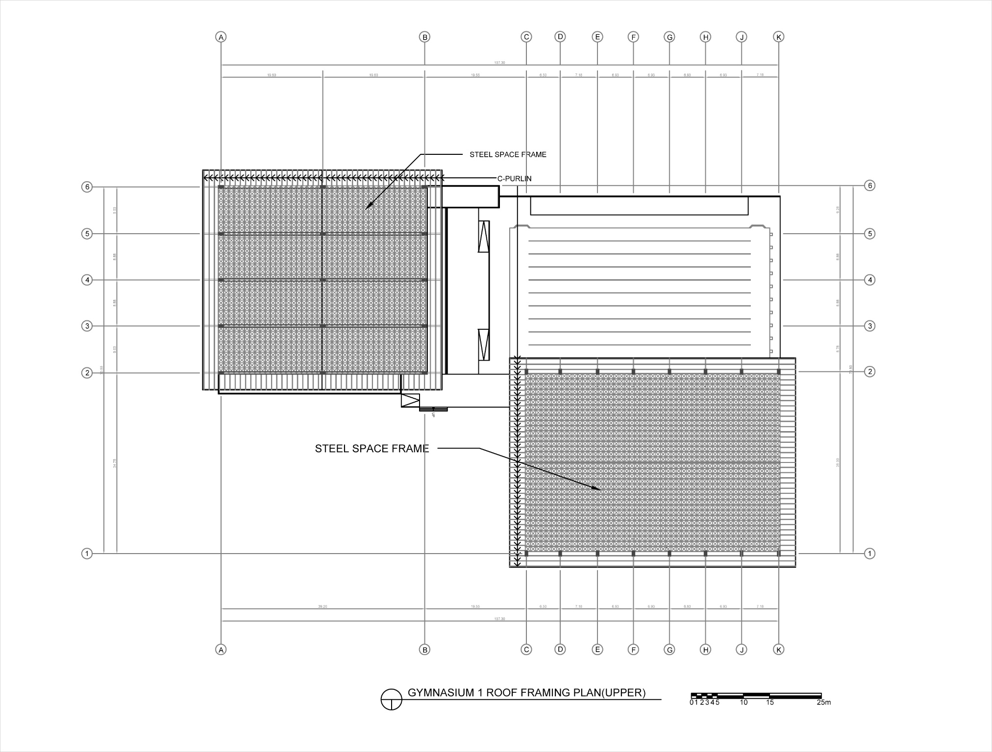

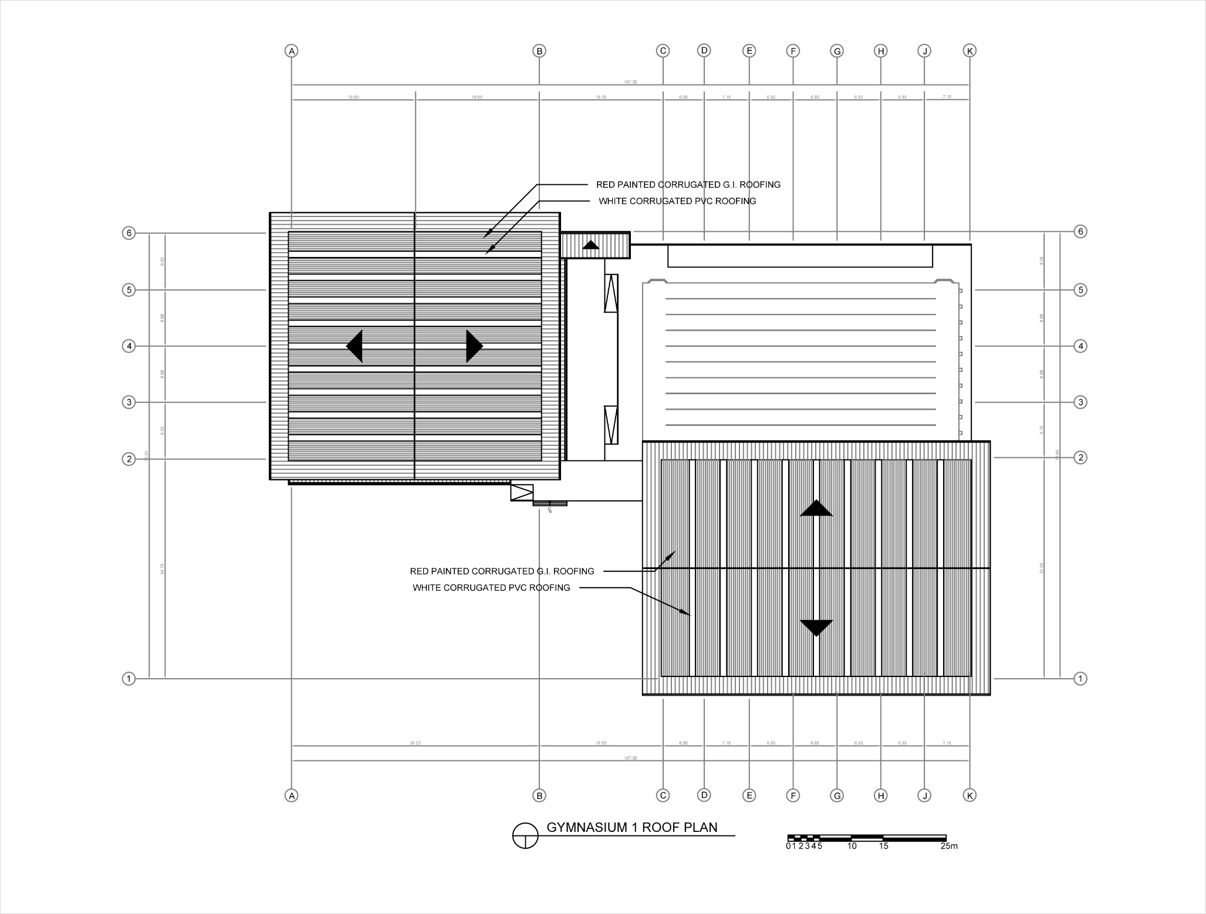

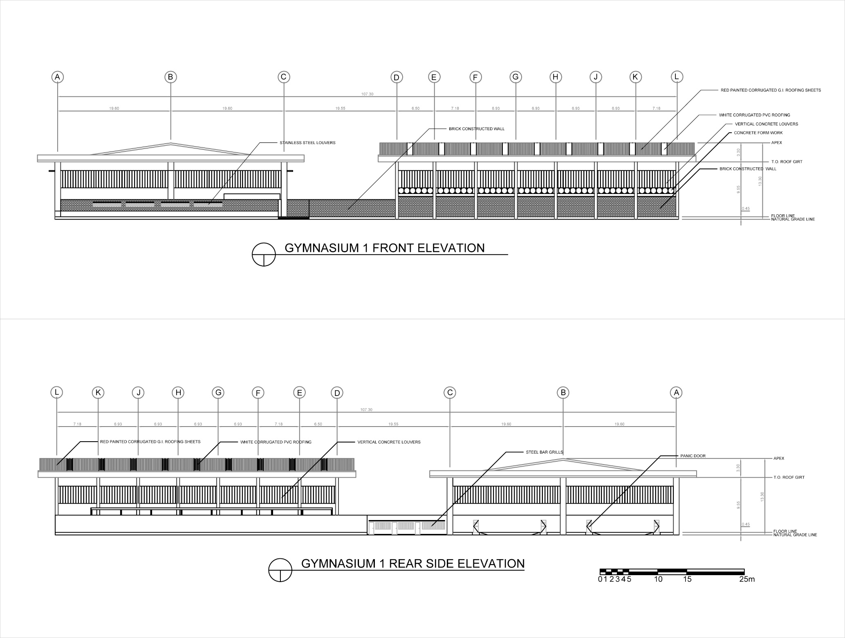

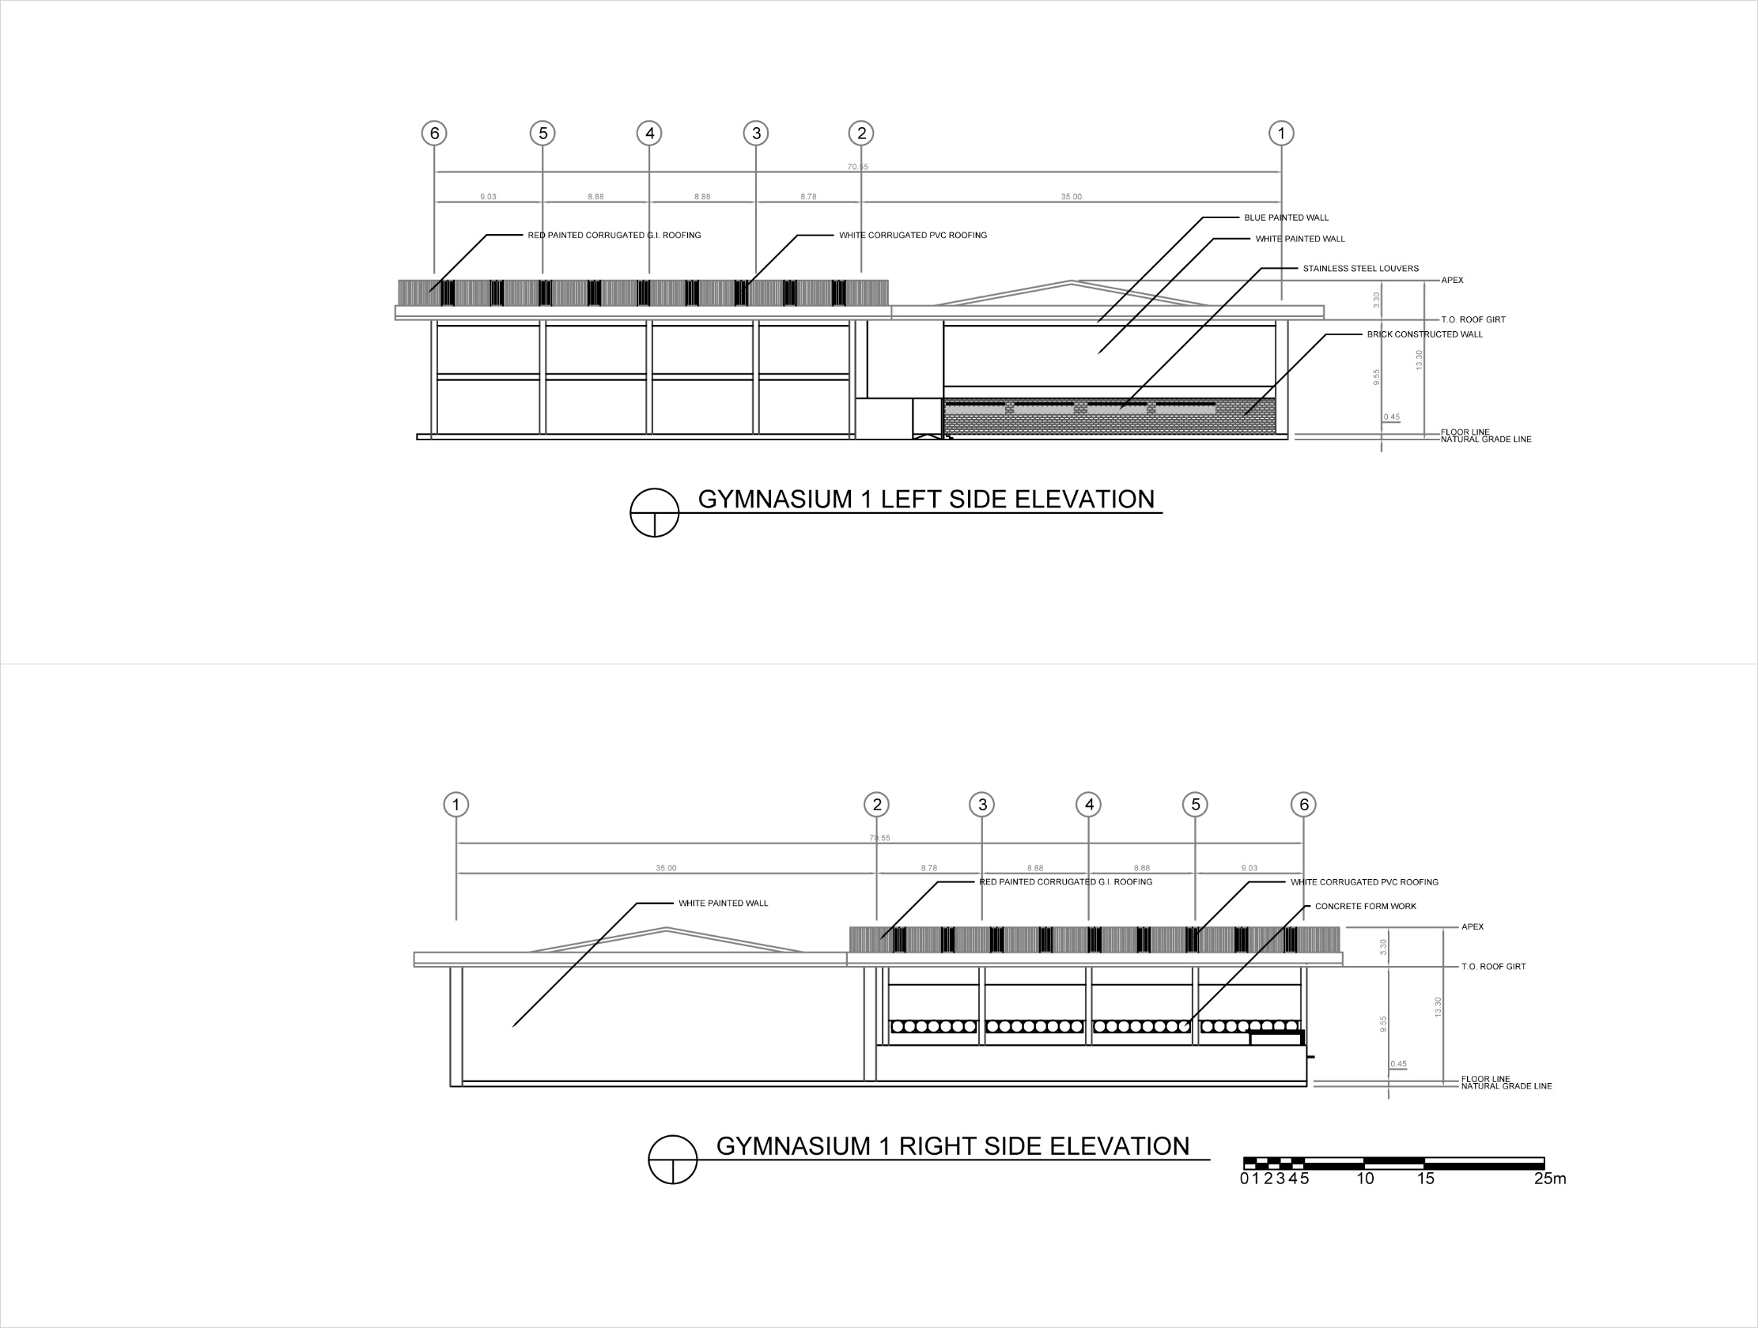

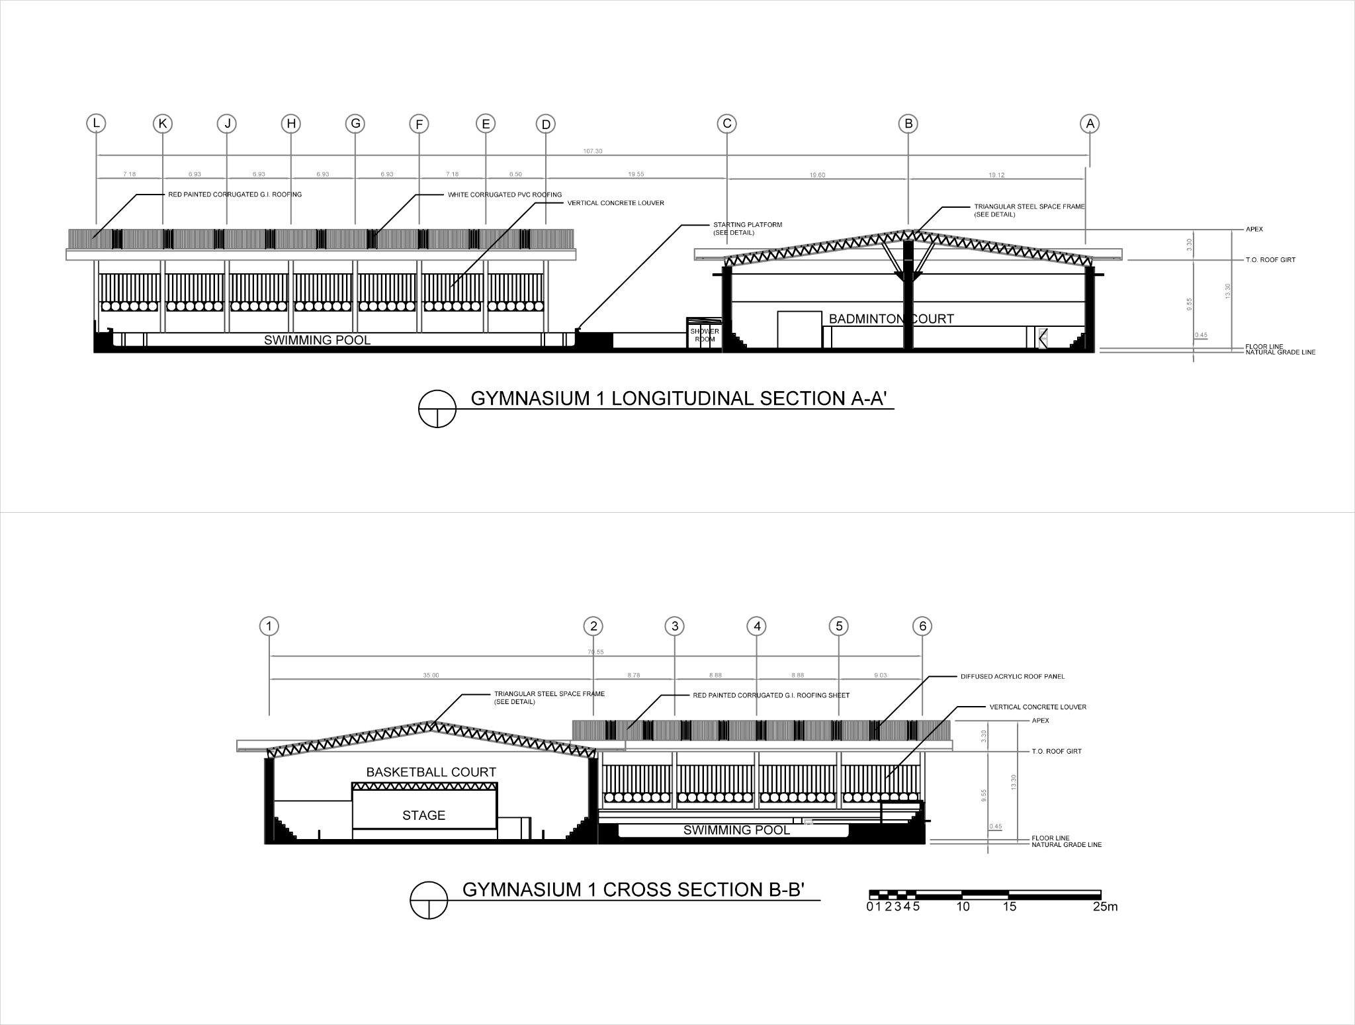

**9.3.4 Gymnasium 2**

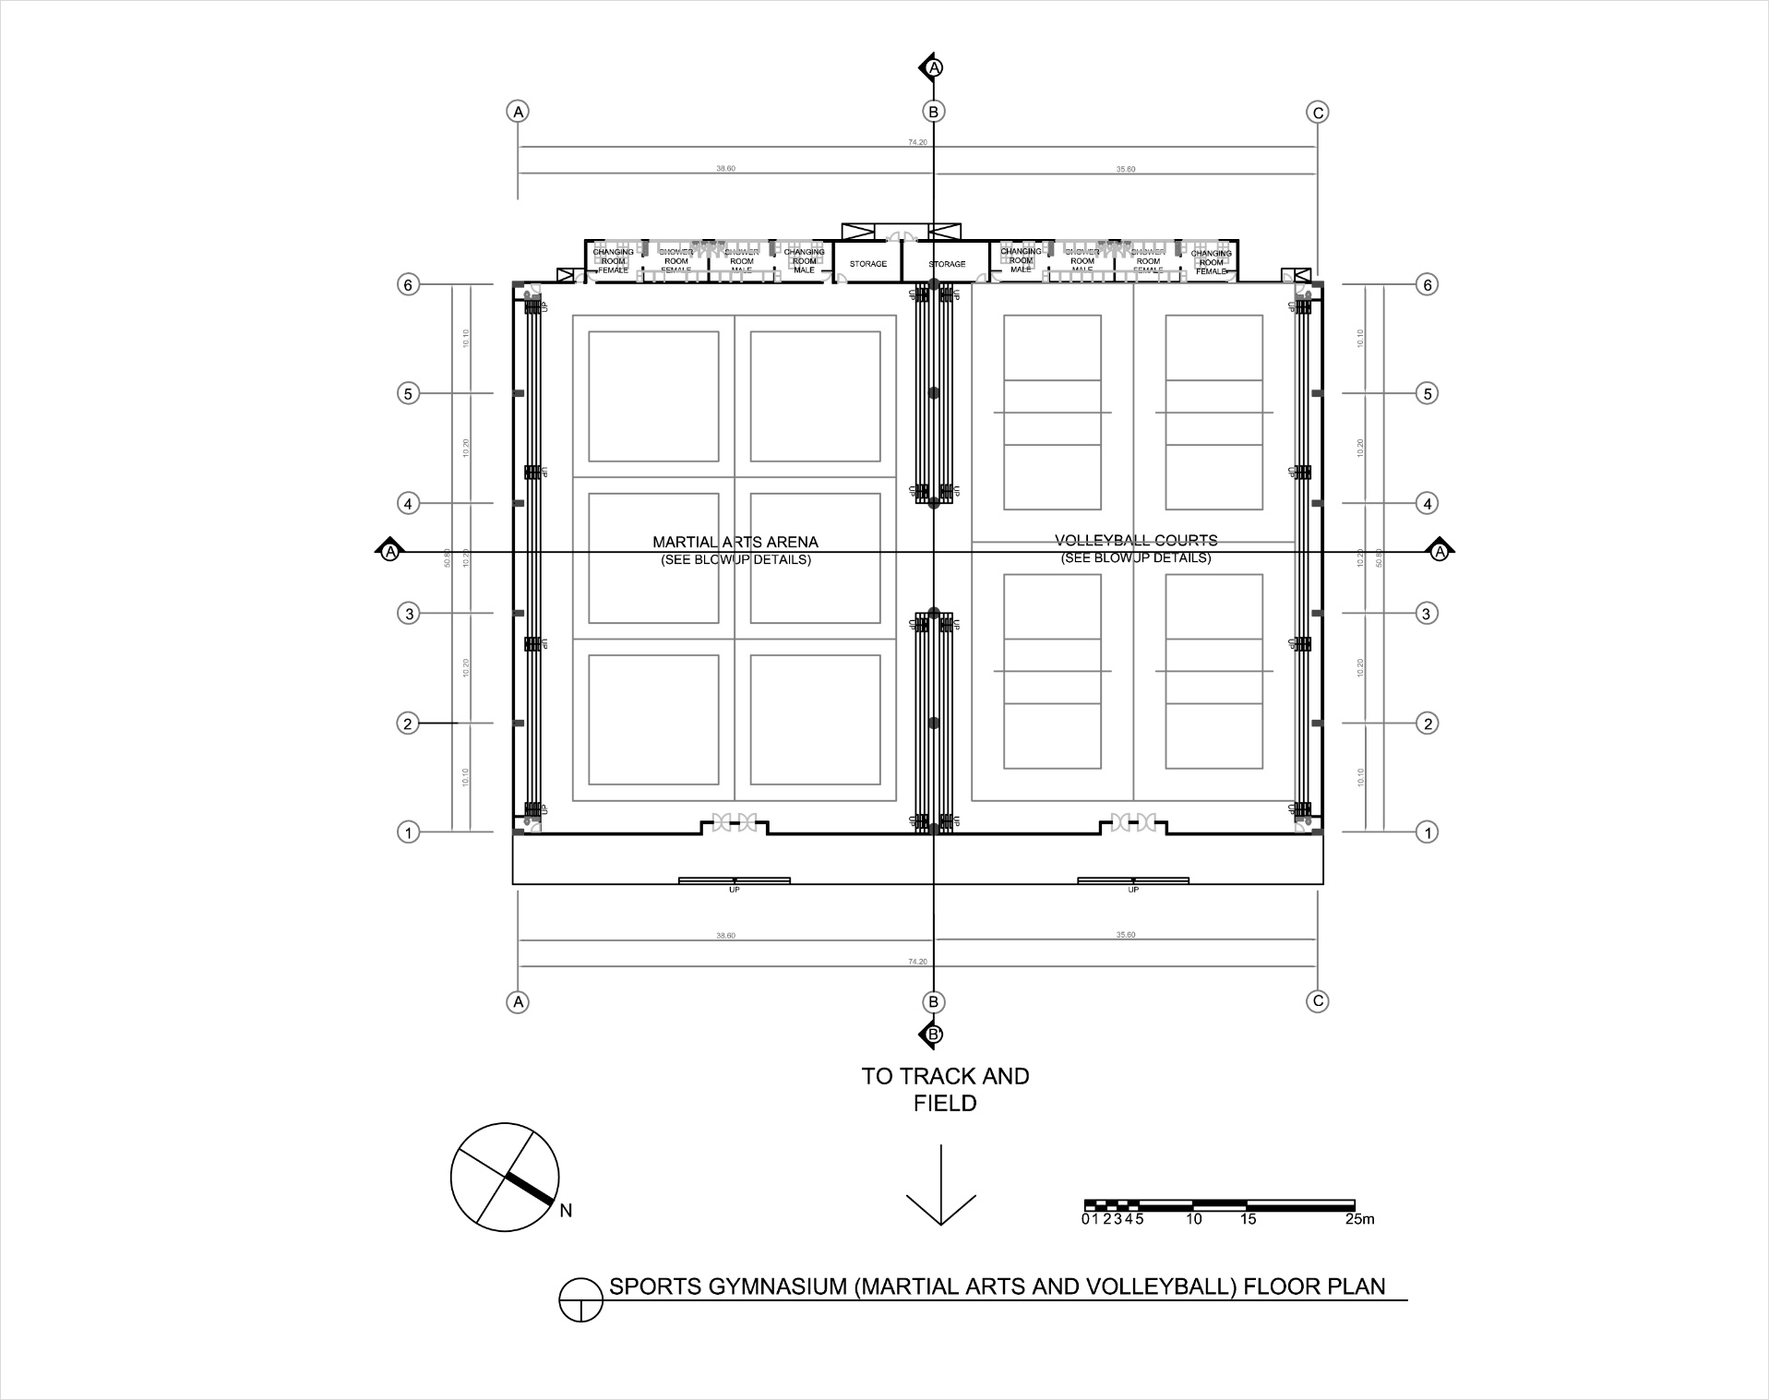

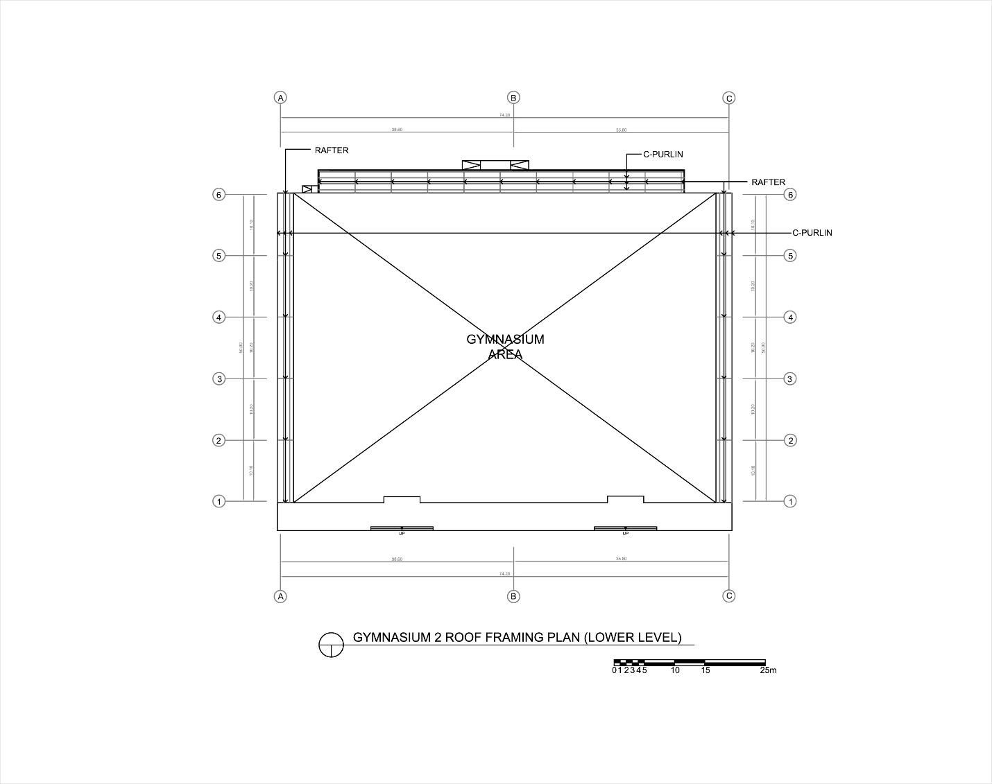

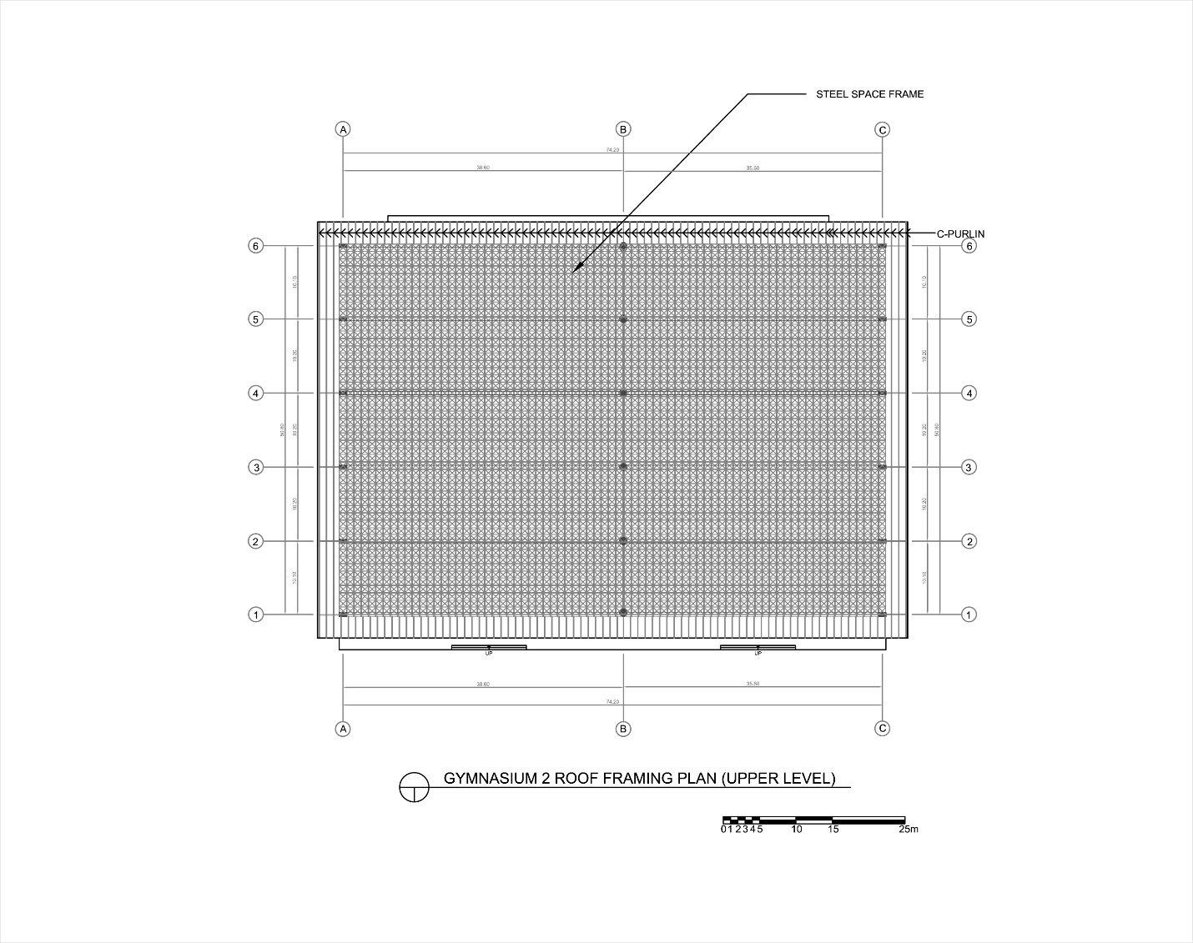

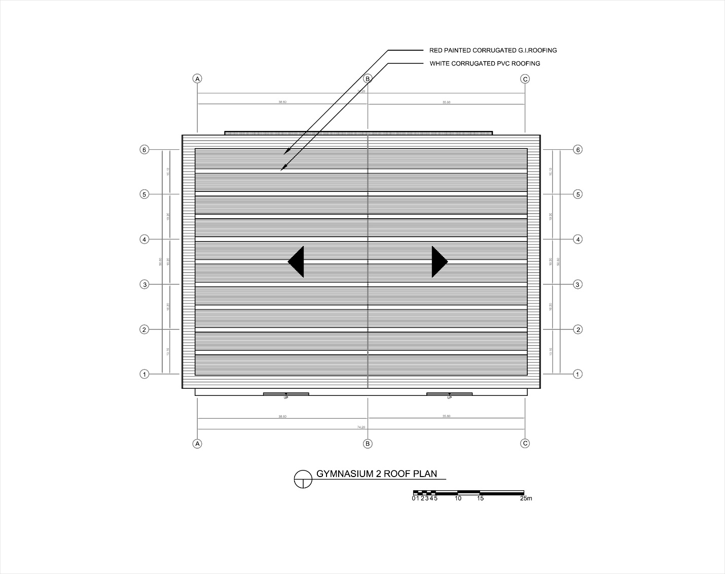

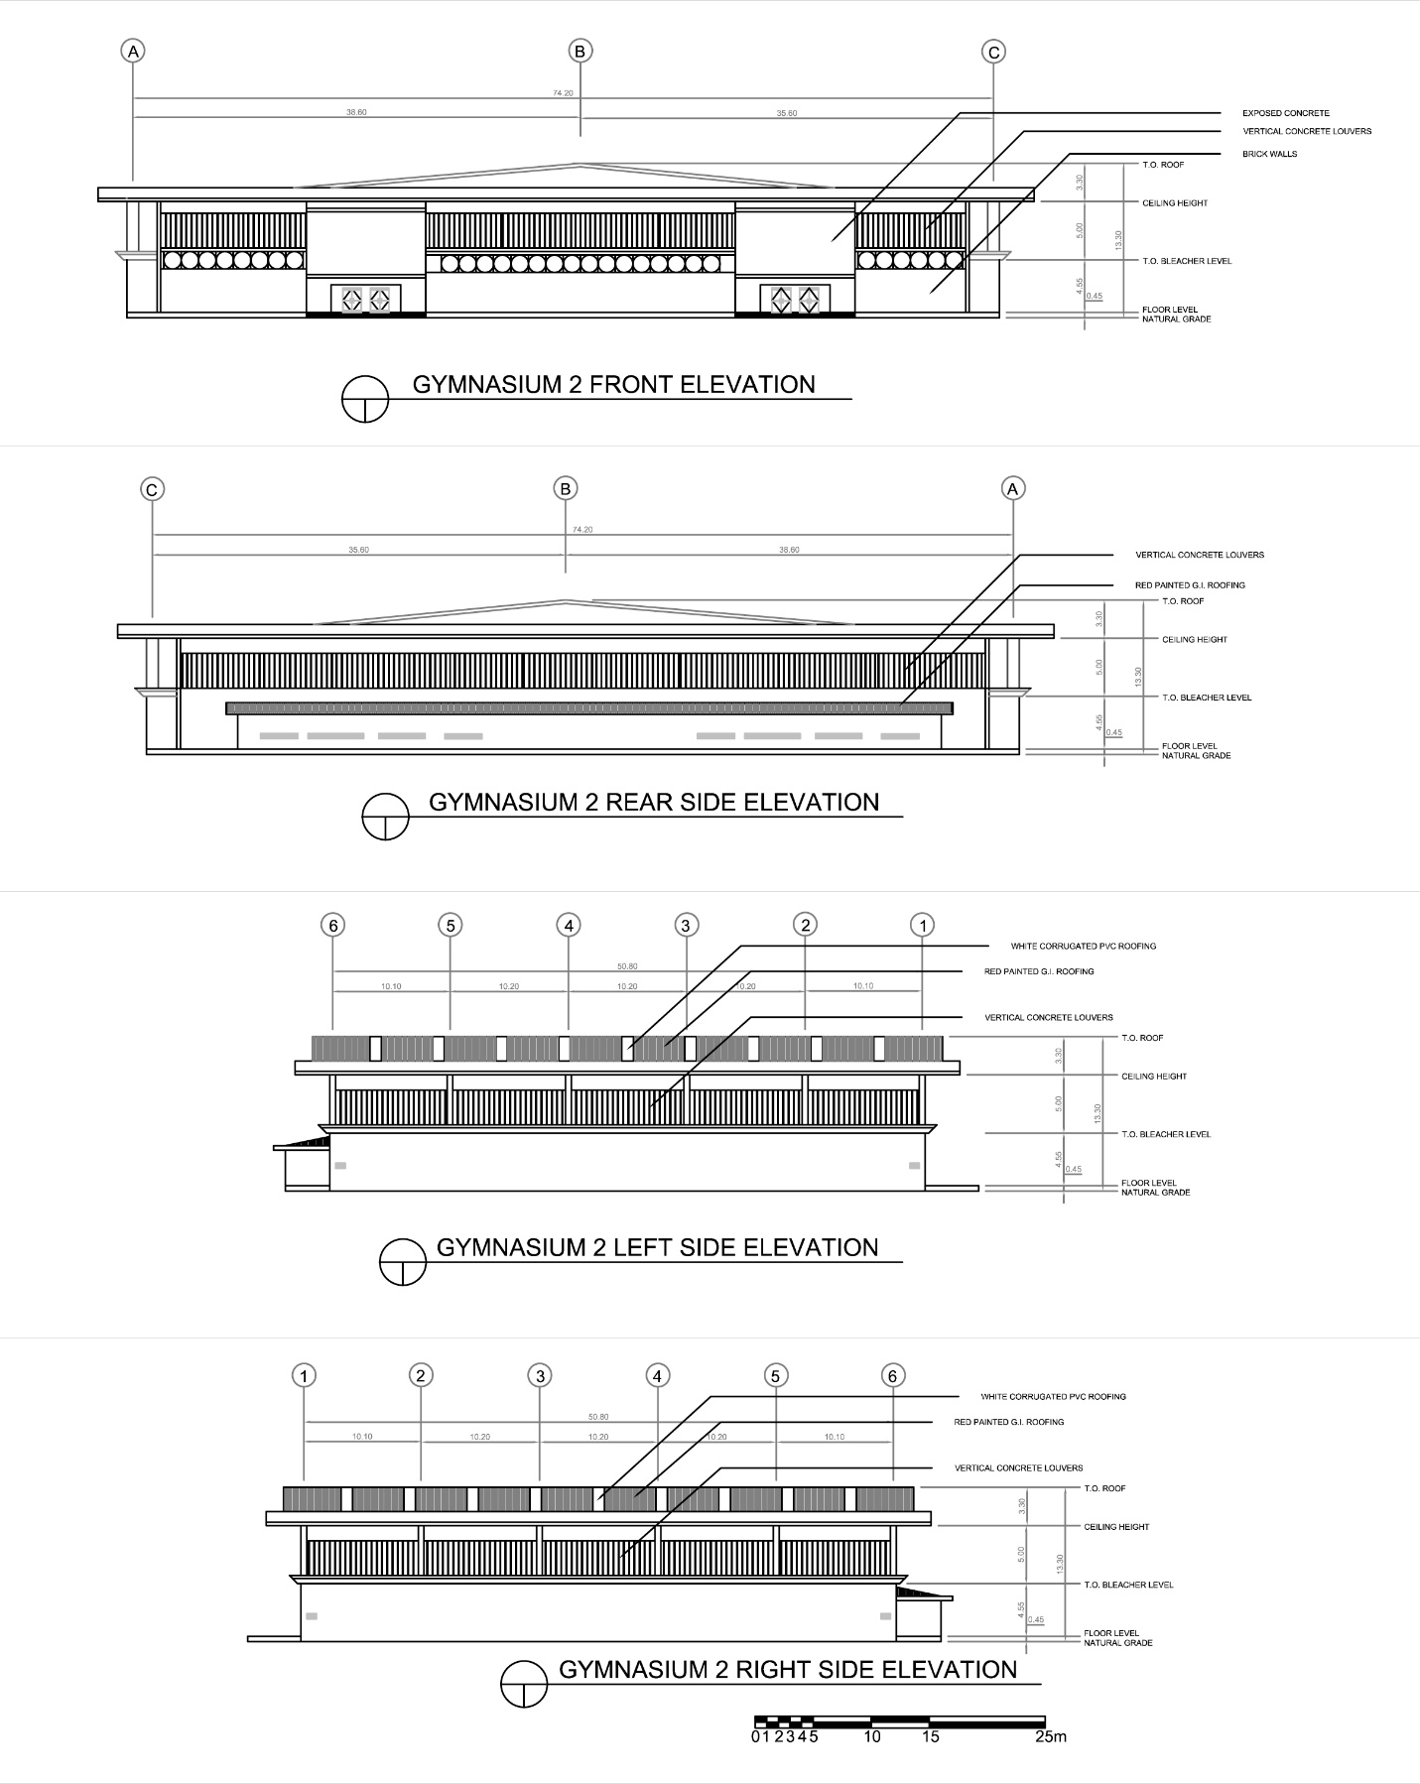

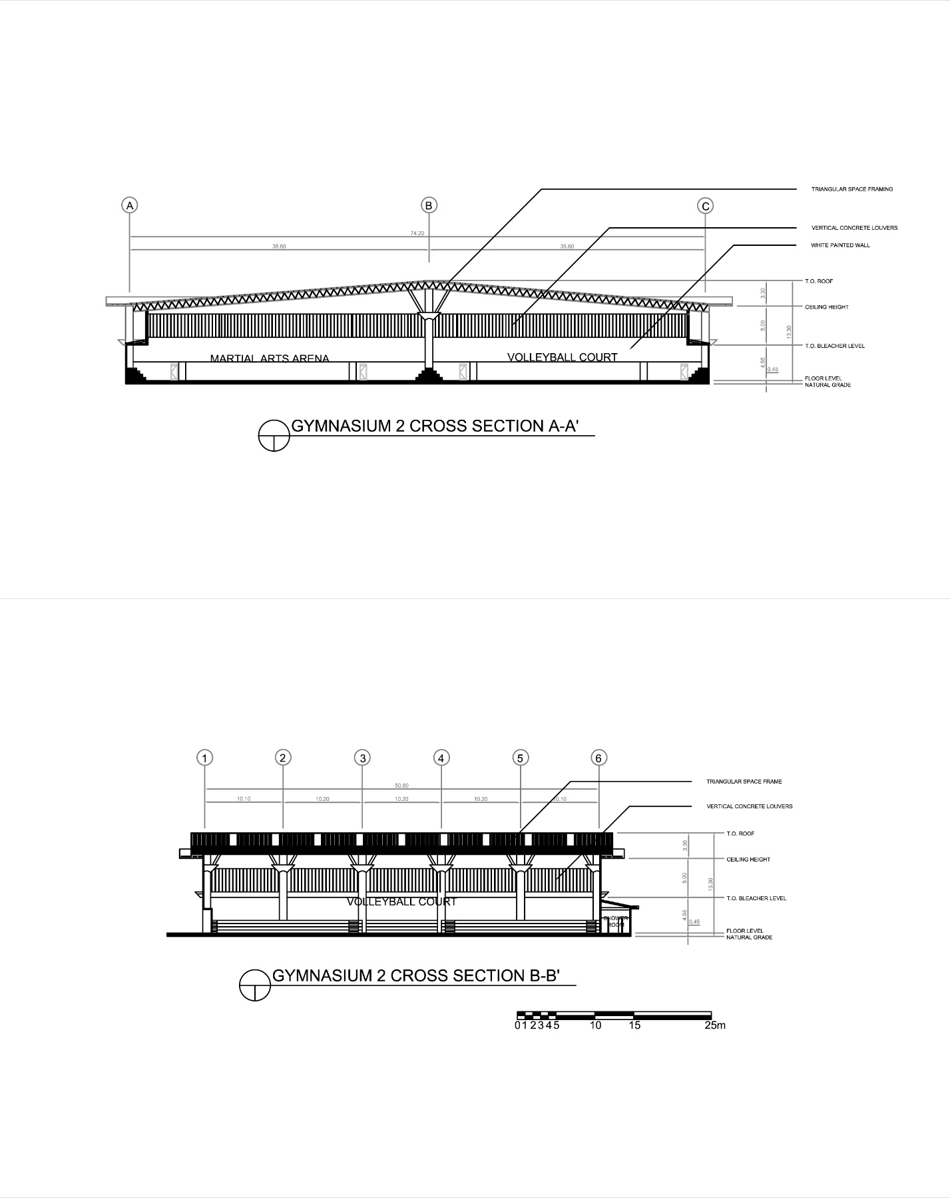

**9.4. PERSPECTIVES**

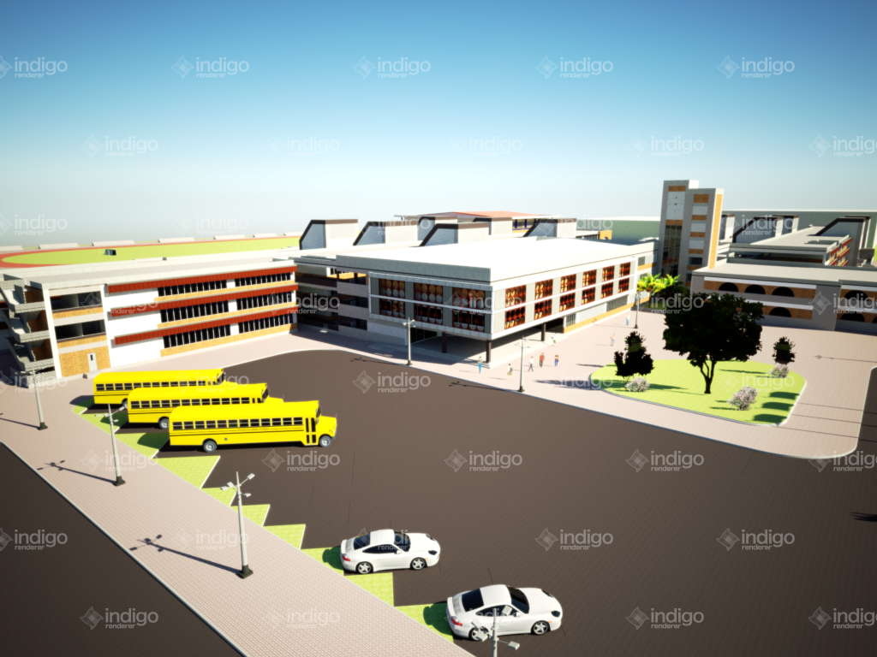

FIG. 1SCHOOL EXTERIOR VIEW

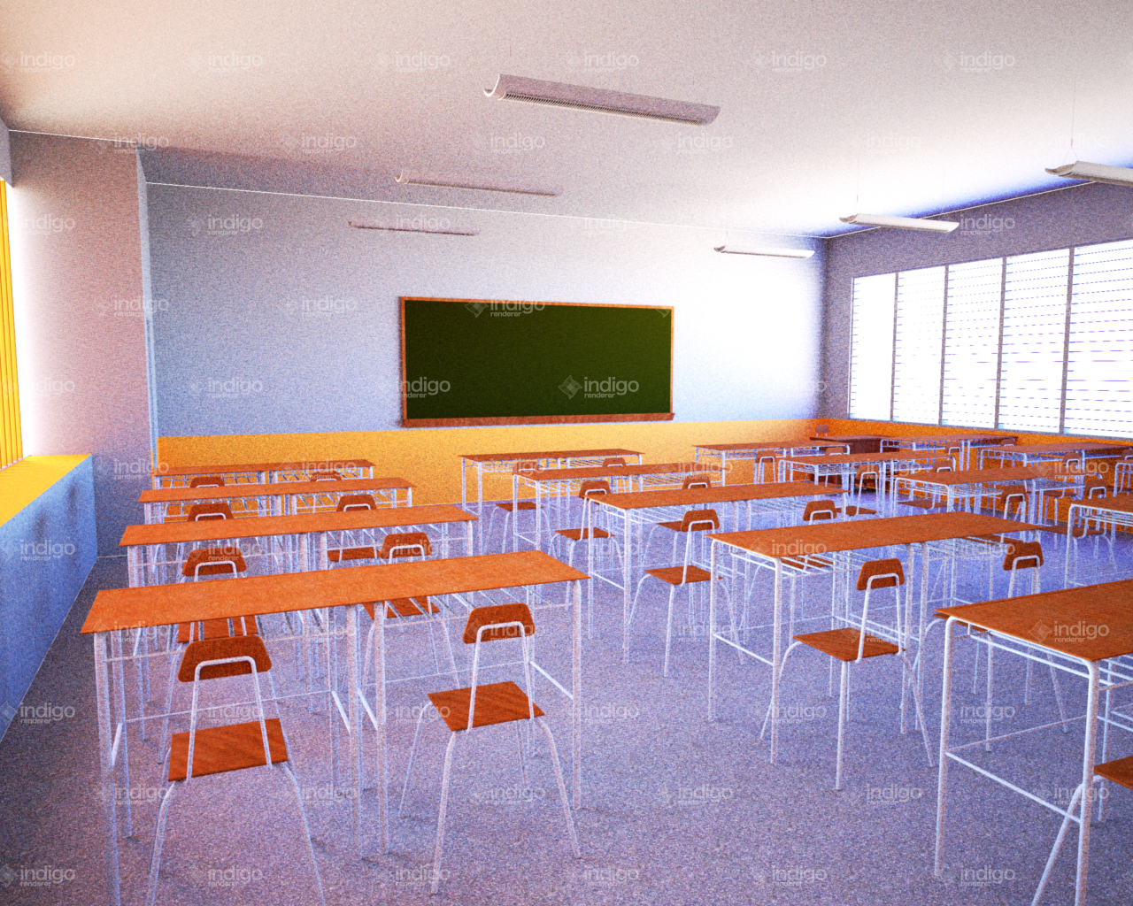

FIG. 2 SCHOOL CLASSROOM VIEW

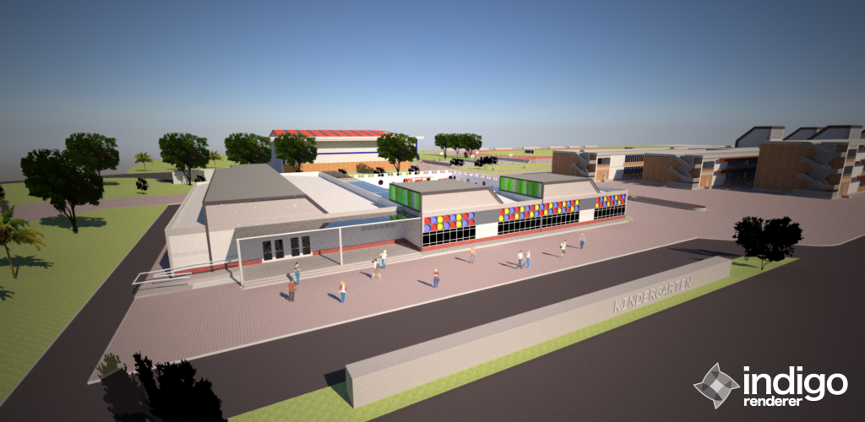

FIG. 3 KINDERGARTEN FAÇADE VEIW

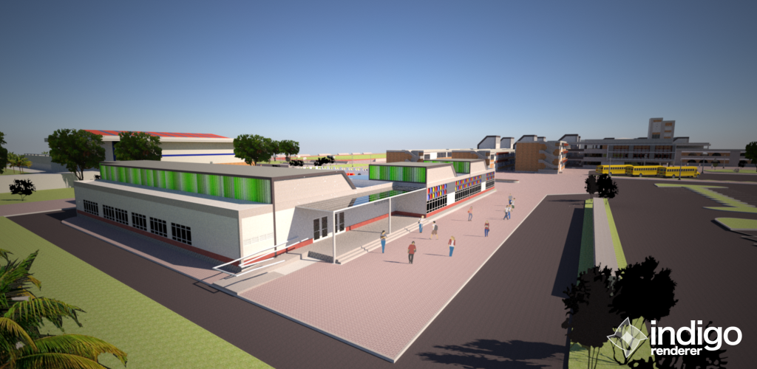

FIG. 4 KINDERGARTEN OBLIQUE VIEW

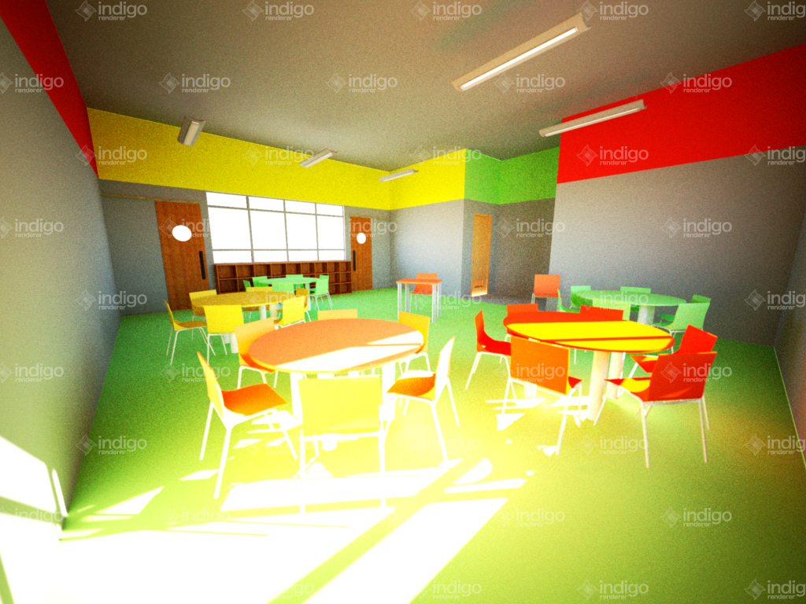

FIG. 5 KINDERGARTEN CLASSROOM VIEW

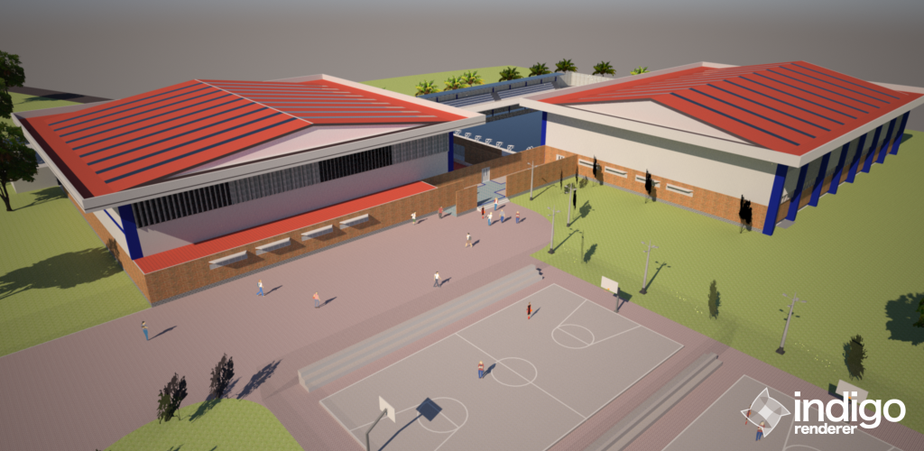

FIG. 6 GYMNASIUM 1 EXTERIOR VIEW

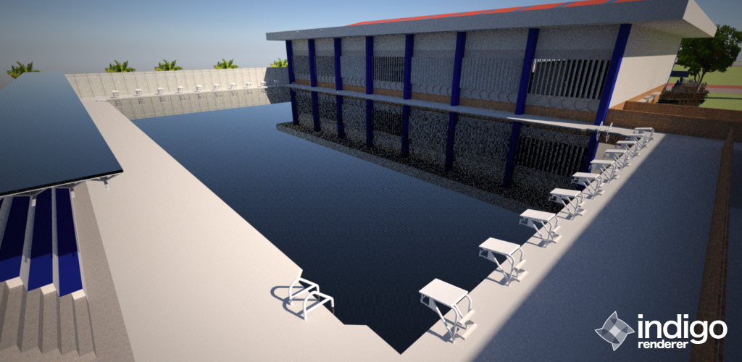

FIG 7. GYMNASIUM1 SWIMMINGPOOL VIEW

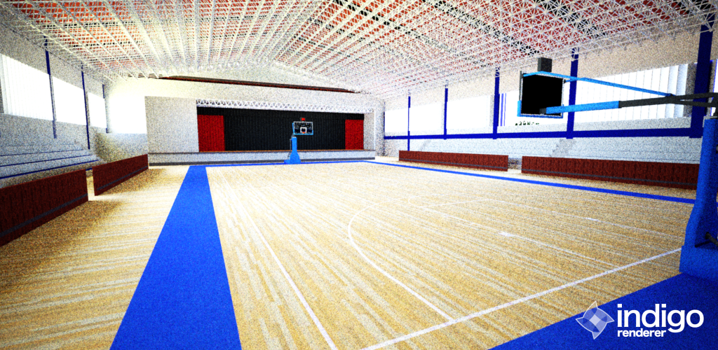

FIG. 8 GYMNASIUM 1 BASKETBALL COURT VIEW

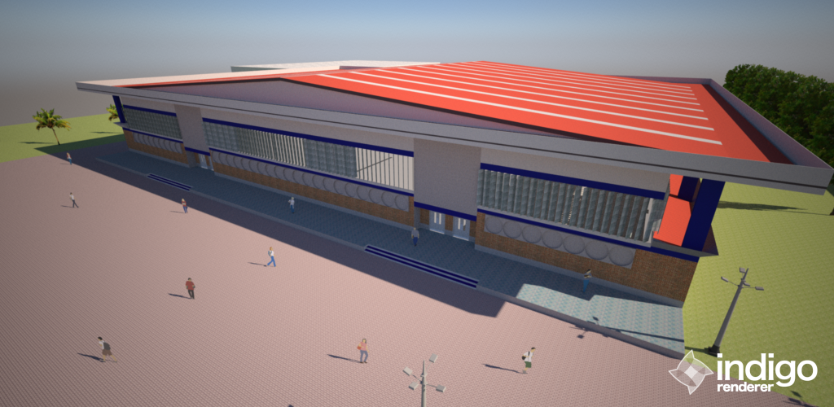

FIG. 9 GYMNAIUM 2 EXTERIOR VIEW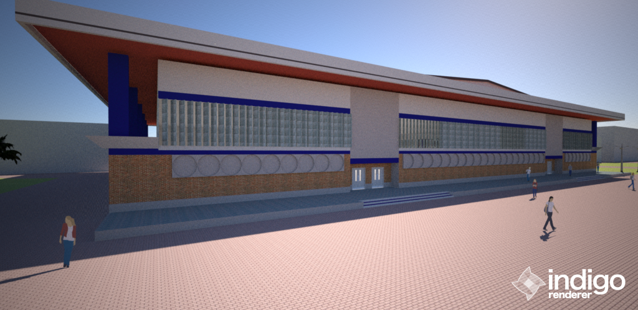

FIG. 10 GYMNASIUM 2 SPOT VIEW

**9.5. RECOMMENDATIONS**

- As to why the sports oriented school is needed in the Philippines is not only to win the medals from different events but for the future welfare of the people. The proposed school would provide what is necessary for what it takes to learn what a healthy life is.

- Since the proposed project would implement that sports is not something only an athlete would practice but for all, that it will open the doors of sports for the public. And to do so, the cooperation of local government and DepEd’s help is necessary to provide maximum experience of what has been introduced.

- With the systematic curriculums that is provided by the International Olympic Committee, it will be a step forward for the Philippines to get a future achievement.

- Although the school is off-limits to the public entry, the proponent considered that school would hold the events of what the sports school would usually hold, like sports festival, and for the ease of public access, the proponent provided an access point of where the non-student public can access through the sports facilities.

- To achieve the ease of pedestrian circulation, the wings are arranged in paralleled positions.

- Further developments shall be done accordance to the site development plan and future expansions can be carefully studied through development of the sports and educations. The further development shall follow the principles of Olympism and proponent’s design principles and careful consideration of design is necessary.

BIBLIOGRAPHY

BP 344. (1983). “Batas Pambansa 344.” Philippines.

DepEd. *DepEd Region 7*. Retrieved 9 29, 2012, from DepEd Region 7 Web: http://www.depedro7.com.ph/mission.php

Dr. PerryJim. (2003). Olympism for the 21st Century. “Centre d’Estudis Olímpics” (pages: 1-8). Barcelona: Leeds University.

IOC. “International Olympic Committee.” http://www.olympic.org/olympism-in-action

Mandaue City Government. (2011). “Official Website of Mandaue City”. http://www.mandauecity.gov.ph/aboutus/history/

MCDSP. “Mandaue City Development Strategy Program CY 2002-2020.” Mandaue City.

NBC. (1979). “National Building Code.” Philippines.

NSCB.(2007 8, 1). “NSCB”. National Statistical Coordinational Board: http://www.nscb.gov.ph/activestats/psgc/municipality.asp?muncode=072230000&regcode=07&provcode=22 PD 1185. (1986). “Presidential Degree no. 1185.” Philippines.

Philippine Network Foundation.. “Philippine Network”. Philippine Network Foundation web page: http://www.ph.net/htdocs/education/issue.htm

POC. . “Philippine Olympic Committee.” http://www.olympic.ph/pocofficers.html

POC.. “Philippine Olympic Committee.” http://www.olympic.ph/history.html

TannerKenneth. (2000 April). “School Design Planning and Laboratory.” SPDL: http://sdpl.coe.uga.edu/research/principlesofdesign.html

Wikipedia. (2008). “Wikipedia org”. http://en.wikipedia.org/wiki/Education_in_the_Philippines

Osmena, Ian and Casicas, Carlo. (March 2004) "An Environment for Learning: A Proposed New Sacred Heart School Jesuit"

1. Dr. Jim Parry, *2003*, **Olympics for the 21st Century** [pdf] available at: <<http://fiep.cat/documents/Olympism%20for%20the%2021st%20century.pdf>>[accessed at Sept 12 2012]